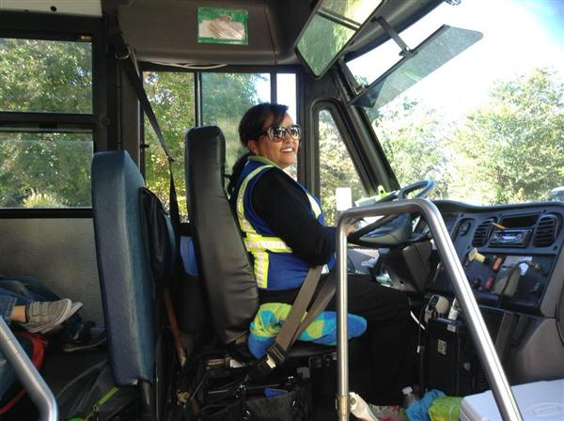
Join the Best. Drive with APS.
Arlington Public Schools Bus Driver Career Fair
Tuesday, June 27, 2017
9 AM - 2 PM
Arlington Employment Center
2100 Washington Boulevard, Lower Level Conference Room D
Arlington, Virginia 22204
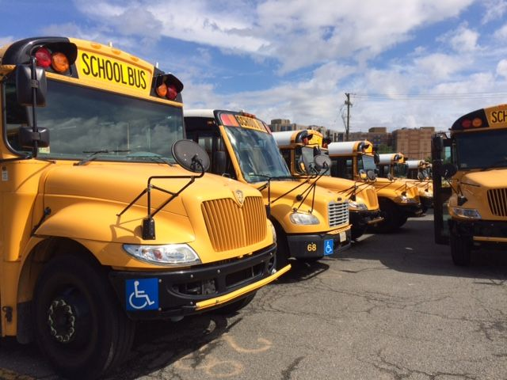
Earn a Commercial Driver’s License (CDL) without any cost to you!
Bus driver pay starts at $17.80 an hour, with successful completion of paid classroom and on the road training and CDL licensing process.
Eligibility for a 30 hour/week, 11-month contract, when available, at rates starting at $18.79 plus benefits!
Benefits for contracted drivers include:

- Health Insurance
- Dental Plan
- Vision Plan
- Retirement Plan
- Sick Leave
- Paid Holidays and Training
- Summer Opportunities

Apply online prior to career fair at https://www.apsva.us/apply-today. Registration for the event is encouraged and can be completed at https://www.apsdrive.eventbrite.com. Please bring a copy of your 5 year driving record. Questions? Contact Darlene Carr-Greene @ 703 228 6640.

