PERFORMANCE ASSESSMENT TASK
Grade 3

UNIT II: Economics

STANDARD: Social Studies 3.7
English 3.4 f, 3.6 b, e, 3.7

ENDURING UNDERSTANDING: Students will understand that people make economic choices that affect human, natural and capital resources.

CONCEPTUAL UNIT QUESTION: What choices can people make when they cannot have everything they need/want?

SCENARIO: You are living in Ancient Greece and produce a good or a service. The local Agora has an opening for a new shop that sells a good or a service to the people of Ancient Greece.

Your job is to research the resources available in Ancient Greece and create one good or service you could specialize in and sell at the shop in the Agora. You will present a poster that describes your good or service to the other shopkeepers in the Agora. There are many other people who want the chance to own the shop, so you must be able to sell a good or service that is needed by the Greeks, explain why you chose this good or service and what resources will be needed to produce it in order for it to be chosen.

TASK: You will collect information from the documents provided and from what you already learned about Economics and Ancient Greece to
- describe what resources were available in Ancient Greece (content is accurate)
- describe the jobs people specialized in Ancient Greece (describe people, places, events and the connections among them)
- make a decision about the good or service you can provide for the people of Greece (relate information from two or more sources)
- give clear and strong reasons for why your good or service is needed in the Agora (elaborate on evidence)
- be persuasive and expressive in a poster about your new good or service (be persuasive and expressive in a poster about your new good or service, express ideas clearly)

DOCUMENTS: Use each of the documents provided to research information on your task. Include information from each document in your presentation.
Document A: Natural Resources in Ancient Greece
Document B: Human Resources in Ancient Greece
Document C: Capital Resources in Ancient Greece

PRODUCT DESCRIPTION: You will produce a poster that you will present to the other shopkeepers at the Agora that
- names the good or service you plan to sell at the new shop
- illustrates its purpose
- explains why you think this good or service is needed by the people of Ancient Greece
- uses persuasive language to convince the rest of the group to agree with you
- includes at least two references to the documents provided by explaining what natural, human or capital resources are needed to produce your good or service
- is clearly worded and on topic

REFLECTION: You only had certain resources available to you when you created your good or service. What economic choices did you have to make and how did those choices affect your decision to create this good or service?

____________________________________________________________________________
________________________________________________________________________________________________________________________________________________________________________________________________________________________________________________________________________________________________________________
____________________________________________________________________________________________________________________________________________________________________________________________________________________________________
Name______________________________ PAT RUBRIC: Economics

Category | 4 Exceeds Expectations | 3 Meets Expectations | 2 Approaching Expectations | 1 Below Expectations | Score
Content | All facts and details are written accurately. | Almost all facts and details are written accurately. | Some facts and details are written accurately. | There are several facts and details that are not accurate.
Basic Skills | Demonstrates mastery of describing the importance of resources in Ancient Greece. | Demonstrates ability of describing the importance of resources in Ancient Greece. | Demonstrates several errors when describing the importance of resources in Ancient Greece. | Does not demonstrate the ability to describe the importance of resources in Ancient Greece.
Analysis/Interpretation  Skills | Examines and uses all of the documents successfully to create a good or a service and gives reasons to support their decision. | Examines and uses most of the documents successfully to create a good or a service and gives reasons to support their decision. | Examines and uses some of the documents successfully to create a good or a service and gives reasons to support their decision. | Does not examine or use the documents successfully to create a good or a service and give reasons to support their decision.
Application/Synthesis  Skills | The poster provides clear and strong reasons for the good or service choice. | The poster provides somewhat clear and strong reasons for the good or service choice. | The poster has reasons for the good or service choice. | The poster does not provide reasons for the good or service choice.
Communication Skills | The presentation is very persuasive and effectively communicates a perspective. | The presentation is somewhat persuasive and communicates a perspective. | The presentation communicates a perspective. | The presentation is not persuasive and does not communicate a perspective.
Comments: Total Score______

Document A: Natural Resources in Ancient Greece
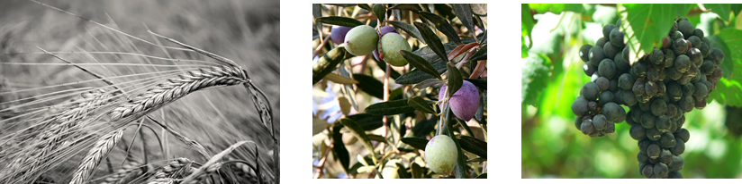

- Ancient Greece was located on a peninsula with mountains and hills and was surrounded by many islands and the Mediterranean Sea.

- Greece had limited rich soil.

- Barley was the most common type of grain/cereal produced in Ancient Greece.

- Ancient Greece was home to many olive trees, which provided olive oil that was used for cooking, cleaning and lighting. It took more than twenty years for the olive tree to provide fruit, and it only produced fruit every other year.

- Grapes grew well in the rocky soil.

- Figs, almonds, pomegranates, cabbage, onions, beans and herbs grew well in Ancient Greece.

- Ancient Greece did not have good pasture land for livestock, so meat was scarce. The Greeks loved fish found in the Mediterranean Sea.
Document B: Human Resources in Ancient Greece

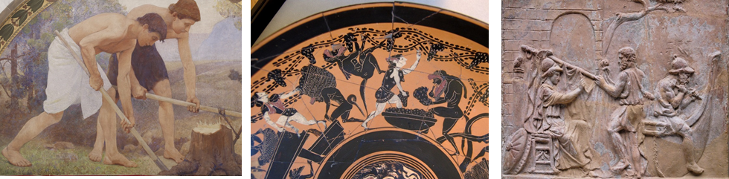

- People of ancient Greece lived near the Mediterranean Sea and specialized in building ships.

- The sea also provided jobs for fishermen.

- Farmers grew many crops in Ancient Greece.

- Potters made many kinds of pottery that were created for everyday use by the Greeks.

- Vases and pots were usually made by the potter and someone else usually specialized in painting the pieces.

Document C: Capital Resources in Ancient Greece

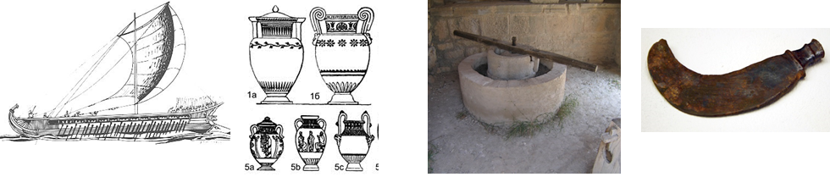

- Olive presses were used to make olive oil. They were made up of a grinding stone that was moved by humans, animals and water or wind power.

- Vases, pots and jugs were pieces of pottery that were used for everyday jobs like storing and mixing food, cups and jugs and holding oils and perfumes.

- Greek ships were made of wood used to sail around the Mediterranean Sea for the purpose of fishing and trade. Fishermen used nets to catch fish in the sea.

- The Greeks used hand-held tools like sickles (tools used for cutting) to harvest grain crops.

Student Document Organizer: Economics in Ancient Greece

Which natural resources are needed to produce the good or service you plan to sell at your shop in the Agora? Why do you need these resources?

________________________________________________________________________________________________________________________________________________________________________________________________________________________________________________________________________________________________________________________________________________________________________

Which capital resources are needed to produce the good or service you plan to sell at your shop in the Agora? Why do you need these resources?

____________________________________________________________________________________________________________________________________________________________________________________________________________________________________________________________________________________________________________________________________________________________________________________________________________________________________

Which human resources are needed to produce the good or service you plan to sell at your shop in the Agora? Why do you need these resources?

____________________________________________________________________________________________________________________________________________________________________________________________________________________________________________________________________________________________________________________________________________________________________________________________________________________________________
PAT TASK CHECKLIST
Good or Service

PRODUCT CHECKLIST: After reviewing all the information, I created a poster that describes a good or service that would be needed by the people of Ancient Greece.

_____ I have reviewed all the documents for multiple pieces of evidence.
All my notes are on the graphic organizer.
_____ I have created a poster that names my good or service and illustrates its
purpose.
_____ I have included at least two reasons for producing ____________ as my good
or service.

My product --

includes accurate content learned in the Greece and Economics Units

has been edited for spelling and grammar mistakes

is well organized and neat

is persuasive and clearly written/illustrated

reflects my best effort
Student Document Organizer – Scaffolded Version: Economics in Ancient Greece

Natural Resources
I will need _________________________ to produce my good or service because ________________________________________________________
_______________________________________________________________.
I will need _________________________ to produce my good or service because ________________________________________________________
_______________________________________________________________.
I will need _________________________ to produce my good or service because ________________________________________________________
________________________________________________________________.

Capital Resources
I will need _________________________ to produce my good or service because ________________________________________________________
_______________________________________________________________.
I will need _________________________ to produce my good or service because ________________________________________________________
_______________________________________________________________.
I will need _________________________ to produce my good or service because ________________________________________________________
_______________________________________________________________.

Human Resources
I will need _________________________ to produce my good or service because ________________________________________________________
_______________________________________________________________.
I will need _________________________ to produce my good or service because ________________________________________________________
_______________________________________________________________.
I will need _________________________ to produce my good or service because ________________________________________________________
_______________________________________________________________.

PAT TASK CHECKLIST

PRODUCT CHECKLIST: After reviewing all the information, I created a poster that describes a good or service that would be needed by the people of Ancient Greece.

_____ I have reviewed all the documents for multiple pieces of evidence.
All my notes are on the graphic organizer.
_____ I have created a poster that names my good or service and illustrates its
purpose.
_____ I have included at least two reasons for producing my good or service.

My product --

includes accurate content learned in the Greece and Economics Units

has been edited for spelling and grammar mistakes

is well organized and neat

is persuasive and clearly written/illustrated

reflects my best effort

PAT Score Form
Teacher: ______________________ Unit: __________________ Date: ______________________
Student Name | Content |  |  |  | Basics |  |  |  | Analysis |  |  |  | Application |  |  |  | Communication x2 |  |  |  | Total
 | 4 | 3 | 2 | 1 | 4 | 3 | 2 | 1 | 4 | 3 | 2 | 1 | 4 | 3 | 2 | 1 | 4 | 3 | 2 | 1

Economics in Ancient Greece Image Credits

Mitchell, F. Depiction of a Greek trireme, 1984. Ancient and Medieval Warfare: The History of the Strategies, Tactics, and Leadership of Classical Warfare, New Jersey, United States: Avery Publishing Group. http://www.au.af.mil/au/awc/awcgate/gabrmetz/gabr0066.htm

Leitmotiv. Moulin à olives. 2008. (olive press)
http://flickr.com/photos/edoug/827586924/

Weis, Herman. Ancient Greek pottery by shape. 2007. History of culture. Ancient Greece. Moscow, 1903. https://commons.wikimedia.org/wiki/File:Shapes_of_ancient_greek_pottery.jpg

Bonney-Turner, Olive Tree Kids (The Fruit of an Olive Tree), 2006. en:Image:Olivesfromjordan.jpg
https://commons.wikimedia.org/wiki/File:Olivesfromjordan.jpg

Sookdhis, Chrisada, Clusters of Shiraz. 2006 https://en.wikipedia.org/wiki/File:Shiraz_grapes.jpg

Pearce, Charles Sprague, Detail from Labor mural in lunette from the Family and Education series by Charles Sprague Pearce. North Corridor, Great Hall, Library of Congress Thomas Jefferson Building, Washington, D.C, 1896. www.loc.gov

Painter, Chiusi, Vintage by sileni and maenads. Attic black-figure cup, end of 6th century BC. Cabinet des Médailles. https://upload.wikimedia.org/wikipedia/commons/3/34/Cup_vintage_Cdm_Paris_320_n4.jpg

Author unknown, The building of the ship Argo. Terracotta relief, Roman artwork, probably 1st century AD. British Museum. Upper floor, room 69: Greek and Roman life
https://upload.wikimedia.org/wikipedia/commons/4/42/Building_Argo_BM_TerrD603.jpg

Dall'Orto, Giovanni, Ancient Greek iron sickle, 2009, currently exhibited in Room 12 ("private life") of the Kerameikos Archaeological Museum (Athens). https://en.wikipedia.org/wiki/Sickle

Ficus carica (fig). 2010 https://en.wikipedia.org/wiki/Ficus

Almond blossom, 2010, Wild Flowers of Israel via the PikiWiki - Israel free image collection project.
en.wikipedia.org800 × 669Search by image

Tarpenning, Bill, Brassica oleracea viridis Cabbage at a market near Greenville, Mississippi. Image #96cs1134/CD1468-014.
https://en.wikipedia.org/wiki/Cabbage#/media/File:Cabbage.jpg
Ausmus, Stephen, Pungent red onions are nutritional wonders, 2007. This image was released by the Agricultural Research Service.
en.wikipedia.org1836 × 2700Search by image

Rasbak, Vica faba or broad beans, known in the US as fava beans. 2011.
en.wikipedia.org922 × 765Search by image

Herbs: basil, scallion. 2004. http://flickr.com/photos/97558037@N00/53082703/
en.wikipedia.org300 × 400Search by image

Map Greek Sanctuaries, Map of the major regions of mainland Ancient Greece. 2010. blank map from Map_greek_sanctuaries-en.svg
en.wikipedia.org950 × 1100Search by image

Daderot, Net, 2013, Exhibit in the Natural History Museum of Utah, Salt Lake City, Utah https://commons.wikimedia.org/wiki/File:Net,_78401870_BC,_Danger_Cave,_Utah,_milkweed_cordage_-_Natural_History_Museum_of_Utah_-_DSC07275.JPG SA.

