PERFORMANCE ASSESSMENT TASK
Grade 3 – Teacher Document

UNIT I: Geography and Map Skills

STANDARD: Social Studies: 3.5 c, 3.6
English: 3.2, 3.7 a, 3.10 a, 3.11 b, c

ENDURING UNDERSTANDING: Students will understand that locations in the world have unique geographic features.

CONCEPTUAL UNIT QUESTION:

SCENARIO: The Acme Atlas (Map) Company is printing a new atlas and they want to include newly found places. You have discovered a new place and want it to be included in the new book. In order for this to happen, you must make a presentation to the Acme Atlas Company explaining your location and why your new place should be in their new atlas.

TASK: You will collect information from the document(s) provided to
- interpret a world map (and continent maps if you choose) to determine where your new place is located
- describe accurate information about the location you have chosen
- analyze the landforms and bodies of water of your location
- create a map detailing your discovery, including a title, compass rose, the Equator, Prime Meridian and map key.
- present your new location to the ACME Atlas Company

DOCUMENTS: Use the documents provided to research information on your task.
Document A: Map of the World
Document B: Continent maps in classroom Atlas or eMaps (Digital School Maps)

Name____________________

STUDENT PAT DOCUMENT ORGANIZER: Geography and Map Skills

New Place on the Map

Background: The Acme Atlas (Map) Company is printing a new book of maps and they want to include newly found places. You have discovered a new place and want it to be included in the new book. In order for this to happen, you must make a presentation to the Acme Atlas Company explaining your location why your new place should be in their new book.

Product Description:
You will use a world map, and individual continent maps if needed to locate your new place. In addition, you will identify where your new place is located using directional words and other landforms so other people can find your new place.

You must show the publisher of Acme Atlas Company where the new land is by creating your own map showing:

- Where your new place is located in relation to the seven continents.
- Where it is located in relation to the five oceans.
- Show the land forms and bodies of water found in and near your new place.
- Label your map with a compass rose, equator, prime meridian, and map key.
- Name your new place.

Written Description:

You will write 3-5 sentences to tell the Acme Atlas company about your new place and explain why you feel it should be included in their new atlas.

Student Document Organizer:

Describe important information about your specific location on the world map.

Where is your place located in relation to the equator and the Prime Meridian? Use directional words.

________________________________________________________________________________________________________________________________________________________________________________________________________________________________________________

Where is your place located in relation to other land forms?

____________________________________________________________________________________________________________________________________________________________________________________________________________________________________________________________________________________________________________

Where is your place located in relation to other bodies of water?

________________________________________________________________________________________________________________________________________________________________________________________________________________________________________________

What geographical features and natural resources does your new place have? Why are these important to your new place?

____________________________________________________________________________________________________________________________________________________________________________________________________________________________________________________________________________________________________________________________________________________________________________________________________________________________________

PRODUCT CHECKLIST: After reviewing all the information, I will create a map of a new location in the world.

I have reviewed all the documents for multiple pieces of evidence. All
my notes are on the graphic organizer.

I have included at least three pieces of information about my location
(landform, bodies of water, natural resources)

My product:

includes vocabulary and content learned in the Geography & Map
Skills Unit

has been edited for spelling and grammar mistakes

is well organized and neat

reflects my best effort

Student Document Organizer – Scaffolded Version:

My new place is located ________________________________________ of the equator.

My new place is located ________________________________________ of the Prime Meridian.

My new place is ___________________(north, south, east or west) of__________________________.

My new place is located near the _________________________________ body of water.

My new place has _____________________________________________
_________________________________(mountains, rivers, valleys, lakes)
My new place ________________________________________________
____________________________________________________________

PRODUCT CHECKLIST: After reviewing all the information, I will create a map of a new location in the world.

I have reviewed all the documents for multiple pieces of evidence. All
my notes are on the graphic organizer.

I have included at least three pieces of information about my location
(landform, bodies of water, natural resources)

My product:

includes vocabulary and content learned in the Geography & Map
Skills Unit

has been edited for spelling and grammar mistakes

is well organized and neat

reflects my best effort

Document A: Map of the World
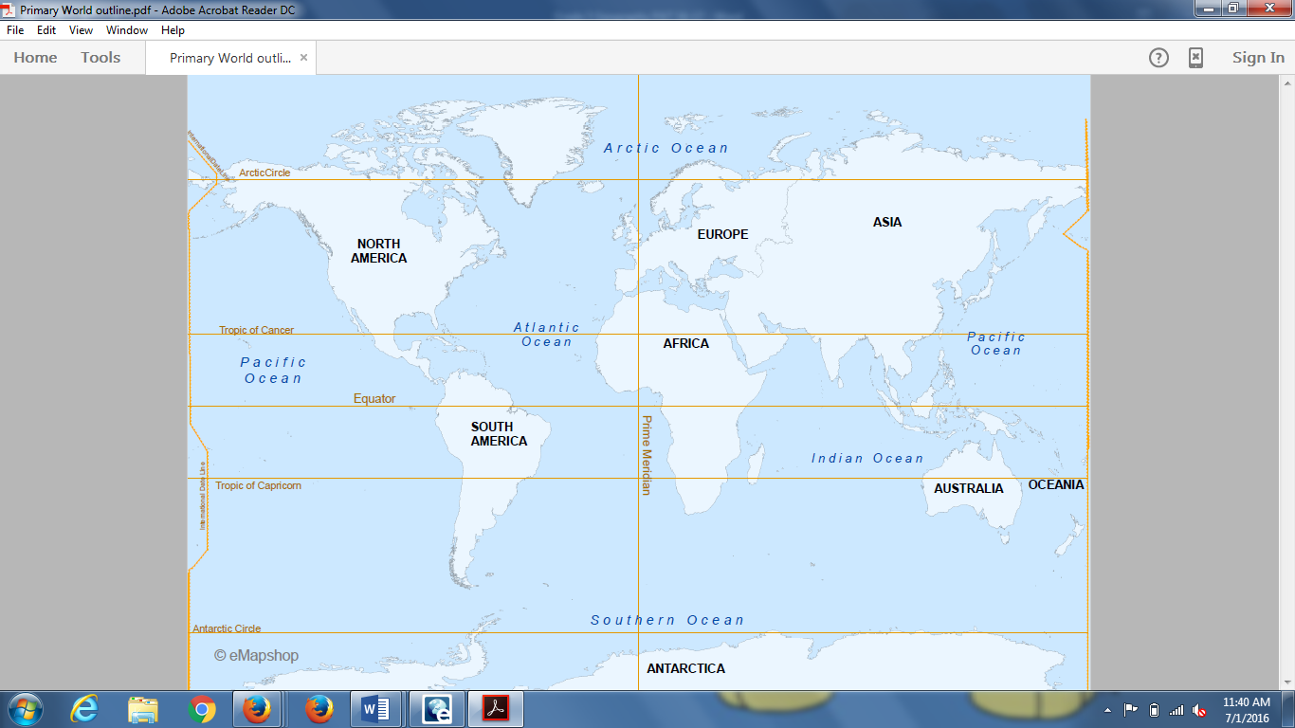

From eMapshop version 3.0

Name____________________ PAT RUBRIC: Geography and Map Skills

Category | 4 Exceeds Expectations | 3 Meets Expectations | 2 Approaching Expectations | 1 Below Expectations | Score
Content | All supportive evidence and details are written accurately. | Most of the supporting evidence and details are written accurately. | Some of the supporting evidence and details are written accurately. | Supporting evidence and details are not reported accurately.
Basic Skills | Demonstrates mastery with describing the reasons for choosing a specific location. | Demonstrates ability with describing the reasons for choosing a specific location. | Demonstrates some ability with describing the reasons for choosing a specific location. | Does not demonstrate ability describing the reasons for choosing a specific location.
Analysis/Interpretation Skills | Examines and uses all of the documents successfully to identify unique characteristics of a location. | Examines and uses most of the documents successfully to identify unique characteristics of a location. | Examines and uses some of the documents successfully to identify unique characteristics of a location. | Does not examine or use any of the documents successfully to identify unique characteristics of a location.
Application/Synthesis Skills | Analyzes multiple resources to provide a clear and specific reason(s) for selection of a specific location. | Analyzes multiple resources to provide a clear reason(s) for selection of a specific location. | Analyzes resources but does not provide a clear and specific reason for selection of a specific location. | Resources are not analyzed and no reason is given for selecting a specific location.
Communication Skills | The presentation clearly communicates the reasons behind the choice of a specific location. | The presentation communicates the reasons behind the choice of a specific location. | The presentation includes some accurate content but does not fully communicate the reasons behind the choice of a specific location. | The presentation does not communicate the reasons behind the choice of a specific location.

Total score: _________
Comments: (out of 20)
PAT Score Form (optional)

Teacher: Unit: Date: ___________

Student Name | Content |  |  |  | Basics |  |  |  |  | Analysis |  |  |  | Application |  |  |  | Communication x2 |  |  |  | Total
 | 4 | 3 | 2 | 1 | 4 | 3 | 2 | 1 | 4 |  | 3 | 2 | 1 | 4 | 3 | 2 | 1 | 4 | 3 | 2 | 1

