PERFORMANCE ASSESSMENT TASK
Grade 3

UNIT VI: History, Government, Economics, Geography

STANDARD: Social Studies: 3.1 a-j, 3.2, 3.3, 3.4, 3.5 a-c, 3.6 a-e, 3.7, 3.8, 3.9, 3.10, 3.12 a-c
Language Arts: 3.1, 3.2, 3.9, 3.10, 3.11

ENDURING UNDERSTANDING: Ancient civilizations contribute to our lives today through the systems they develop to adapt and thrive.

CONCEPTUAL UNIT QUESTION: How does a civilization include the themes of history, economics, government and geography?

SCENARIO: The leader of an empire has hired you to go to one of the three locations they have found to create (set up) a new civilization. You and your team of explorers have been given the task of setting up a form of government, a way to use the resources at the location, and explain how your new civilization will adapt to your new land. The only requirement for setting up this new civilization is to report back to the leader of the empire about how this new civilization will expand and help profit the empire.

TASK: You will collect information from the documents provided to
- describe accurate information about the civilization you have found-resources found within the location (content is accurate)
- explain how the individuals in your civilization adapt to their new land
- make a decision about the name for the new civilization (relate information from two or more sources)
- give clear and strong reasons for why the contributions of your civilization are important to the empire and also to the future (formulate an argument from a specific perspective)

DOCUMENTS: Use each of the documents provided to research information on your task. Include information from each document in your presentation.
Document A: World Map and Maps of 3 Locations
Document B: Ways People Adapted to their Environment in Ancient World Cultures
Document C: Government Contributions from Ancient World Cultures
Document D: Contributions from Ancient World Cultures

Student Directions
Student Directions

SCENARIO: The leader of an empire has hired you to go to one of the three locations they have found to create (set up) a new civilization. You and your team of explorers have been given the task of setting up a form of government, a way to use the resources at the location, and explain how your new civilization will adapt to your new land. The only requirement for setting up this new civilization is to report back to the leader of the empire about how this new civilization will expand and help profit the empire. You will make a report to your leader about your civilization.

PRODUCT DESCRIPTION: You will create a presentation to explain your new civilization, it’s location, government, economy, and its historical significance to the empire and the future. Your presentation will include the following:

- Where is your civilization located in relation to the world today?
- A map of your location with features marked and included in a legend
- Type of government used by the people.
- What were its rules and laws?
- The flag of your civilization.
- What natural resources were found there?
- Type of economy (barter, exchange money for goods and services) your civilization used.
- Was there a specialization of this civilization?
- What were the lasting contributions of this civilization?

Your final product may be completed in several different ways:

- Write a 2-3 paragraph report with 2-3 visuals included.
- Create a presentation using your I-Pad (You may use the programs: Explain Everything, Google Classroom, Pixie or any other presentation application.
- Poster Presentation- Written descriptions of visuals included.

Name______________________________
PAT RUBRIC: Government and History

Category | 4 Exceeds Expectations | 3 Meets Expectations | 2 Approaching Expectations | 1 Below Expectations | Score
Content | All facts and details are written accurately. | Almost all facts and details are written accurately. | Some facts and details are written accurately. | There are several facts and details that are not accurate.
Basic Skills | Demonstrates mastery of describing the government, history, economy and location of a new civilization. | Demonstrates ability of describing the government, history, economy and location of a new civilization.. | Demonstrates several errors when describing the government, history, economy and location of a new civilization. | Does not demonstrate the ability to describe the government, history, economy and location of a new civilization.
Analysis/  Interpretation  Skills | Examines and uses all of the documents successfully to determine the government, history, economy and location of a new civilization. | Examines and uses most of the documents successfully to determine the government, history, economy and location of a new civilization. | Examines and uses some of the documents successfully to determine the government, history, economy and location of a new civilization. | Does not examine or use the documents successfully to determine the government, history, economy and location of a new civilization.
Application/Synthesis  Skills | The final product provides clear and strong understanding of government, history, economy and location of a new civilization. | The final product provides somewhat clear understanding of the government, history, economy and location of a new civilization. | The final product has reasons for the government, history, economy and location of a new civilization.. | The final product does not provide reasons for the government, history, economy and location of a new civilization.
Communication Skills | The final product is very persuasive and effectively communicates a perspective. | The final product is somewhat persuasive and communicates a perspective. | The final product communicates a perspective. | The final product is not persuasive and does not communicate a perspective.
Comments: Total Score______________

Student Documents

1. Where is your civilization located and how does its location affect its natural resources?
________________________________________________________________________________________________________________________________________________________________________________________________________________________________________________________________________________________________________________________________________________________________________________________________________________________________________________________________________________________________

2.What type of government does your civilization have?
________________________________________________________________________________________________________________________________________________________________________________________________________________________________________________________________________________________________________________________________________________________________________________________________________________________________________________________________________________________________

3.In your civilization, what type of economy do the people use to get the things they needed and wanted?
________________________________________________________________________________________________________________________________________________________________________________________________________________________________________________________________________________________________________________________________________________________________________________________________________________________________________________________________________________________________

4.What do you think the lasting contributions of your civilization will be?
________________________________________________________________________________________________________________________________________________________________________________________________________________________________________________________________________________________________________________________________________________________________________________________________________________________________________________________________________________________________

5. Describe the flag of your civilization and the importance of its symbols.
________________________________________________________________________________________________________________________________________________________________________________________________________________________________________________________________________________________________________________________________________________________________________________________________________________

PAT TASK CHECKLIST
New Civilization Presentation

UNIT VI: Government, History, Economics and Geography

PRODUCT CHECKLIST: I have created a presentation that thoroughly explains the history, importance and contributions of my civilization.

I have reviewed all the documents for multiple pieces of evidence. All my notes are on the graphic organizer.

____I have included a written description of my civilization (location, economy, government, history)

My product --

includes accurate content learned in the Government, History, Economics and Geography Units
has been edited for spelling and grammar mistakes
is well organized and neat
is persuasive and clearly written
reflects my best effort

REFLECTION: What were the major contributions of your civilization and how do these contributions affect The United States of America today?

______________________________________________________________________________________________________________________________________________________________________________________________________________________________________________________________________________________________________________________________________________________________________________________________________________________________________________________________________________________________________________________________________________________________________________________________________________________________________________________

TEACHER NOTES:

In order to help with timing at the end of the year and differentiation needs you can choose to use either of the two following options.

PAT Mini Version Requirements: If you are completing a mini-version of this PAT, the students must use the Student Documents to answer questions 1-4 ONLY (see below), and then will write a 1-2 paragraph description of their civilization in place of a project. This mini- version may be used with any of the three locations.

STUDENT DOCUMENT SCAFFOLDED VERSION (These scaffolded questions are to be used with Location A only)

- My civilization is located (found) in ______________________________
(name the continent).
- In the mountains I found____________________________(type of resources).
- The forest is important because______________________________________
(type of resources).
- The river is helpful to my civilization because it gives us ______________________.
- It is also helpful because______________________________.
- The government in my civilization was _______________________________ (ruled by a king or emperor, a direct democracy, a representative democracy).
- The name of my civilization is ____________________________________. I chose this name because __________________________________________.

Student Document A - Maps
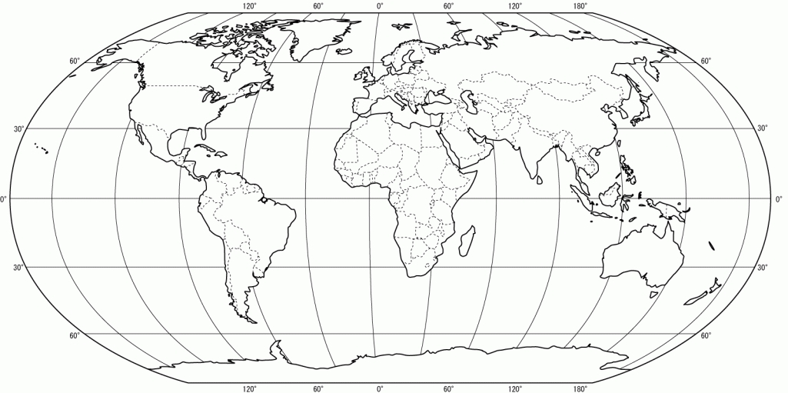
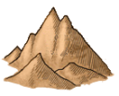
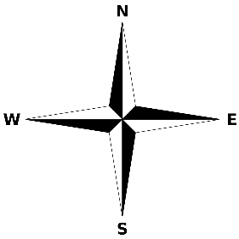
Locations A, B and C
A
B
C

Forest Hills Rivers Mountains Lake Desert Grassland
Atlantic Ocean

Location A

Location B
Southern Ocean

Location C

Ways People in Ancient World Cultures Adapted
to their Environments

Ancient China | - Farmed in fertile soil along the rivers  - Fished in the rivers and seas  - Mined natural resource
Ancient Egypt | - Farmed in fertile soil along the Nile River  - Created irrigation systems  - Traded along the Mediterranean coast
Ancient Greece | - Limited farming due to mountains  - Traded across the Mediterranean Sea  - Built ships to fish in and trade across the Mediterranean Sea
Ancient Rome | - Limited farming due to mountains  - Traded across the Mediterranean Sea  - Built roads to connect to land in western Europe and Africa
West African Empire of Mali | - Mined gold  - Traded gold for salt from the Sahara Desert  - Farmed and raised animals on the grasslands
Student Document B

Ways People in Ancient World Cultures Adapted
to their Environments

adapt to an environment – to get used to a new place so you can survive there
Ancient China | - Farmed in fertile (good for growing) soil along the rivers  - Fished in the rivers and seas  - Mined (removed from the earth) natural resource (useful things that come from nature)
Ancient  Egypt | - Farmed in fertile (good for growing) soil along the Nile River  - Created irrigation systems (pipes used to bring water to the land from a river)  - Traded along the Mediterranean coast
Ancient Greece | - Limited (not very much) farming due to mountains  - Traded across the Mediterranean Sea  - Built ships to fish in and trade across the Mediterranean Sea
Ancient Rome | - Limited (not very much) farming due to mountains  - Traded across the Mediterranean Sea  - Built roads to connect to land in western Europe and Africa
West African Empire of Mali | - Mined (removed from the earth) gold  - Traded gold for salt from the Sahara Desert  - Farmed and raised animals on the grasslands
Student Document B: Scaffolded Version

Student Document C

 | Government Contributions from Ancient World Cultures
- Government: A group of people that makes laws, carries out laws, and decides if laws have been broken
- The purpose of laws is to keep people safe and maintain order.
- Governments are necessary because they develop laws and protect the rights and property of individuals.
Ancient  China | - Ancient China was mostly ruled by powerful families called dynasties. The first dynasty was the Shang and the last was the Qing. Emperors would continue to rule over China for more than 2000 years.
Ancient  Egypt | - Ancient Egyptian Government was ruled by the Pharaoh. The Pharaoh was the supreme leader of the government. The Pharaoh couldn't run the government all by himself, so he had a hierarchy of rulers and leaders below him who ran different aspects of the government.
Ancient  Greece | - Ancient Greece was a direct democracy: A government in which people vote to make their own rules and laws
Ancient  Rome | - Ancient Rome was a representative democracy: A government in which the people vote for (elect) a smaller group of citizens to make the rules and laws for everyone
Western African Empire of Mali | - The kings of Mali were rich and powerful men who controlled trade in West Africa. Mali became one of the largest and wealthiest empires in the region and was an important trade center.
 | Government Contributions from Ancient World Cultures
- Government: A group of people that makes laws, carries out laws, and decides if laws have been broken
- The purpose of laws is to keep people safe and maintain order.

- Governments are needed because they make laws and protect (keep safe) the rights and property of people.
Ancient  China | - Ancient China was mostly ruled by powerful families called dynasties. Rulers called Emperors ruled over China for more than 2000 years.
Ancient  Egypt | - Ancient Egyptian Government was ruled by the Pharaoh. The Pharaoh was the supreme (most important) leader of the government. The Pharaoh couldn't run the government all by himself, so he had a hierarchy (different levels) of rulers and leaders below him who ran different parts of the government.
Ancient  Greece | - Ancient Greece was a direct democracy: A government in which people vote to make their own rules and laws
Ancient  Rome | - Ancient Rome was a representative democracy: A government in which the people vote for (elect) a smaller group of citizens to make the rules and laws for everyone
Western African Empire of Mali | - The kings of Mali were rich and powerful men who controlled trade in West Africa. Mali became one of the largest and wealthiest (richest) empires in the area and was an important trade center.
Student Document C: Scaffolded Version
Student Document D
 | Contributions from Ancient World Cultures
- contribution: The act of giving or doing something
- architecture: The design of buildings
- inventions: new products or ideas that have never been created before
Ancient  China | - Written language - characters and symbols  - Inventions - kite, silk cloth, compass, fireworks  - architecture - Great Wall of China
Ancient  Egypt | - Written language - hieroglyphics  - Inventions - paper made from papyrus, 365 day calendar, clock  - Architecture - Pyramids
Ancient  Greece | - Architecture - The Parthenon (columns)  - Art - Mosaics, sculpture, and paintings are on buildings, pottery  - Olympic games of today are modeled after the games of ancient Greece.
Ancient  Rome | - Architecture - The Colosseum and aqueducts (arches)  - Art - Mosaics, sculpture, and paintings are displayed on buildings.
Western African Empire of Mali | - Many storytellers in Mali passed on stories and traditions from one generation to the next  - People used salt for their health and for preserving foods

Student Document D: Scaffolded Version

 | Contributions from Ancient World Cultures
- contribution: The act of giving or doing something
- architecture: The design of buildings
- inventions: new products or ideas that have never been created before
Ancient  China | - Written language - characters and symbols  - Inventions - kite, silk cloth, compass, fireworks  - architecture - Great Wall of China
Ancient  Egypt | - Written language - hieroglyphics  - Inventions - paper made from papyrus, 365 day calendar, clock  - Architecture - Pyramids
Ancient  Greece | - Architecture - The Parthenon (columns)  - Art - Mosaics, sculpture, and paintings are on buildings, pottery  - Olympic games of today are modeled after the games of ancient Greece.
Ancient  Rome | - Architecture - The Colosseum and aqueducts (arches)  - Art - Mosaics, sculpture, and paintings are on buildings.
Western African Empire of Mali | - Many storytellers in Mali passed on stories and traditions (ideas and beliefs that are important to people) from one generation to the next (from grandparent, to parent to child).  - People used salt for their health and for preserving foods (keeping foods safe to eat).

PAT Score Form
Teacher: ______________________ Unit: __________________ Date: ______________________
Student Name | Content |  |  |  | Basics |  |  |  | Analysis |  |  |  | Application |  |  |  | Communication x2 |  |  |  | Total
 | 4 | 3 | 2 | 1 | 4 | 3 | 2 | 1 | 4 | 3 | 2 | 1 | 4 | 3 | 2 | 1 | 4 | 3 | 2 | 1

