MINI-PERFORMANCE ASSESSMENT TASK SCAFFOLDED
Grade 6

UNIT II: Colonial America

STANDARD: CE.1a; CE.11a, USI.1b, USI.5a, USI.5b

ENDURING UNDERSTANDING: Environment and Interaction affect the development of economic, social and political life in a society.

CONCEPTUAL UNIT QUESTION: What factors affected the development and interactions of the different colonial regions and their ways of life?

SCENARIO (Revised): You are an artist working for a company that wants new settlers for America. For the colonies to grow and get wealthier, the company needs people to settle the land. You have been asked to create a poster showing the positive economic, social and political reasons to move to your colony. The competition for settlers is tough, so include what is unique about your colony to convince people that it is the best. You have limited space, so be sure to use catchy phrases and create compelling images to get your point across.

TASK: You will collect information from the documents provided to complete the following tasks:
- describe the economic, social and political benefits and costs of settling in one of the following colonies: Massachusetts, Pennsylvania or Georgia
- analyze the interactions between the colonists and their environment. How did the environment affect the choices a particular group made to produce goods and services, including examples of specialization and interdependence?
- elaborate on three benefit/costs arguments to appeal to potential immigrants to come to your colony. Consider negative and positive factors.
- create by hand a poster that would appear in a British newspaper attempting to entice immigration to the colonies.

DOCUMENTS: Use each of the documents provided to research information on your task. Include information from each document in your presentation.
Document A: Colonies Comparison Chart
Document B: Colonial Advertisements

PRODUCT: You will create a poster highlighting Massachusetts, Pennsylvania or Georgia that
- includes the vocabulary and concepts learned in the Colonial America Unit
- describes the colony using basic facts and images to include:
- climate and geography
- economy/resources
- social and religious atmosphere
- political life
- connects the climate and geography with the economic choices colonists made
- provides three major reasons, economic, social and political to encourage immigration to your colony
- includes persuasive language to make potentially non-beneficial qualities look beneficial to the immigrants
  - KEY VOCABULARY: Abundance, Competition, Economic Venture, Import/Export, Interdependence, Markets, Profit.
Glossary:
economic incentives – choice of ways to make a living

social incentives – religious freedom, educational opportunities, groups of people living in the region and their ways of life

political incentives – voice in government and opportunities to participate in law-making/elections

PAT RUBRIC: Colonial America
Category | 4 Exceeds Expectations | 3 Meets Expectations | 2 Approaching Expectations | 1 Below Expectations | Score
Content | Demonstrates thorough and accurate understanding of the development of a colony. | Demonstrates a complete and accurate understanding of the development of a colony with some inaccuracies. | Demonstrates an incomplete understanding of the development of a colony with numerous inaccuracies. | Demonstrates inaccuracies and misconceptions about the development of a colony.
Basic Skills | Demonstrates mastery of identification of a colonial geographic region and its economic, social, and political features. | Demonstrates ability to identifying a colonial geographic region and its economic, social, and political features without significant error. | Demonstrates a number of errors when identifying a colonial geographic region and its economic, social, and political features but roughly shows an understanding. | Demonstrates many critical errors when identifying a colonial region and its economic, social, and political features.
Analysis/Interpretation  Skills | Examines thoroughly all of the given documents.  Clearly organizes and relates information from the documents to analyze the interaction between the colonists and their environment. | Examines several of the given documents.  Makes a credible effort to organize and relate information from some of the documents to analyze the interaction between the colonists and their environment. | Examines some of the given documents.  Makes little effort to organize and relate information from documents to analyze the interaction between the colonists and their environment. | Gives no evidence that given documents were examined.  Fails to organize or relate information to analyze the interaction between the colonists and their environment.
Application/Synthesis  Skills | Cites and elaborates evidence from given documents to persuade and reinterpret reasons for colonization into a brochure. | Cites some evidence from given documents but does not elaborate. Restates ordinary reasons for colonization in an acceptable brochure. | Cites little evidence from the given documents. Few correct reasons for colonization are listed in a simple brochure. | Cites no evidence from the given documents. Fails to provide reasons for colonization.
Communication Skills | Brochure is well organized with clearly stated, complex ideas supported by citations from all documents.  Brochure is persuasive and effectively conveys the key concepts of the task. | Brochure is somewhat organized with clearly stated ordinary ideas supported by citations from several documents.  Brochure is interesting and conveys some key concepts of the task. | Brochure is poorly organized with few unclear, restated ideas supported by citations from few documents.  Brochure is simple and ineffectively conveys few of the key concepts of the task. | Brochure is unorganized with irrelevant statements and no document citations.  Brochure is incomplete.

Document A
Colonies Comparison Chart

 | Massachusetts | Pennsylvania | Georgia
Dates Founded | Separatists in Plymouth 1620  Puritans in Massachusetts Bay 1630  Massachusetts as one colony 1691 | 1681 King Charles II grants Penn the land | 1732
Reasons for settling and the people who settled (include specific groups of people) | Founders:  Separatists = William Bradford (1620)  Puritans = John Winthrop (1630)  Plymouth Colony was settled by separatists from the Church of England who wanted to avoid religious persecution.  Massachusetts Bay Colony was settled by the Puritans to avoid religious persecution.  Eventually they both join together to become one colony called Massachusetts in 1691 | Founder: William Penn  Pennsylvania was settled by the Quakers, who wanted freedom to practice their faith without interference.  Diverse population of English, German, Dutch and Swedish immigrants  Great Law of 1682 promises that people of all faiths would be treated equally | Founder: King George II and James Oglethorpe  Georgia was settled by people who had been in debtors’ prisons in England. They hoped to experience economic freedom and start a new life in the New World.
Climate and Geography | Appalachian Mountains, Boston harbor, hilly terrain, rocky soil, forests, jagged coastline  Moderate summers,  long cold winters | Appalachian Mountains, coastal lowlands, harbors, bays and rivers, fertile soil for large farms  Snowy winters and moderate climate, wide and deep rivers | Appalachian Mountains, Piedmont, Atlantic Coastal Plain, good harbors and rivers, fertile soil  Humid climate with mild winters and hot summers
 | Massachusetts | Pennsylvania | Georgia
Economy/Resources | Crop and livestock farming, lumber, shops, shipping, whaling, tradesmen  Natural resources: e.g., timber, fish, deep harbors  Human resources: e.g., skilled craftsmen, shopkeepers, shipbuilders  Capital resources: e.g., tools, buildings | Farming – dairy, wheat, corn, merchants and tradesmen, lumber, shipbuilding  Natural Resources: e.g., rich farmlands, rivers  Human resources: e.g., unskilled and skilled workers, fishermen  Capital resources: e.g., tools, buildings | Farming (plantations and independent farms) – tobacco, cotton, indigo, rice, trade, skilled labor  Natural resources: e.g., fertile farmlands, rivers, harbors  Human resources: e.g., farmers, enslaved African Americans  Capital resources: e.g., tools, buildings
Religions Practiced (religious freedom?) | Community government by the rules of the Bible as an example to the rest of the world  “…city upon a hill.”  Little religious freedom | Had religious freedom  Great Law of 1682 promises that people of all faiths would be treated equally  Quakers | Had some religious freedom although most were Episcopalian
Political Life/Government | Villages and churches were centers of life. Religious reformers and separatists  Political life: town meetings; church members elect leaders/make laws | Villages and cities, varied and diverse lifestyles, diverse religions  Political life: market towns, General Assembly and appointed governor | Plantations (slavery), indentured servants, fewer cities, fewer schools, Church of England  Political life: counties, elected assembly, appointed governor
Adapted from History Alive! materials
Document A (cont.)

Colonies Comparison Chart Question Matrix

 | Massachusetts | Pennsylvania | Georgia
What words would you use to describe the daily life in colony? | Strict, ordered
What British workers, skilled and unskilled, may find the colony a desirable place to call home? |  |  | Farm hands, tutors
What natural materials would be needed to support the local economies in the colony? |  | None, the Pennsylvania colony had many natural resources to support it. Imports primarily were finished goods from England.
Briefly describe the people who would be in charge. | The clergy, educated landowners

Document B
Colonial Advertisements

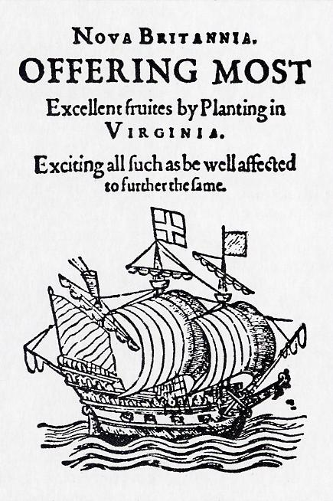
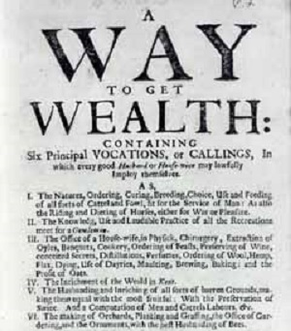

- What words shown in the advertisements stand out?
- What reaction do you think the creators of the advertisements were looking for?

Newspaper Advertisement Template

