MINI-PERFORMANCE ASSESSMENT TASK SCAFFOLDED
Grade 6

UNIT III: American Revolution

STANDARD: CE.1a,c,g,j; CE.2a,b; US1.1a,d,e,h; US1.6a,b,c

ENDURING UNDERSTANDING: Political, economic and social values are modified through revolution to meet the needs of people in a new independent society.

CONCEPTUAL UNIT QUESTIONS: When is it right to say “No more!” and fight for what you believe is right? How did fundamental political principles and British mercantilism lead to the American Revolution?

SCENARIO: It’s the summer of 1776 and the Declaration of Independence has just been written. You are a newspaper printer and you think the 13 Colonies should be free from Great Britain. Review a timeline from events and some of Thomas Jefferson’s complaints against the King George III and Parliament. Write an editorial telling readers to support American independence.

TASK: You will collect information from document A and B to
- identifying British actions and American responses that led to independence
- give details to correctly explain the Patriots’ reasons for independence
- persuade undecided or neutral colonists to support your point of view

DOCUMENTS: Use each of the documents provided to research information on your task. Include information from each document in your presentation.
Document A: The Road to Revolution Chronology
Document B: Excerpts from the Declaration of Independence

PRODUCT: You will write a 3 paragraph editorial that
- accurately and clearly explains why you chose to support either the Patriots
- uses content related vocabulary
- provides three arguments/reasons, quoting the Declaration of Independence
- uses persuasive language to convince undecided or neutral colonists to support your point of view, answering “Is it right for the colonists to say ‘No more!’ and fight Great Britain?”

PAT RUBRIC: American Revolution
Category | 4 Exceeds Expectations | 3 Meets Expectations | 2 Approaching Expectations | 1 Below Expectations | Score
Content | Demonstrates thorough and accurate understanding of events leading to the American Revolution. | Demonstrates an accurate understanding of events leading to the American Revolution. | Demonstrates an incomplete understanding of events leading to the American Revolution. | Demonstrates inaccuracies and misconceptions about events leading to the American Revolution.
Basic Skills | Demonstrates mastery of sequencing events that led to the American Revolution. | Demonstrates ability to sequence events that led to the American Revolution without significant error. | Demonstrates a number of errors when sequencing events that led to the American Revolution but can complete a rough approximation of it sequencing events. | Demonstrates many critical errors when sequencing events leading to the American Revolution.
Analysis/  Interpretation  Skills | Examines thoroughly all of the given documents.  Evaluates information from the documents to make meaningful inferences/conclusions about Patriot and Loyalist points of view. | Examines several of the given documents.  Makes a credible effort to evaluate information from some of the documents to make meaningful inferences/conclusions about Patriot and Loyalist points of view. | Examines some of the given documents.  Makes little effort to evaluate information. Makes irrelevant inferences/conclusions about Patriot and Loyalist points of view. | Gives no evidence that given documents were examined.  Fails to evaluate information to make any inferences/ conclusions about Patriot and Loyalist points of view.
Application/  Synthesis  Skills | Cites and elaborates evidence from given documents to develop an in-depth argument to support the Patriot or Loyalist cause.  Powerfully connects evidence to enduring understandings and/or generalizations. | Cites evidence from given documents but does not elaborate on the information.  Relates evidence to enduring understandings and/or generalizations. | Cites some evidence from the given documents to restate information.  Develops a superficial, argument that does not clearly relate to enduring understandings and/or generalizations. | Cites no evidence from the given documents.  Restates information without reference to any essential understandings, generalizations or insights.
Communication Skills | Product is well organized with clearly stated, complex ideas supported by citations from all documents.  Communication tools effectively convey the message. | Product is somewhat organized with clearly stated ordinary ideas supported by citations from several documents.  Communication tools adequately convey the message. | Product is poorly organized with few unclear, restated ideas supported by citations from few documents.  Communication tools poorly convey the message. | Product is unorganized with irrelevant statements and no document citations.  Communication tools fail to convey the message.

Document A

The Road to Revolution Chronology

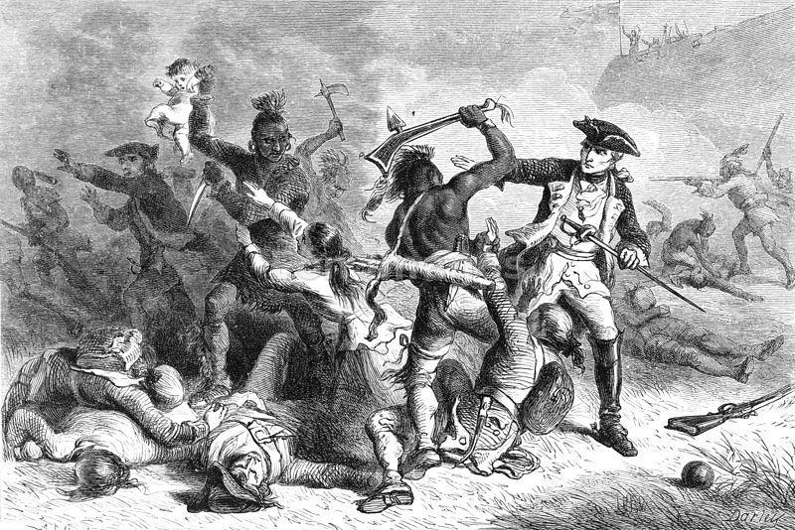
1756: The French and Indian War - Great Britain fights France and several Indian tribes over land.

1763: Great Britain wins the war and gains France’s land in the Treaty of Paris. Great Britain spent a lot of money on the war and put new taxes on the colonies to pay for it.

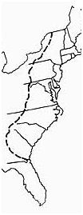
1763: The king’s Proclamation of 1763 says the colonists could not move west of the Appalachian Mountains so that Indian tribes will stop attacking the colonies.

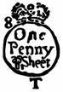
1765: The Stamp Act taxed all of the colonists’ paperwork. The Stamp Act required colonists to pay Great Britain for every contract, newspaper, pamphlet, and even playing cards they used or bought. The colonists hated this tax and thought it was unfair because they did not have a chance to vote for or against it in Parliament.

Parliament also passed the Quartering Act. It forced colonists to give British soldiers a place to sleep in their homes.

1766: After protests, the Stamp Act was taken away.

1767: Parliament passes the Townshend Duties, new taxes on goods from Great Britain like glass,
paper, and tea. The colonists made Great Britain very mad by not buying any of these things.
Document A continued

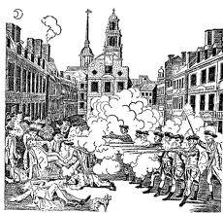
Document A cont.

1770: The Boston Massacre: A small group of colonists teased a British soldier and threw snowballs and rocks. A crowd gathered and the soldier called for help. Soon the group of soldiers were surrounded. Shots were fired and several colonists were wounded and five died. People in Boston called it a massacre and spread the news of what the soldiers had done to other colonies.

The Townshend Duties were later repealed, except for the tax on tea.

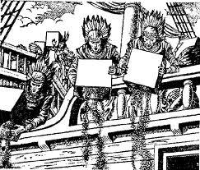
December 1773: Colonists were mad they were only allowed to buy tea from Great Britain with Parliament’s tax on it. This leads to the Boston Tea Party and protests in other cities.

March – June 1774: Great Britain closed the Port of Boston until payment was made for the stolen and destroyed tea. Many people in Boston who worked around ships lost their jobs. Parliament also wrote tougher laws, including quartering more soldiers in Boston.

September 1774: Delegates from each colony met in Philadelphia, Pennsylvania to talk about their complaints and problems with Great Britain. The meeting is called the First Continental Congress.

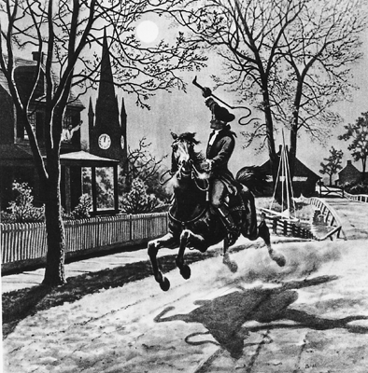
April 1775: Battles of Lexington and Concord - A militia (volunteer soldiers) in Massachusetts called the "Minutemen” defended their guns and other supplies in the first battle of the Revolutionary War. The British soldiers lost and were forced to retreat back to Boston. This was called the “shot heard ‘round” the world because the British had the best army.

May 1775: The Second Continental Congress met in Philadelphia.

June 1775: The Continental Congress chose George Washington as commander-in-chief of its new Continental Army. Later, British troops won at the Battle of Bunker Hill, but lost many soldiers in the fight.
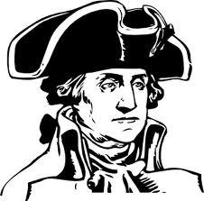
Document A cont.

March 1776: Washington’s army forced the British to leave Boston.

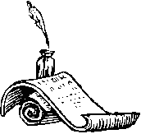

July 1776: Thomas Jefferson writes the The Declaration of Independence at the Second Continental Congress. The colonies officially said they were no longer part of Great Britain.

THINK ABOUT:

Were some colonists’ actions successful in changing British policies? If so, which ones?

Why do you think Parliament taxed imports like tea and glass instead of goods like cotton or tobacco?

Adapted from www.pbs.org/ktca/chronicle_timeline.html

Document B

Paraphrased from the Declaration of Independence, 1776

“..The King of Great Britain has a long history of hurting the colonies and he has acted as an absolute tyrant (unfair leader) over these states. The following facts will prove this to the world. The king has taken away our self-rule and written new unfair laws such as:

Forcing us to give soldiers a place to sleep in our homes,
Cutting off our trade and business with all other countries,
Taxing us without a vote or representation in Parliament,
Taking away our colonies’ own governments and our right to make laws for ourselves”

THINK ABOUT:
What were my strongest arguments for independence?

What examples will you use for evidence?

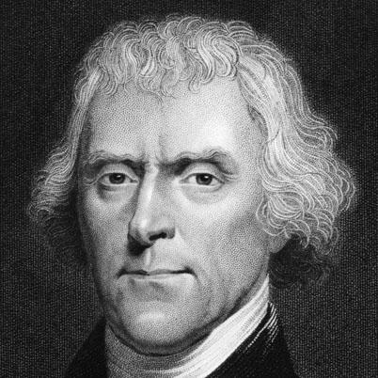

Thomas Jefferson

PAT DOCUMENT ORGANIZER: American Revolution

Task Skills: | What actions by Great Britain angered the colonists? | What were the main arguments in favor of independence? | What persuasive language will help you convince others to join your side?
Document A:
The Road to Revolution Chronology
Document B:
Except from the
Declaration of Independence

TASK CHECKLIST

Editorial

UNIT III: American Revolution

PRODUCT CHECKLIST:

- After reviewing all three documents, I will write an editorial to persuade undecided or neutral colonists to support the Patriots’ war for independence from Great Britain.

- I have reviewed the timeline and Declaration of Independence for multiple pieces of evidence. All my notes are on the graphic organizer.

- TASK SKILL #1: I have correctly identified the cause-and-effect sequence of British and American actions and reactions that have led to this conflict.

- TASK SKILL #2: I have summarized the Patriot argument for independence. Why should the colonies be separate from Great Britain?

- TASK SKILL #3: I have supported my point of view by explaining three powerful arguments from the Declaration of Independence to convince others to join my side.

- TASK SKILL #4: My editorial
___ includes vocabulary and concepts learned in the American Revolution
Unit
___ has been reviewed for spelling and grammar mistakes
___ is well organized
___ is persuasive
___ is in final form and reflects my best effort

Editorial Outline
Introduction Paragraph Introduce your argument answering the question “Is it right for the colonists to say ‘No more!’ and fight Great Britain?”

Topic Sentence (Give a hook! Catch your readers’ attention by identifying the reason why independence is needed):
____________________________________________________________________________________________________________________________________________
Supporting Details (summarize three arguments from the Declaration of Independence):
- ________________________________________________________________
- ________________________________________________________________
- ________________________________________________________________

Conclusion (use persuasive action to call for independence):
______________________________________________________________________

Body Paragraph Explain the three supporting details you mentioned in the introduction in greater detail, connect Jefferson’s words to the events in the timeline.
- ________________________________________________________________________________________________________________________________________________________________________________________________________________________________________________________________
- ________________________________________________________________________________________________________________________________________________________________________________________________________________________________________________________________
- ________________________________________________________________________________________________________________________________________________________________________________________________________________________________________________________________

Conclusion Paragraph Summarize your arguments then use your most powerful language to persuade readers. Why is this decision so important?

Topic Sentence:
Supporting Detail 1:
Supporting Detail 2:
Supporting Detail 3:
Final Sentence (call for action!):

PAT Score Form

Teacher: Unit # ___ Date: __________________

Student Name | Content |  |  |  | Basics |  |  |  | Analysis |  |  |  | Application |  |  |  | Communication |  |  |  | Total
 | 4 | 3 | 2 | 1 | 4 | 3 | 2 | 1 | 4 | 3 | 2 | 1 | 4 | 3 | 2 | 1 | 4 | 3 | 2 | 1

