MINI-PERFORMANCE ASSESSMENT TASK
Grade 6

UNIT III: American Revolution

STANDARD: CE.1a,c,g,j; CE.2a,b; US1.1a,d,e,h; US1.6a,b,c

ENDURING UNDERSTANDING: Political, economic and social values are modified through revolution to meet the needs of people in a new independent society.

CONCEPTUAL UNIT QUESTIONS: When is it right to say “No more!” and fight for what you believe is right? How did fundamental political principles and British mercantilism lead to the American Revolution?

SCENARIO: You are a print shop owner who will investigate the arguments for and against the American Revolution. After your analysis, you will write an editorial based on your notes to persuade undecided or neutral colonists to support either the Patriots or the Loyalists. Your loyal readers await your decision!

TASK: You will collect information from the documents provided to
- review the sequence the events leading to the American Revolution in chronological order, identifying cause-and-effect relationships
- describe accurately the points of view of Loyalists and Patriots
- determine your point of view and give evidence of the arguments/principles that support it
- persuade undecided or neutral colonists to support your point of view

DOCUMENTS: Use each of the documents provided to research information on your task. Include information from each document in your presentation.
Document A: The Road to Revolution Chronology
Document B: Excerpts from the Declaration of Independence
Document C: The Bostonians Paying the Exciseman, or Tarring and Feathering

PRODUCT: You will write a 3 paragraph editorial that
- accurately and clearly explains why you chose to support either the Patriots or Loyalists
- uses content related vocabulary
- provides three arguments/reasons for your point of view, for or against independence
- uses persuasive language to convince the undecided or neutral colonists to support your point of view, answering the question “Is it right for the colonists to say ‘No more!’ and fight Great Britain?”

PAT RUBRIC: American Revolution
Category | 4 Exceeds Expectations | 3 Meets Expectations | 2 Approaching Expectations | 1 Below Expectations | Score
Content | Demonstrates thorough and accurate understanding of events leading to the American Revolution. | Demonstrates an accurate understanding of events leading to the American Revolution. | Demonstrates an incomplete understanding of events leading to the American Revolution. | Demonstrates inaccuracies and misconceptions about events leading to the American Revolution.
Basic Skills | Demonstrates mastery of sequencing events that led to the American Revolution. | Demonstrates ability to sequence events that led to the American Revolution without significant error. | Demonstrates a number of errors when sequencing events that led to the American Revolution but can complete a rough approximation of it sequencing events. | Demonstrates many critical errors when sequencing events leading to the American Revolution.
Analysis/  Interpretation  Skills | Examines thoroughly all of the given documents.  Evaluates information from the documents to make meaningful inferences/conclusions about Patriot and Loyalist points of view. | Examines several of the given documents.  Makes a credible effort to evaluate information from some of the documents to make meaningful inferences/conclusions about Patriot and Loyalist points of view. | Examines some of the given documents.  Makes little effort to evaluate information. Makes irrelevant inferences/conclusions about Patriot and Loyalist points of view. | Gives no evidence that given documents were examined.  Fails to evaluate information to make any inferences/ conclusions about Patriot and Loyalist points of view.
Application/  Synthesis  Skills | Cites and elaborates evidence from given documents to develop an in-depth argument to support the Patriot or Loyalist cause.  Powerfully connects evidence to enduring understandings and/or generalizations. | Cites evidence from given documents but does not elaborate on the information.  Relates evidence to enduring understandings and/or generalizations. | Cites some evidence from the given documents to restate information.  Develops a superficial, argument that does not clearly relate to enduring understandings and/or generalizations. | Cites no evidence from the given documents.  Restates information without reference to any essential understandings, generalizations or insights.
Communication Skills | Product is well organized with clearly stated, complex ideas supported by citations from all documents.  Communication tools effectively convey the message. | Product is somewhat organized with clearly stated ordinary ideas supported by citations from several documents.  Communication tools adequately convey the message. | Product is poorly organized with few unclear, restated ideas supported by citations from few documents.  Communication tools poorly convey the message. | Product is unorganized with irrelevant statements and no document citations.  Communication tools fail to convey the message.

Document A
The Road to Revolution Chronology

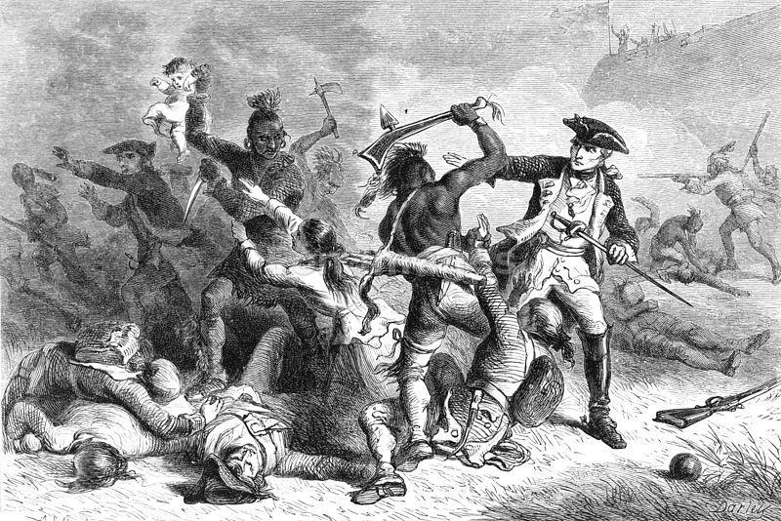
1756: War begins between Great Britain and France over their North American territories (French and Indian War).

1763: Great Britain wins the war and gains France’s land in the Treaty of Paris. Great Britain spent a lot of money on the war and now they’ll need to spend even more to keep their soldiers in North America to defend the 13 colonies and all their new territory. Parliament, Great Britain’s law-making body, decides the colonies will pay new taxes to cover these costs.
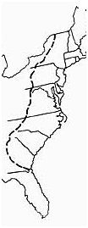
1763: After Pontiac’s Rebellion, King George III agreed to reserve the lands west of the Appalachian Mountains for the Indians in the Proclamation of 1763. Colonists could not move there and those who had were forced to return to the colonies.

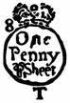
1765: The Stamp Act taxed printed materials and legal documents. The Stamp Act required all legal documents, licenses, commercial contracts, newspapers, pamphlets, and playing cards to carry a tax stamp. The colonists violently opposed thus infringement into their everyday lives and felt they should not be taxed by Parliament if they were not represented in Parliament. (The residents of Great Britain were taxed just as heavily, if not more so, and had little representation or voice in Parliament themselves.)

Parliament further angered American colonists by passing the Quartering Act, which required the colonists to provide barracks (housing) and supplies to British troops.
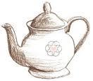
1766: The Stamp Act was repealed (taken away).

1767: Parliament passes the Townshend Duties. These taxes were
placed on goods imported from Great Britain like glass, lead, paper, and
tea. Their purpose was to provide salaries for colonial officials appointed
by the King so that the colonial governments could not force the officials
to make decisions by withholding their salaries.

The colonists organized boycotts and active resistance movements which escalated matters and led
to open rebellion against Great Britain.
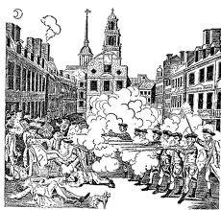
Document A cont.

1770: The Boston Massacre: A small group of colonists teased a British sentry in front of the Customs House. The sentry reacted which led to hostility. A crowd gathered and the sentry called for help. A group of soldiers who came to the rescue were surrounded. Shots were fired which left several colonists wounded and five dead. It was dubbed a massacre and became a rallying point for Boston against Great Britain. The Townshend Duties were later repealed, except for the symbolic tax on tea.

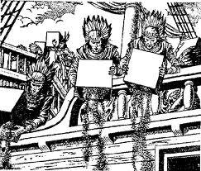
December 1773: The Tea Act led to the Tea Party in Boston and protests other cities.

March – June 1774: Great Britain closed the Port of Boston until payment was made for the destroyed tea. Additionally, Parliament enacted a series of laws that included quartering soldiers on private property.

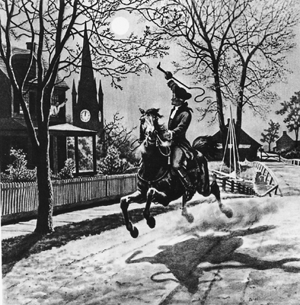
September 1774: Delegates from each colony met in Philadelphia, Pennsylvania in order to form the First Continental Congress. It was designed to discuss colonial complaints.

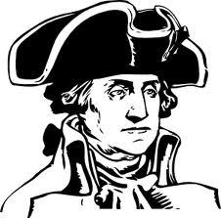
April 1775: Battles of Lexington and Concord: An organized Massachusetts militia ("Minutemen”) defended colonial munitions (guns and supplies) and forced British soldiers to retreat back to Boston. Great Britain was shocked.

May 1775: The Second Continental Congress convened in Philadelphia.

June 1775: The Continental Congress appointed George Washington as commander-in-chief of its newly established Continental Army. Soon after,
the British troops achieved victory at the Battle of Bunker (Breed’s) Hill, but suffered severe casualties during three assaults against determined colonial troops.

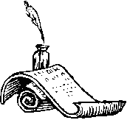
March 1776: Washington commanded the American siege that eventually forced the British to evacuate Boston.

July 1776: The Declaration of Independence, adopted by the Second Continental Congress, officially cuts American ties with Great Britain.

THINK ABOUT:
Were some colonists’ actions successful in changing British policies? If so, which ones?
Why do you think Parliament taxed imports like tea and glass instead of goods like cotton or tobacco? Adapted from www.pbs.org/ktca/chronicle_timeline.html
Document B

Excerpt from the Declaration of Independence, 1776

“..The history of the present King of Great Britain is a history of repeated injuries and usurpations (illegal acts), all having in direct object (purpose) the establishment of an absolute Tyranny over these states. To prove this, let Facts be submitted (made known) to a candid world. He has combined with others to subject us to a jurisdiction (control) foreign to our constitution, and unacknowledged by our laws; giving his Assent (agreement) to their Acts of pretended Legislation:

For quartering large bodies of armed troops among us
For cutting off our Trade with all parts of the world:
For imposing Taxes on us without our Consent:
For depriving us in many cases, of the benefits of Trial by Jury:
For transporting us beyond Seas to be tried for pretended offenses…
For taking away our Charters, abolishing our most valuable Laws, and altering fundamentally (changing the basic) Forms of our Governments:
For suspending (stopped from meeting) our own Legislatures and declaring themselves invested with power to legislate for us in all cases whatsoever.
He has abdicated (given up) Government here, by declaring us out of his Protection and waging War against us.
He has plundered (robbed) our seas, ravaged (ruined) our Coasts, burnt our towns, and destroyed the lives of our people.”

THINK ABOUT:
What were my strongest arguments for independence?

What examples will you use for evidence?

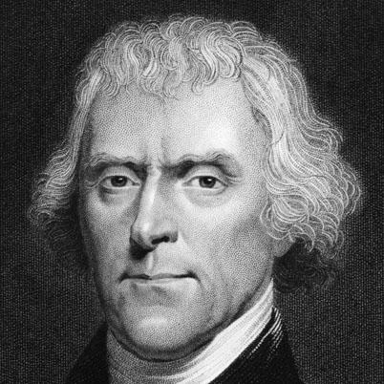

Thomas Jefferson

Document C

The Bostonians Paying the Exciseman, or Tarring and Feathering
www.LOC.gov

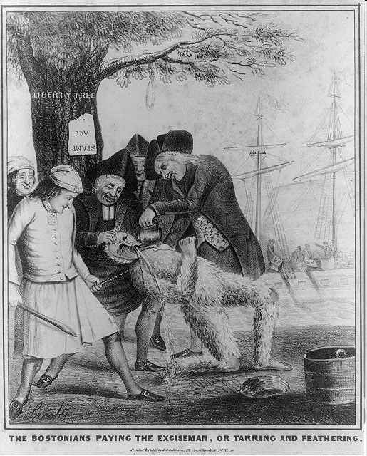
What is happening to the British exciseman (tax collector)?

How would you describe the expressions on Bostonians (people from Boston)?

What event is occurring in the background?

What is significant about the tree?

Why do you think the sign is upside-down? What might that symbolize?

THINK ABOUT:
How are the people of Boston portrayed in this cartoon? Do you agree?

What do you think was the artist’s purpose for this cartoon? What point of view does it support?

PAT DOCUMENT ORGANIZER: American Revolution
Task Skills: | Sequence the events leading to the revolution in order, identifying cause-and-effect relationships.  How did Great Britain anger the colonists? | Accurately describe the points of view of Loyalists and Patriots.  What was the main argument of each side? | Give evidence that supports either the Loyalists or the Patriots.  Why is your side right? Why are others wrong? | Persuade undecided or neutral colonists to support your view.  What persuasive language will help you convince others to join your side?
Document A:
The Road to Revolution Chronology
Document B:
Except from the
Declaration of Independence
Document C:
The Bostonians Paying the Exciseman, or Tarring and Feathering

TASK CHECKLIST

Editorial

UNIT III: American Revolution

PRODUCT CHECKLIST:

- After reviewing all three documents, I will attempt to persuade undecided or neutral colonists to support the _________________ in my editorial.

- I have reviewed all three documents for multiple pieces of evidence. All my notes are on the graphic organizer for the four tasks. Use the documents for evidence of new learning and connections to what you already know!

- TASK SKILL #1: I have correctly identified the cause-and-effect sequence of British and American actions and reactions.

- TASK SKILL #2: I have identified the opposing point of view (If you are a Patriot, show you know how the Loyalist feel about the events. If you are a Loyalist, show you know how the Patriots feel about the events.)

- TASK SKILL #3: My opinion is clear and I have supported it with three powerful arguments and pieces of evidence to convince others to join my side.

- TASK SKILL #4: My editorial:
___ includes vocabulary and concepts learned in the American Revolution
Unit
___ has been reviewed for spelling and grammar mistakes
___ is well organized
___ is persuasive
___ is in final form and reflects my best effort

Possible Editorial Outline
Introduction Paragraph

Give a hook! Catch your readers’ attention by identifying the problem.
____________________________________________________________________________________________________________________________________________

Introduce the other side’s main argument, explain why they are wrong, and why your side is right. For example: “While the _________________ believe that _________________________________, you should support us __________________ because ________________________________________
_______________________________________________________________________________.”

Body Paragraph(s)

Explain at least three reasons why your side is right. Give detailed evidence for your point of view.
______________________________________________________________________
________________________________________________________________________________________________________________________________________________________________________________________________________________________________________________________________________________________________________________________________________________________________________________________________________________________________________________________________________________________________________________________________________________________________________________

Conclusion Paragraph

Summarize your arguments then use your most powerful language to persuade readers. Why is this decision so important?
______________________________________________________________________________________________________________________________________________________________________________________________________________________________________________________________________________________________________________________________________________________________________________________________________________________________________________________________________________________________________________________________________________________________________________________________________________________________________________________
PAT Score Form

Teacher: Unit #________ Date: __________________

Student Name | Content |  |  |  | Basics |  |  |  | Analysis |  |  |  | Application |  |  |  | Communication |  |  |  | Total
 | 4 | 3 | 2 | 1 | 4 | 3 | 2 | 1 | 4 | 3 | 2 | 1 | 4 | 3 | 2 | 1 | 4 | 3 | 2 | 1

