MINI-PERFORMANCE ASSESSMENT TASK SCAFFOLDED
Grade 6
UNIT VIII: Westward Expansion

STANDARD: CE.1c,f,h; USI.1a,d,e,h; USI.2c,d; USI.8a,b,c

ENDURING UNDERSTANDING: Expansion brings economic changes and technological innovation that has costs and benefits.

CONCEPTUAL UNIT QUESTION: How did westward expansion change the United States and demonstrate the determination of its people? How did economic factors and advances in technology influence expansion, westward movement, and economic growth in the United States?

SCENARIO: You work at a museum. A new exhibit has been created that focuses on Westward Expansion. As the art director for the museum, you have been asked to design a poster to encourage people to visit the exhibit. Your poster will help visitors understand the importance of westward expansion and the main reasons why people might move west.

TASK: You will collect information from the documents provided to:
- demonstrate thorough and accurate understanding reasons for westward expansion
- demonstrate use of primary sources to identify impact of westward expansion
- analyze information from the documents to draw meaningful conclusions about the geographic and economic changes that took place due to Westward Expansion
- elaborate on evidence from given documents to create a poster for an exhibit
- create a poster that clearly encourages people to learn more about westward expansion

DOCUMENTS: Use each of the documents provided to research information on your task. Include information from each document in your presentation.
Document A: Song, “I Will Go West” loc.gov
Document B: Painting, Westward the Course of Empire Takes Its Way,
E. Leutze, 1861

PRODUCT DESCRIPTION: You will create a Museum Exhibit Sign using PicCollage to encourage people to visit a museum exhibit on westward expansion which
- includes the vocabulary and concepts learned in the Westward Expansion Unit
- focuses on the importance of westward expansion
- connects westward expansion with economic choices
- provides two major reasons, economic and geographic, that motivated the migration West.
- includes persuasive language and imagery to encourage museum patrons to visit your exhibit

PAT RUBRIC: Westward Expansion
Category | 4 Exceeds Expectations | 3 Meets Expectations | 2 Approaching Expectations | 1 Below Expectations | Score
Content | All supportive facts and details are written accurately. | Most supportive facts and details are written accurately. | Some supportive facts and details are written accurately. | Supportive facts and details are NOT written accurately.
Basic Skills | Demonstrates substantial use of primary sources to identify change for different groups of Americans, the land and the economy during Westward Expansion. | Demonstrates acceptable use of primary sources to find identify the change for different groups of Americans, the land and the economy during Westward Expansion. | Demonstrates a few errors when using primary sources to identify the change for different groups of Americans, the land and the economy during Westward Expansion. | Demonstrates many critical errors when using primary sources to identify the change for different groups of Americans, the land and the economy during Westward Expansion.
Analysis/Interpretation  Skills | Thoroughly analyzes information from the documents to draw meaningful conclusions about the geographic, social, political, economic, and technological changes that took place due to Westward Expansion. | Makes a credible effort to analyze information from some of the documents to draw meaningful conclusions about the geographic, social, political, economic, and technological changes that took place due to Westward Expansion. | Makes little effort to analyze information. Gives weak or superficial conclusions about the geographic, social, political, economic, and technological changes that took place due to Westward Expansion. | Fails to analyze information to give conclusions about the geographic, social, political, economic, and technological changes that took place due to Westward Expansion.
Application/Synthesis  Skills | Cites and elaborates evidence from given documents to develop an in-depth exhibit sign depicting the overall impact of Westward Expansion on the United States. | Cites evidence from given documents but does not elaborate on the information. Develops an adequate exhibit sign depicting the overall impact of Westward Expansion on the United States. | Cites some evidence from the given documents to develop a weak exhibit sign depicting the overall impact of Westward Expansion on the United States. | Cites no evidence from the given documents.  Fails to develop an exhibit sign depicting the overall impact of Westward Expansion on the United States.
Communication Skills | Exhibit sign is informative and reflective of impact of Westward Expansion. It is well organized using a variety of sources, and includes clearly stated, complex ideas. | Exhibit sign is informative. It is organized with clearly stated ordinary ideas. | Exhibit sign is somewhat informative, but is poorly organized with few unclear, restated ideas. | Exhibit sign is unorganized with irrelevant statements and images.

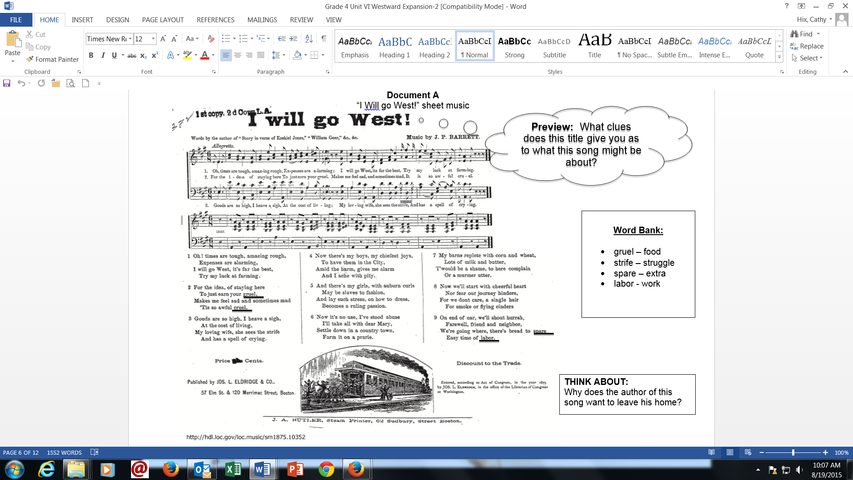
Document B
Document B cont.
Notes for Westward the Course of Empire Takes Its Way
Emmanuel Leutze, 1861
*See modified painting*
- Man standing on top of a mountain holding the American flag.
- Mountain man comforting women
- Men clearing a path through a dark, wooded area
- An African-American leading a horse
- A young boy with a bow and arrow
- Pieces of a wagon and an ox skull

PAT GRAPHIC ORGANIZER: Westward Expansion
Documents | Reasons it was important for the country to expand west | Reasons why people moved west
Song- “I Will Go West”

B- “Empire” painting

PIC COLLAGE (http://pic-collage.com/)

1. How do I add photos/pictures/videos?
To add photos, tap the “+” icon or the blank space on canvas, and select “Photos”.
Choose the photos you like to add to your collage.
You can add photos/videos from Camera, Albums, Web, Facebook and Instagram. You can also add photos of your Facebook friends! To find more photos from Instagram, please search #hashtags and usernames on Instagram.
The maximum number of photos can be added in a collage is 30.
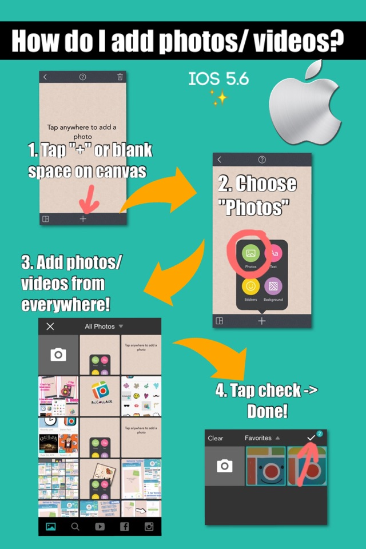
Please refer to the instruction collage as below.

2. How to change background?
There are two ways to change background:(1)
1. Tap on the Frame icon on the lower left corner of the collage canvas
2. Select the background color icon on the upper left of the menu
3. Choose background. Please refer to the instruction collage as below.
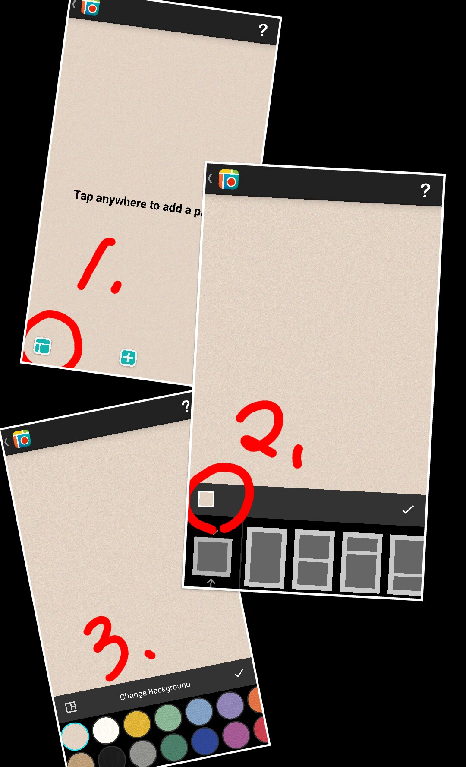

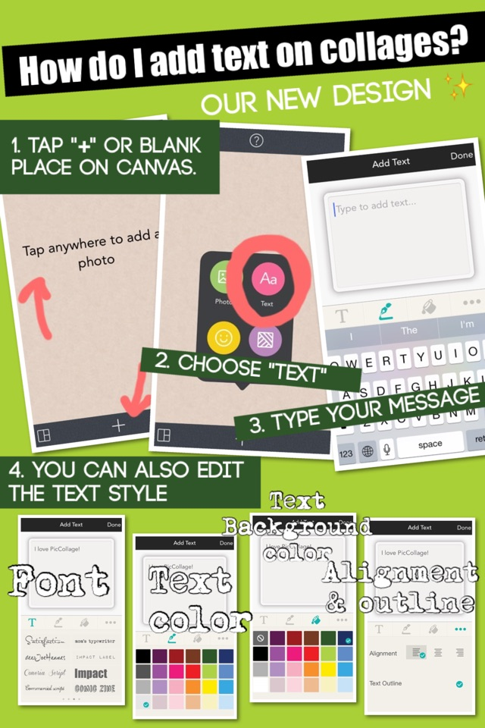

3. How do I add text (edit text)?
To add text, tap the “+” icon or tap on the blank spot of the canvas and select “Add Text” and type whatever you want. Then tap the Options button below the text box to change the font and color of the text. Please refer to the instruction collage as below.

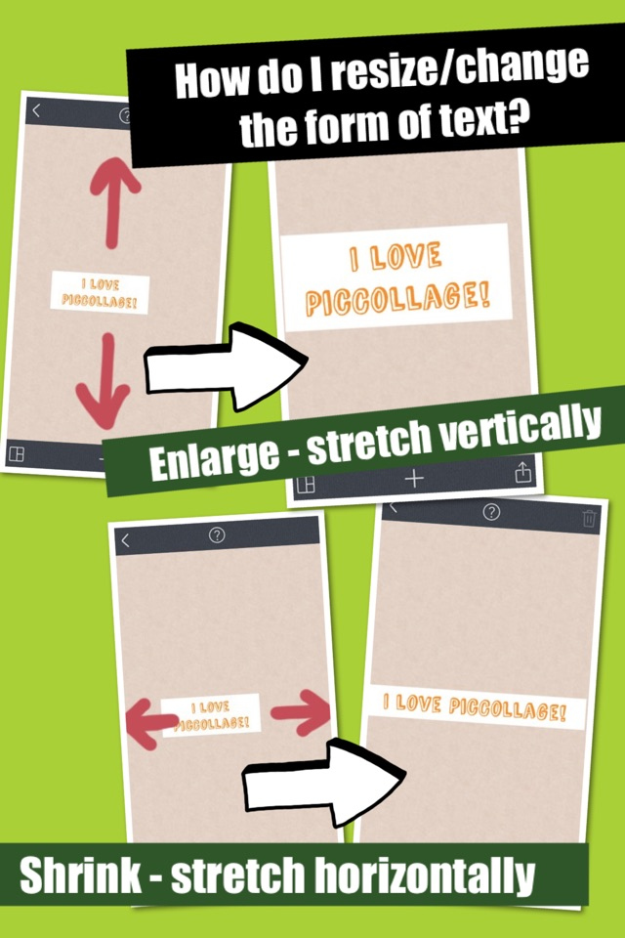

If you want to change the size/ form of the text box, you can stretch it vertically to enlarge it and horizontally to shrink it, and double tap to edit the text. Please refer to the instruction collage as below.

ADD NEW RECORDING FORM

PAT Score Form
Teacher: Unit #: Date: ___________
Student Name | Content |  |  |  | Basics |  |  |  | Analysis |  |  |  | Application |  |  |  | Communication |  |  |  | Total
 | 4 | 3 | 2 | 1 | 4 | 3 | 2 | 1 | 4 | 3 | 2 | 1 | 4 | 3 | 2 | 1 | 4 | 3 | 2 | 1

