MINI-PERFORMANCE ASSESSMENT TASK
Grade 6

UNIT VIII: Westward Expansion

STANDARD: CE.1c,f,h; USI.1a,d,e,h; USI.2c,d; USI.8a,b,c

ENDURING UNDERSTANDING: Expansion brings economic changes and technological innovation that has costs and benefits.

CONCEPTUAL UNIT QUESTION: How did westward expansion change the United States and demonstrate the determination of its people? How did economic factors and advances in technology influence expansion, westward movement, and economic growth in the United States?

SCENARIO: You are a museum curator and have been asked to prepare a special exhibit on Westward Expansion focusing on geographic and economic change. You are eager to get visitors to this exhibit. You must create a sign for the museum with images and slogan to attract potential visitors. Since it is your responsibility to interpret cultural material, you must analyze a painting and a song to prepare a theme for your exhibit.
TASK: You will collect information from the documents provided to:
- demonstrate thorough and accurate understanding reasons for westward expansion
- demonstrate use of primary sources to identify impact of westward expansion
- analyze information from the documents to draw meaningful conclusions about the geographic and economic changes that took place due to Westward Expansion
- elaborate on evidence from given documents to create a poster for an exhibit (Application/Synthesis Skills)
- create a poster that clearly incorporates the theme of the exhibit

DOCUMENTS: Use each of the documents provided to research information on your task. Include information from each document in your presentation.
Document A: Song, “Sweet Betsy from Pike” by John A. Stone (before 1858)
Document B: Painting, Westward the Course of Empire Takes Its Way,
E. Leutze, 1861

PRODUCT DESCRIPTION: You will create a Museum Exhibit Sign using PicCollage to bring attention and spark interest in the hardships faced by the various groups of settlers moving West during the 1800s. This sign should:
- includes the vocabulary and concepts learned in the Westward Expansion Unit
- describes the journey using basic facts and images to include:
climate and geography
economy/resources
social and religious atmosphere
political life
- connects the climate and geography with the economic choices pioneers made
- provides two major reasons, economic and geographic, that motivated the migration West
- includes persuasive language and imagery to encourage museum patrons to visit your exhibit

PAT RUBRIC: Westward Expansion
Category | 4 Exceeds Expectations | 3 Meets Expectations | 2 Approaching Expectations | 1 Below Expectations | Score
Content | All supportive facts and details are written accurately. | Most supportive facts and details are written accurately. | Some supportive facts and details are written accurately. | Supportive facts and details are NOT written accurately.
Basic Skills | Demonstrates substantial use of primary sources to identify change for different groups of Americans, the land and the economy during Westward Expansion. | Demonstrates acceptable use of primary sources to find identify the change for different groups of Americans, the land and the economy during Westward Expansion. | Demonstrates a few errors when using primary sources to identify the change for different groups of Americans, the land and the economy during Westward Expansion. | Demonstrates many critical errors when using primary sources to identify the change for different groups of Americans, the land and the economy during Westward Expansion.
Analysis/Interpretation  Skills | Thoroughly analyzes information from the documents to draw meaningful conclusions about the geographic, social, political, economic, and technological changes that took place due to Westward Expansion. | Makes a credible effort to analyze information from some of the documents to draw meaningful conclusions about the geographic, social, political, economic, and technological changes that took place due to Westward Expansion. | Makes little effort to analyze information. Gives weak or superficial conclusions about the geographic, social, political, economic, and technological changes that took place due to Westward Expansion. | Fails to analyze information to give conclusions about the geographic, social, political, economic, and technological changes that took place due to Westward Expansion.
Application/Synthesis  Skills | Cites and elaborates evidence from given documents to develop an in-depth exhibit sign depicting the overall impact of Westward Expansion on the United States. | Cites evidence from given documents but does not elaborate on the information. Develops an adequate exhibit sign depicting the overall impact of Westward Expansion on the United States. | Cites some evidence from the given documents to develop a weak exhibit sign depicting the overall impact of Westward Expansion on the United States. | Cites no evidence from the given documents.  Fails to develop an exhibit sign depicting the overall impact of Westward Expansion on the United States.
Communication Skills | Exhibit sign is informative and reflective of impact of Westward Expansion. It is well organized using a variety of sources, and includes clearly stated, complex ideas. | Exhibit sign is informative. It is organized with clearly stated ordinary ideas. | Exhibit sign is somewhat informative, but is poorly organized with few unclear, restated ideas. | Exhibit sign is unorganized with irrelevant statements and images.

Document A

Document B
Sweet Betsy from Pike
Folk Song
c. 1870
Oh don't you remember sweet Betsy from Pike,
Who crossed the wide prairie with her lover Ike,
With two yoke of oxen, a big yellow dog,
A tall Shangai rooster, and one spotted hog?
CHORUS:
Singing dang fol dee dido,
Singing dang fol dee day.
One evening quite early they camped on the Platte.
'Twas near by the road on a green shady flat.
Where Betsy, sore-footed, lay down to repose --
With wonder Ike gazed on that Pike County rose.
The Shanghai ran off, and their cattle all died;
That morning the last piece of bacon was fried;
Poor Ike was discouraged and Betsy got mad,
The dog drooped his tail and looked wondrously sad.
They stopped at Salt Lake to inquire of the way,
Where Brigham declared that sweet Betsy should stay;
But Betsy got frightened and ran like a deer
While Brigham stood pawing the ground like a steer.
They soon reached the desert where Betsy gave out,
And down in the sand she lay rolling about;
While Ike, half distracted, looked on with surprise,
Saying, "Betsy, get up, you'll get sand in your eyes."
Sweet Betsy got up in a great deal of pain,
Declared she'd go back to Pike County again;
But Ike gave a sigh and they fondly embraced,
And they traveled along with his arm round her waist.
The Injuns came down in a wild yelling horde,
And Betsy was scared they would scalp her adored;
Behind the front wagon wheel Betsy did crawl,
And there fought the Injuns with musket and ball.
They suddenly stopped on a very high hill,
With wonder looked down upon old Placerville;
Ike sighed when he said, and he cast his eyes down,
"Sweet Betsy, my darling, we've got to Hangtown."
Long Ike and Sweet Betsy attended a dance;
Ike wore a pair of his Pike County pants;
Sweet Betsy was dressed up in ribbons and rings;
Says Ike, "You're an angel, but where are your wings?"
'Twas out on the prairie one bright starry night,
They broke out the whiskey and Betsy got tight,
She sang and she howled and she danced o'er the plain,
And showed her bare legs to the whole wagon train.
The terrible desert was burning and bare,
And Isaac he shrank from the death lurkin' there,
"Dear old Pike County, I'll come back to you."
Says Betsy, "You'll go by yourself if you do."
They swam wild rivers and climbed the tall peaks,
And camped on the prairies for weeks upon weeks,
Starvation and cholera, hard work and slaughter,
They reached Californy, spite of hell and high water.
A miner said, "Betsy, will you dance with me?"
"I will, you old hoss, if you don't make too free.
But don't dance me hard, do you want to know why?
Doggone ye, I'm chock full of strong alkali."
Long Ike and Sweet Betsy got married, of course,
But Ike, getting jealous, obtained a divorce,
While Betsy, well satisfied, said with a shout,
"Goodbye, you big lummox, I'm glad you backed out!"

PAT GRAPHIC ORGANIZER: Westward Expansion

Document A:
ARTWORK Westward the Course of Empire Takes Its Way, Emmanuel Leutze, 1861
Examine the painting carefully. Use the Zoom Feature to take note of the details.

1. Describe the different types of people heading West, present In the painting?

2. What actions of specific groups or individuals indicate determination?

3. What changes do you see in the geography? What geographical regions might these travelers be located in?

4. What are the economic reasons for westward expansion present in the picture?

DOCUMENT B:

SONG “Sweet Betsy from Pike”, by John A. Stone (before 1858)

Read/Listen the song at least 2 times.

1. Use 3 adjectives to describe the mood of this song. Circle one and record a
lyric to support your descriptive word choice.

2. What Westward Movement events or people are mentioned? List 3 or more.

3. Infer why a song like this would have been written.

4. What are specific examples of some of the hardships of traveling West? Use quotes to
support your answer.

5. What are examples of benefits of traveling West?

Info on How to Use PicCollage

1. How do I add photos/pictures/videos?
To add photos, tap the “+” icon or the blank space on canvas, and select “Photos”.
Choose the photos you like to add to your collage.
You can add photos/videos from Camera, Albums, Web, Facebook and Instagram. You can also add photos of your Facebook friends! To find more photos from Instagram, please search #hashtags and usernames on Instagram.
The maximum number of photos can be added in a collage is 30.Please refer to the instruction collage as below.

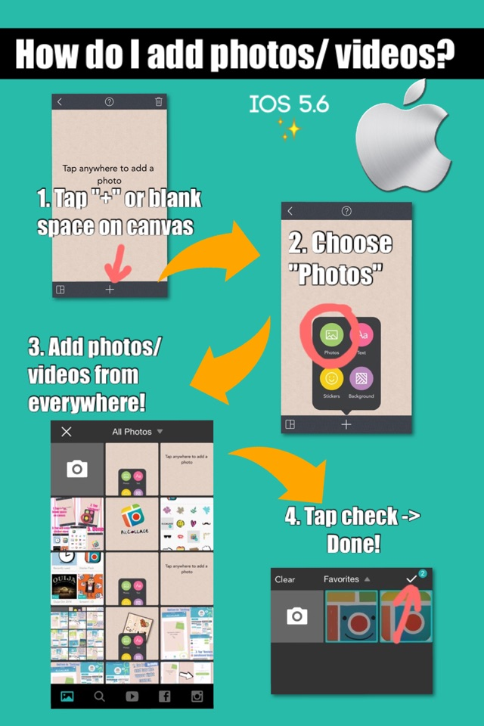

2. How to change background?
There are two ways to change background:(1)
1. Tap on the Frame icon on the lower left corner of the collage canvas
2. Select the background color icon on the upper left of the menu
3. Choose backgroundPlease refer to the instruction collage as below.

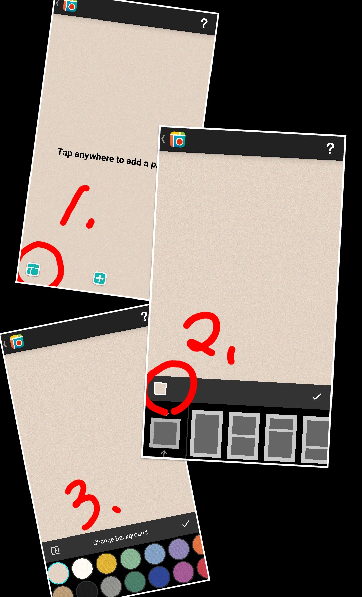

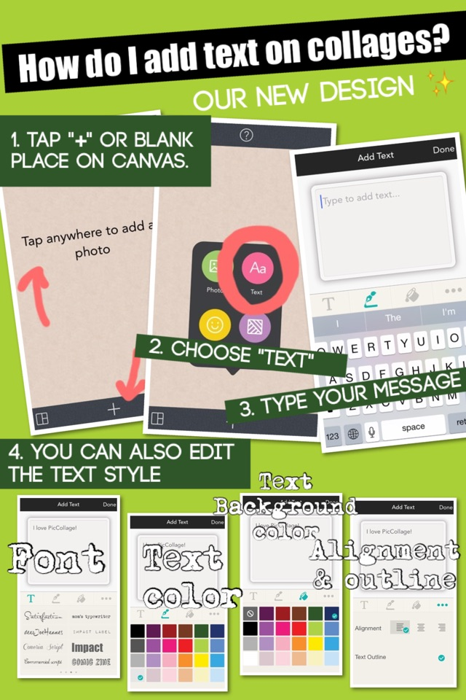

3. How do I add text (edit text)?
To add text, tap the “+” icon or tap on the blank spot of the canvas and select “Add Text” and type whatever you want. Then tap the Options button below the text box to change the font and color of the text.Please refer to the instruction collage as below.

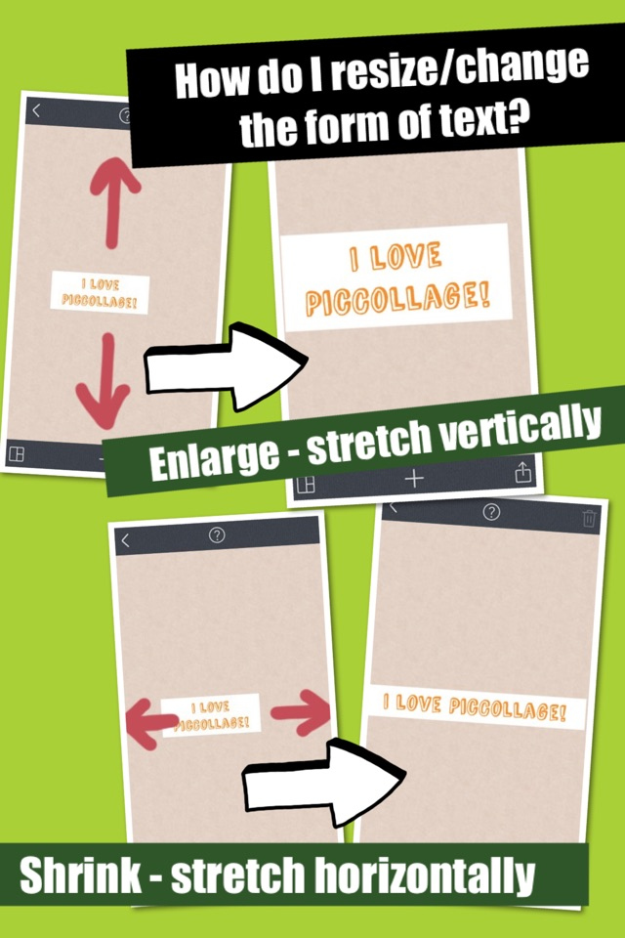

If you want to change the size/ form of the text box, you can stretch it vertically to enlarge it and horizontally to shrink it, and double tap to edit the text.Please refer to the instruction
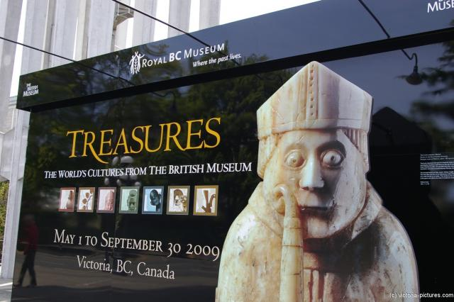
SAMPLE POSTERS
sampe
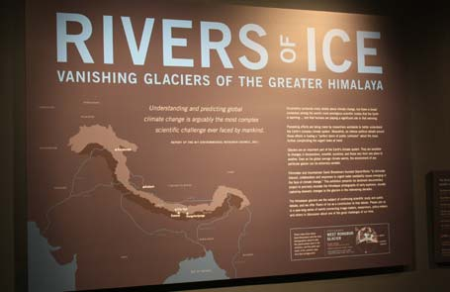

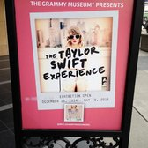
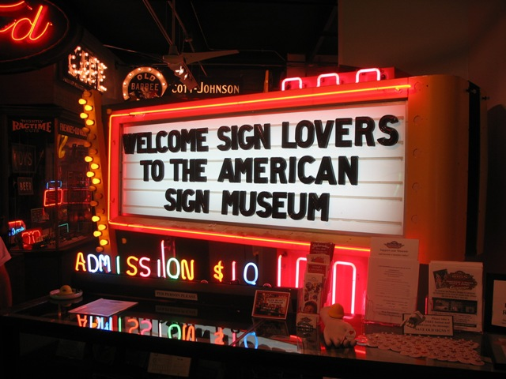

INSERT NEW OPTIONAL RESPORTING FORM
PAT Score Form

Teacher: Unit #: Date: ___________

Student Name | Content |  |  |  | Basics |  |  |  | Analysis |  |  |  | Application |  |  |  | Communication |  |  |  | Total
 | 4 | 3 | 2 | 1 | 4 | 3 | 2 | 1 | 4 | 3 | 2 | 1 | 4 | 3 | 2 | 1 | 4 | 3 | 2 | 1

