MINI-PEFORMANCE ASSESSMENT TASK SCAFFOLDED
Grade 7

UNIT V: Civil Rights Movement: Citizens Work For Justice

STANDARD: CE6.a, b, c, d; USII.8d; USII.9a, c

ENDURING UNDERSTANDING: It is the responsibility of all citizens to work both within and outside of all three levels and branches of the government to correct social injustice.

CONCEPTUAL UNIT QUESTION: How can citizens use the courts to correct social injustice? What role does the government play in correcting social injustices?

SCENARIO: You are a history professor at George Washington University and experienced the Civil Rights Movement first hand growing up. Your local community center is putting together a photography show based on pictures from the Civil Rights Movement. They have chosen four photographs and want to make sure the photographs show the actions of the executive, legislative and judicial branches as well average citizens who were active during the Civil Rights Movement. They have asked you to examine the photographs and write a description of what is happening and an explanation of its importance. Your written work will be placed underneath the photograph during the show.

TASK: You will collect information from the following document to
- label and describe each of the primary source pictures
- explain the importance of the actions represented in the primary source pictures.

DOCUMENTS: Use the document provided to research information on your task.
Document A: Civil Rights Timeline

PRODUCT DESCRIPTION: You will write four separate descriptions of the primary source pictures. Your descriptions should
- describe the actions of average citizens, the Legislative, the Executive and the Judicial branch as illustrated in the pictures
- provide a clear and organized explanation as to why the event was important
- includes information and vocabulary from Document A

Name: _____________________
PAT RUBRIC: Civil Rights Movement: Citizens Work For Justice

Category | 4 Exceeds Expectations | 3 Meets Expectations | 2 Approaching Expectations | 1 Below Expectations | Score
Content | All supportive facts and details are written accurately. | Most of the supportive facts and details are written accurately. | Some of the supportive facts and details are written accurately. | Supportive facts and details are not reported accurately.
Basic Skills | Demonstrates mastery with describing the effectiveness of average citizens and each branch of government during the Civil Rights Movement. | Demonstrates ability with describing the people, places, events and connections during the Civil Rights Movement. | Demonstrates some ability with describing the people, places, events and connections during the Civil Rights Movement. | Does not demonstrate ability describing the people, places, events and connections during the Civil Rights Movement.
Analysis/Interpretation Skills | Examines and uses all of the documents successfully. | Examines and uses most of the documents successfully. | Examines and uses some of the documents successfully. | Does not examine or use any of the documents successfully.
Application/Synthesis Skills | The article provides a clear and specific perspective on progress as it relates to average citizens and each branch of the government during the Civil Rights movement. | The article provides a clear perspective on progress as it relates to average citizens and each branch of the government during the Civil Rights movement. | The article has reasons for the Civil Rights Movement, but the perspective on progress as it relates to average citizens and each branch of the government during the Civil Rights movement. | The article does not provide a clear, specific perspective on the Civil Rights Movement.
Communication Skills | The article is well organized with accurate content and is persuasive in communicating a specific perspective of the Civil Rights movement. | The article is organized with accurate content and communicates a specific perspective on the Civil Rights movement. | The article includes some accurate content but does not communicate a specific perspective on the Civil Rights movement. | The article has inaccurate content and does not communicate a specific perspective about the Civil Rights movement.
Comments____________________________ SCORE___________________________

Document A

Civil Rights Key Events
(CNN Student News) -- Use the following timeline to learn about some of the key events in civil rights history.
1954 The Supreme Court declares school segregation unconstitutional in its ruling on Brown v. Board of Education of Topeka, Kansas.

1957 Arkansas Gov. Orval Faubus uses the National Guard to block nine black students from attending Little Rock High School. Following a court order, President Eisenhower sends in federal troops to allow the black students to enter the school.

1960 Four black college students begin sit-ins at the lunch counter of a Greensboro, North Carolina, restaurant where black patrons are not served.

1964 Congress passes the Civil Rights Act, declaring discrimination based on race illegal.
Source: http://www.cnn.com/2006/EDUCATION/01/31/extra.civil.rights.timeline/index.html

PAT GRAPHIC ORGANIZER: Civil Rights Movement: Citizens Work For Justice
Date Event Occurred | Explain this event | Who was involved?  - Average Citizens (College Students …)  - Legislative Branch (Congress)  - Executive (The President)  - Judicial Branch (Supreme Court)

Primary Source Picture #1

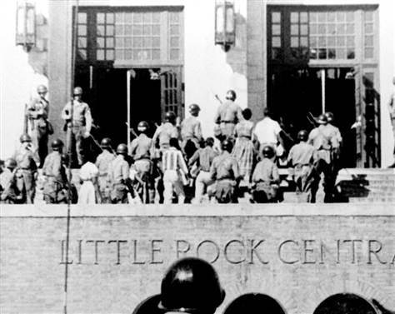

Describe this event | Explain the importance of this event

Primary Source Picture #2

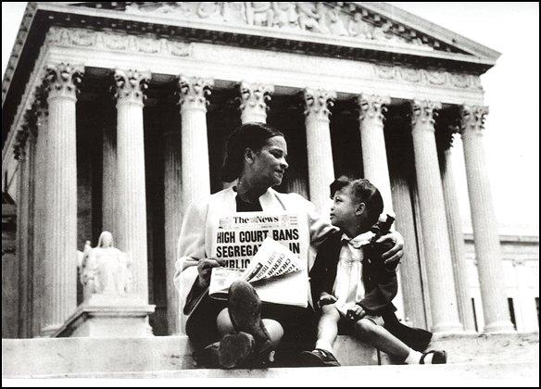

Describe this event | Explain the importance of this event

Primary Source Picture #3
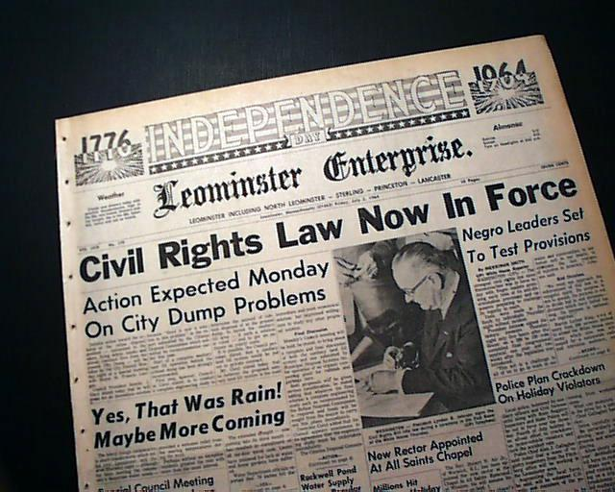

Describe this event | Explain the importance of this event

Primary Source Picture #4
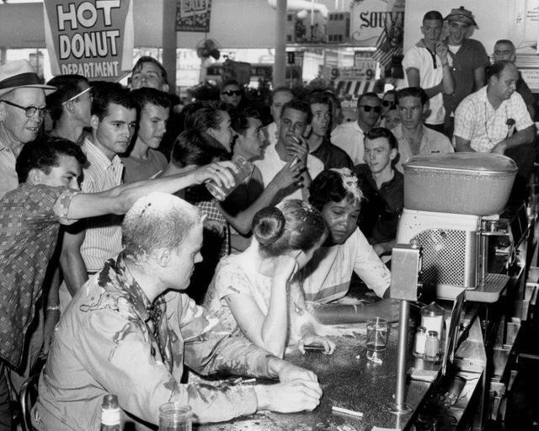

Describe this event | Explain the importance of this event

PAT Score Form (optional)

Teacher: Unit #: Date: ________

Student Name | Content |  |  |  | Basics |  |  |  | Analysis |  |  |  | Application |  |  |  | Communication |  |  |  | Total
 | 4 | 3 | 2 | 1 | 4 | 3 | 2 | 1 | 4 | 3 | 2 | 1 | 4 | 3 | 2 | 1 | 4 | 3 | 2 | 1

