MINI-PEFORMANCE ASSESSMENT TASK
Grade 7
UNIT V: Civil Rights Movement: Citizens Work For Justice

STANDARD: CE6.a, b, c, d; USII.8d; USII.9a, c

ENDURING UNDERSTANDING: It is the responsibility of all citizens to work both within and outside of all three levels and branches of the government to correct social injustice.

CONCEPTUAL UNIT QUESTION: How can citizens use the courts to correct social injustice? What role does the government play in correcting social injustices?

SCENARIO: You have seen the changes in Civil Rights over your many years. Born in the 1940s, you saw firsthand the challenges of African Americans during the Civil Rights movement. Currently you are a reporter for the magazine Civil Rights Today. Based on your knowledge of the changes in rights for African Americans over the years, you have been asked to write an editorial (a newspaper article that gives an opinion on an issue) in which you pick one branch of government and evaluate its effectiveness during the Civil Rights Movement.

TASK: You will collect information from the following documents to
- describe actions of the Legislative, Executive and Juridical branch during the Civil Rights movement and assess their effectiveness in bringing about progress. (describe people, places, events and the connections among them)
- identify how people were progressing during the Civil Rights movement (interpret history through artifacts, cartoons, primary and secondary sources)
- formulate an argument that will convince readers on your opinion of the effectiveness of the chosen branch during the Civil Rights movement (formulate an argument from a specific perspective)
- clearly communicate accurate content (content should be accurate and complete and idea should be expressed clearly)

DOCUMENTS: Use each of the documents provided to research information on your task. Include information from each document in your article.
Document A: Civil Rights Timeline
Document B: Graphs on Progress of African Americans

PRODUCT DESCRIPTION: You will write a one paragraph editorial. Your article should:
- accurately explain what progress has been made in the Civil Rights Movement
- persuade citizens on your opinion of the progress of African Americans as relates to the actions of your chosen branch
- formulate arguments to support your opinion
- include at least 3 references to the documents

Name: _____________________
PAT RUBRIC: Civil Rights Movement: Citizens Work For Justice

Category | 4 Exceeds Expectations | 3 Meets Expectations | 2 Approaching Expectations | 1 Below Expectations | Score
Content | All supportive facts and details are written accurately. | Most of the supportive facts and details are written accurately. | Some of the supportive facts and details are written accurately. | Supportive facts and details are not reported accurately.
Basic Skills | Demonstrates mastery with describing the effectiveness of average citizens and each branch of government during the Civil Rights Movement. | Demonstrates ability with describing the people, places, events and connections during the Civil Rights Movement. | Demonstrates some ability with describing the people, places, events and connections during the Civil Rights Movement. | Does not demonstrate ability describing the people, places, events and connections during the Civil Rights Movement.
Analysis/Interpretation Skills | Examines and uses all of the documents successfully. | Examines and uses most of the documents successfully. | Examines and uses some of the documents successfully. | Does not examine or use any of the documents successfully.
Application/Synthesis Skills | The article provides a clear and specific perspective on progress as it relates to average citizens and each branch of the government during the Civil Rights movement. | The article provides a clear perspective on progress as it relates to average citizens and each branch of the government during the Civil Rights movement. | The article has reasons for the Civil Rights Movement, but the perspective on progress as it relates to average citizens and each branch of the government during the Civil Rights movement. | The article does not provide a clear, specific perspective on the Civil Rights Movement.
Communication Skills | The article is well organized with accurate content and is persuasive in communicating a specific perspective of the Civil Rights movement. | The article is organized with accurate content and communicates a specific perspective on the Civil Rights movement. | The article includes some accurate content but does not communicate a specific perspective on the Civil Rights movement. | The article has inaccurate content and does not communicate a specific perspective about the Civil Rights movement.
Comments____________________________ SCORE___________________________

Document A

Legislative Branch  CONGRESS | Executive Branch  PRESIDENT | Judicial Branch  SUPREME COURT
Makes laws and changes existing laws based on the Constitution. | Enforces the laws made by Congress. | Studies and interprets the laws.

Civil Rights Key Events
(CNN Student News) -- Use the following timeline to learn about some of the key events in civil rights history.
1808 The importation of slaves is banned in the U.S., though illegal slave trade continues.
1857 The Supreme Court rules in the Dred Scott case that slaves do not become free when taken into a free state, that Congress cannot bar slavery from a territory and that blacks cannot become citizens.
1863 President Lincoln issues the Emancipation Proclamation freeing "all slaves in areas still in rebellion."
1865
The Civil War ends.
The 13th Amendment, abolishing slavery, is ratified.
1868 The 14th Amendment, which requires equal protection under the law to all persons, is ratified.
1870 The 15th Amendment, which bans racial discrimination in voting, is ratified.
1896 The Supreme Court approves the "separate but equal" segregation doctrine.
1925 In its first national demonstration the Ku Klux Klan marches on Washington, D.C.
1948 President Truman issues an executive order outlawing segregation in the U.S. military.
1954 The Supreme Court declares school segregation unconstitutional in its ruling on Brown v. Board of Education of Topeka, Kansas.
1955
Rosa Parks is jailed for refusing to move to the back of a Montgomery, Alabama, bus. A boycott follows, and the bus segregation ordinance is declared unconstitutional.

The Federal Interstate Commerce Commission bans segregation on interstate trains and buses.
1957 Arkansas Gov. Orval Faubus uses the National Guard to block nine black students from attending Little Rock High School. Following a court order, President Eisenhower sends in federal troops to allow the black students to enter the school.
1960 Four black college students begin sit-ins at the lunch counter of a Greensboro, North Carolina, restaurant where black patrons are not served.
1961 Freedom Rides begin from Washington, D.C., into Southern states. Student volunteers are bused in to test new laws prohibiting segregation.
1962
The Supreme Court rules that segregation is unconstitutional in all transportation facilities.

1963
Dr. Martin Luther King Jr. delivers his "I Have a Dream" speech to hundreds of thousands at the March on Washington, D.C.

A church bombing in Birmingham, Alabama, leaves four young black girls dead.
1964
Congress passes the Civil Rights Act, declaring discrimination based on race illegal.

Three civil rights workers, two white and one black man, disappear in Mississippi. They were found buried six weeks later.
1965
A march from Selma to Montgomery, Alabama, is organized to demand protection for voting rights.

Congress passes the Voting Rights Act, which made it illegal to force would-be voters to pass literacy tests in order to vote, is signed.
1967 Thurgood Marshall becomes the first black to be named to the Supreme Court.
1968
Dr. Martin Luther King Jr. is assassinated in Memphis, Tennessee. James Earl Ray pleaded guilty of the crime in March 1969 and was sentenced to 99 years in prison.

President Lyndon B. Johnson signs the Civil Rights Act of 1968, which prohibits discrimination in the sale, rental, and financing of housing.
1978 The Supreme Court rules, in a well-known reverse discrimination case (Bakke), that medical school admission programs that allow for positions based on race are unconstitutional.
1983 The Dr. Martin Luther King Jr. federal holiday is established.
1988 The Democratically controlled Congress overrides a presidential veto to pass the Civil Rights Restoration Act. President Ronald Reagan vetoed the law saying it gave the federal government overreaching powers.
1990 President George H.W. Bush vetoes a civil rights bill that he says would impose quotas for employers. A civil rights bill without quotas passes in 1991.
1995
The Supreme Court rules that federal programs that consider race as a category for hiring must have "compelling government interest" to do so.

The Supreme Court rules that the consideration of race in creating congressional districts is unconstitutional.
2003 The Supreme Court upholds the University of Michigan Law School's policy, ruling that race can be one of many factors considered by colleges when selecting their students.
Source: http://www.cnn.com/2006/EDUCATION/01/31/extra.civil.rights.timeline/index.html

Document B- Graphs on Progress of African Americans

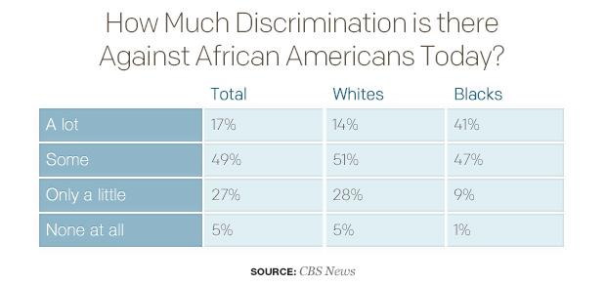
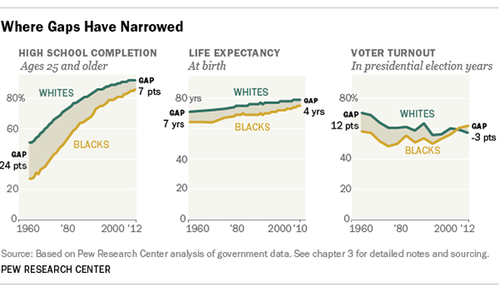

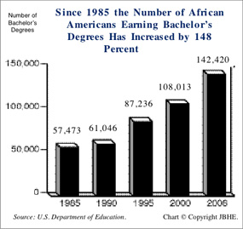

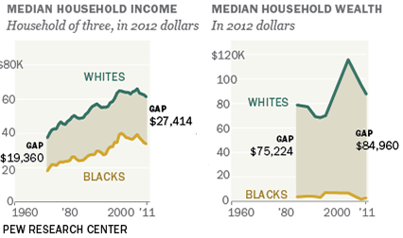

PAT DOCUMENT ORGANIZER: Civil Rights Movement: Citizens Work for Justice
*Be sure to note which document the information is being pulled from

 | Describe actions of the Legislative, Executive and Juridical branch during the Civil Rights movement that brought about progress. | Describe the lasting impacts of the actions of the Legislative Executive and Judicial Branch during the Civil Rights Movement. | Could this branch have done more? What problems still exist? | Pick one of the branches and then formulate an argument about its effectiveness during the Civil Rights movement
Legislative

Executive

Judicial

PAT Score Form (optional)

Teacher: Unit #: Date: ________

Student Name | Content |  |  |  | Basics |  |  |  | Analysis |  |  |  | Application |  |  |  | Communication |  |  |  | Total
 | 4 | 3 | 2 | 1 | 4 | 3 | 2 | 1 | 4 | 3 | 2 | 1 | 4 | 3 | 2 | 1 | 4 | 3 | 2 | 1

