PEFORMANCE ASSESSMENT TASK
Grade 7
UNIT V: Civil Rights Movement: Citizens Work For Justice

STANDARD: CE6.a, b, c, d; USII.8d; USII.9a, c

ENDURING UNDERSTANDING: It is the responsibility of all citizens to work both within and outside of all three levels and branches of the government to correct social injustice.

CONCEPTUAL UNIT QUESTION: How can citizens use the courts to correct social injustice? What role does the government play in correcting social injustices?
SCENARIO: You have seen the changes in Civil Rights over your many years. Born in the 1940s, you saw firsthand the challenges African Americans faced during the Civil Rights movement. Currently you are a reporter for the magazine Civil Rights Today. You have been asked to write an editorial (a newspaper article that gives an opinion on an issue) evaluating how the Legislative, Executive and Juridical branch along with average citizens contributed to the Civil Rights Movement.

TASK: You will collect information from the following documents to
- describe actions of the citizens, the Legislative, the Executive and the Juridical branch during the Civil Rights movement and assess their effectiveness in bringing about progress. (describe people, places, events and the connections among them)
- identify how people were progressing during the Civil Rights movement (interpret history through artifacts, cartoons, primary and secondary sources)
- formulate an argument that will convince readers on your opinion of the effectiveness of average citizens and the Legislative, the Executive and the Juridical branch during the Civil Rights movement (formulate an argument from a specific perspective)
- clearly communicate accurate content (content should be accurate and complete and idea should be expressed clearly)

DOCUMENTS: Use each of the documents provided to research information on your task. Include information from each document in your article.
Document A: Civil Rights Timeline
Document B: Political Cartoon- Martin Luther King, Jr. and President Obama
Document C: Lyrics and sheet music “We Shall Overcome”
Document D: Graphs on Progress of African Americans
Document E: Excerpts from USA Today Article “Equality Still Elusive”

PRODUCT DESCRIPTION: Your written editorial should
- accurately explain what progress has been made in the Civil Rights Movement
- persuade citizens on your opinion of the progress as relates to the actions of average citizens, the Legislative, the Executive and the Juridical branch
- formulate arguments to support your opinion
- include at least 3 references to the documents

REFLECTION: Think about the progress African Americans have made since the early 1900s. After hearing the editorials of some of your classmates, have African Americans achieved the “American Dream” or do they face more challenges? Explain your answer.

____________________________________________________________________________________________________________________________________________________________________________________________________________________________________________________________________________________________________________________________________________________________________________________________________________________________________

Name: _____________________
PAT RUBRIC: Civil Rights Movement: Citizens Work For Justice
Category | 4 Exceeds Expectations | 3 Meets Expectations | 2 Approaching Expectations | 1 Below Expectations | Score
Content | All supportive facts and details are written accurately. | Most of the supportive facts and details are written accurately. | Some of the supportive facts and details are written accurately. | Supportive facts and details are not reported accurately.
Basic Skills | Demonstrates mastery with describing the effectiveness of average citizens and each branch of government during the Civil Rights Movement. | Demonstrates ability with describing the people, places, events and connections during the Civil Rights Movement. | Demonstrates some ability with describing the people, places, events and connections during the Civil Rights Movement. | Does not demonstrate ability describing the people, places, events and connections during the Civil Rights Movement.
Analysis/Interpretation Skills | Examines and uses all of the documents successfully. | Examines and uses most of the documents successfully. | Examines and uses some of the documents successfully. | Does not examine or use any of the documents successfully.
Application/Synthesis Skills | The article provides a clear and specific perspective on progress as it relates to average citizens and each branch of the government during the Civil Rights movement. | The article provides a clear perspective on progress as it relates to average citizens and each branch of the government during the Civil Rights movement. | The article has reasons for the Civil Rights Movement, but the perspective on progress as it relates to average citizens and each branch of the government during the Civil Rights movement. | The article does not provide a clear, specific perspective on the Civil Rights Movement.
Communication Skills | The article is well organized with accurate content and is persuasive in communicating a specific perspective of the Civil Rights movement. | The article is organized with accurate content and communicates a specific perspective on the Civil Rights movement. | The article includes some accurate content but does not communicate a specific perspective on the Civil Rights movement. | The article has inaccurate content and does not communicate a specific perspective about the Civil Rights movement.
Comments____________________________ SCORE___________________________
DOCUMENT A- CIVIL RIGHTS TIMELINE

Legislative Branch  CONGRESS | Executive Branch  PRESIDENT | Judicial Branch  SUPREME COURT | Civic Participation  AVERAGE CITIZENS
Makes laws and changes existing laws based on the Constitution. | Enforces the laws made by Congress. | Studies and interprets the laws. | Citizens getting involved in the government and their community with the goal of bettering both.

Civil Rights Key Events
(CNN Student News) -- Use the following timeline to learn about some of the key events in civil rights history.
1783 Massachusetts outlaws slavery within its borders.
1808 The importation of slaves is banned in the U.S., though illegal slave trade continues.
1820 The Missouri Compromise to maintain a balance of 12 slave and 12 free states.
1857 The Supreme Court rules in the Dred Scott case that slaves do not become free when taken into a free state, that Congress cannot bar slavery from a territory and that blacks cannot become citizens.
1863 President Lincoln issues the Emancipation Proclamation freeing "all slaves in areas still in rebellion."
1865
The Civil War ends.
The 13th Amendment, abolishing slavery, is ratified.
1868 The 14th Amendment, which requires equal protection under the law to all persons, is ratified.
1870 The 15th Amendment, which bans racial discrimination in voting, is ratified.
1896 The Supreme Court approves the "separate but equal" segregation doctrine.
1909 The National Negro Committee convenes. This leads to the founding of the National Association for the Advancement of Colored People (NAACP).
1925 In its first national demonstration the Ku Klux Klan marches on Washington, D.C.

Document A cont.
1948 President Truman issues an executive order outlawing segregation in the U.S. military.
1954 The Supreme Court declares school segregation unconstitutional in its ruling on Brown v. Board of Education of Topeka, Kansas.
1955
Rosa Parks is jailed for refusing to move to the back of a Montgomery, Alabama, bus. A boycott follows, and the bus segregation ordinance is declared unconstitutional.

The Federal Interstate Commerce Commission bans segregation on interstate trains and buses.
1957 Arkansas Gov. Orval Faubus uses the National Guard to block nine black students from attending Little Rock High School. Following a court order, President Eisenhower sends in federal troops to allow the black students to enter the school.
1960 Four black college students begin sit-ins at the lunch counter of a Greensboro, North Carolina, restaurant where black patrons are not served.
1961 Freedom Rides begin from Washington, D.C., into Southern states. Student volunteers are bused in to test new laws prohibiting segregation.
1962
President Kennedy sends federal troops to the University of Mississippi to end riots so that James Meredith, the school's first black student, can attend.

The Supreme Court rules that segregation is unconstitutional in all transportation facilities.

The Department of Defense orders complete integration of military reserve units, excluding the National Guard.
1963
Civil rights leader Medgar Evers is killed by a sniper's bullet.

Dr. Martin Luther King Jr. delivers his "I Have a Dream" speech to hundreds of thousands at the March on Washington, D.C.

A church bombing in Birmingham, Alabama, leaves four young black girls dead.
1964
Congress passes the Civil Rights Act, declaring discrimination based on race illegal.

The 24th Amendment abolishes the poll tax, which originally had been established in the South after Reconstruction to make it difficult for poor blacks to vote.

Document A cont.

Three civil rights workers, two white and one black man, disappear in Mississippi. They were found buried six weeks later.
1965
A march from Selma to Montgomery, Alabama, is organized to demand protection for voting rights.

Malcolm X is assassinated. Malcolm X, a longtime minister of the Nation of Islam, had rejected Dr. Martin Luther King, Jr.'s policies of non-violence. He preached black pride and economic self-reliance for blacks. He eventually became a Muslim and broke with Nation of Islam leader Elijah Muhammad.

A new Voting Rights Act, which made it illegal to force would-be voters to pass literacy tests in order to vote, is signed.
1967 Thurgood Marshall becomes the first black to be named to the Supreme Court.
1968
Dr. Martin Luther King Jr. is assassinated in Memphis, Tennessee. James Earl Ray pleaded guilty of the crime in March 1969 and was sentenced to 99 years in prison.

President Lyndon B. Johnson signs the Civil Rights Act of 1968, which prohibits discrimination in the sale, rental, and financing of housing.
1976 Negro History Week becomes Black History Month.
1978 The Supreme Court rules, in a well-known reverse discrimination case (Bakke), that medical school admission programs that allow for positions based on race are unconstitutional.
1983 The Dr. Martin Luther King Jr. federal holiday is established.
1988 The Democratically controlled Congress overrides a presidential veto to pass the Civil Rights Restoration Act. President Ronald Reagan vetoed the law saying it gave the federal government overreaching powers.
1990 President George H.W. Bush vetoes a civil rights bill that he says would impose quotas for employers. A civil rights bill without quotas passes in 1991.
1995
The Supreme Court rules that federal programs that consider race as a category for hiring must have "compelling government interest" to do so.

The Supreme Court rules that the consideration of race in creating congressional districts is unconstitutional.
Document A cont.
2003 The Supreme Court upholds the University of Michigan Law School's policy, ruling that race can be one of many factors considered by colleges when selecting their students.
2005
Edgar Ray Killen, the leader of the Mississippi murders (1964), is convicted of manslaughter on the 41st anniversary of the crimes.

Rosa Parks dies at the age of 92.
2006 Coretta Scott King, widow of slain civil rights leader Dr. Martin Luther King Jr., dies at the age of 78 of a stroke. Mrs. King had moved into the forefront of the civil rights movement after the passing of her husband in 1968.
Source: http://www.cnn.com/2006/EDUCATION/01/31/extra.civil.rights.timeline/index.html

Document B

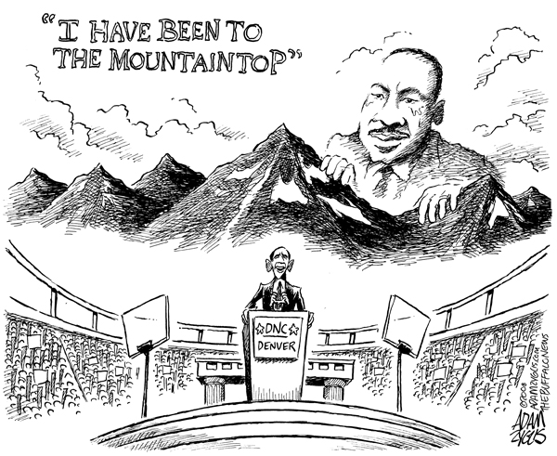

Mini-Glossary
Overcome: verb, to get the better of in a struggle or conflict, conquer; defeat

Document C
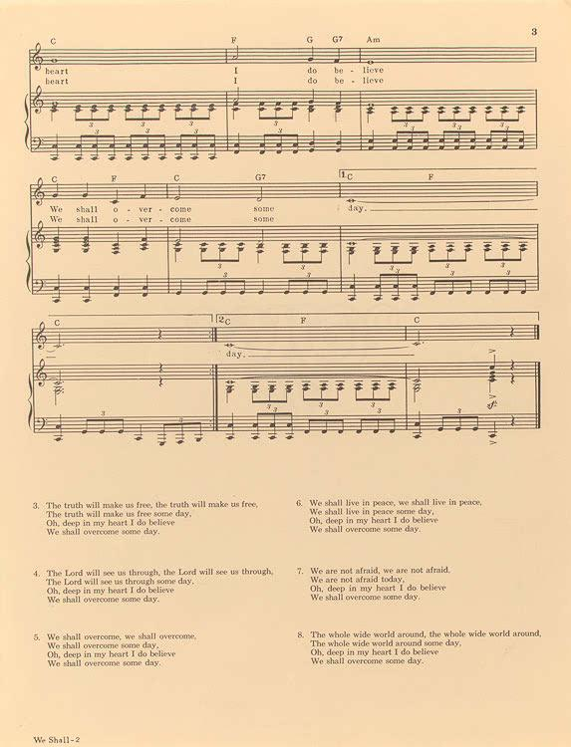

“’We Shall Overcome’ has its roots in African American hymns from the early 20th century, and was first used as a protest song in 1945, when striking tobacco workers in Charleston, S.C., sang it on their picket line. By the 1950s, the song had been discovered by the young activists of the African American civil rights movement, and it quickly became the movement’s unofficial anthem. Its verses were sung on protest marches and in sit-ins, through clouds of tear gas and under rows of police batons, and it brought courage and comfort to bruised, frightened activists as they waited in jail cells, wondering if they would survive the night. When the long years of struggle ended and President Lyndon Johnson vowed to fight for voting rights for all Americans, he included a final promise: ‘We shall overcome.’" (www.loc.gov)

Document D- Graphs on Progress of African Americans

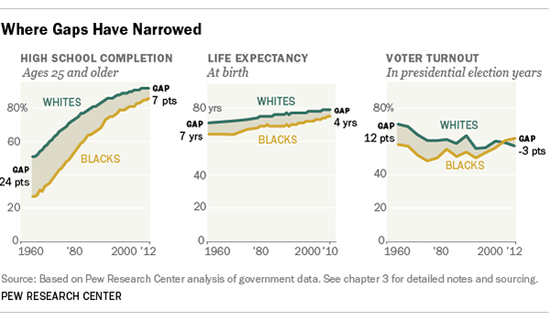

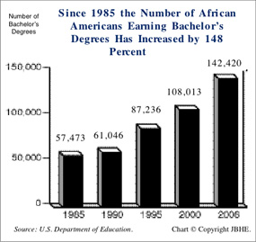

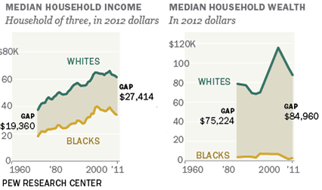

Document E

Equality still elusive 50 years after Civil Rights Act
Richard Wolf
USA TODAY, April 1, 2014
Blacks have made many economic and educational gains, but progress still falls short.
When President John F. Kennedy called on Congress in June 1963 to pass what would eventually become the Civil Rights Act of 1964, he rattled off a string of statistics intended to highlight the nation's continuing racial divide a century after the Emancipation Proclamation.
African Americans born that year, Kennedy said, had "about one-half as much chance of completing high school as a white baby born in the same place on the same day, one-third as much chance of completing college, one-third as much chance of becoming a professional man, twice as much chance of becoming unemployed, about one-seventh as much chance of earning $10,000 a year, a life expectancy which is seven years shorter, and the prospects of earning only half as much."
STOP and THINK: Do you think those statistics are still true today? Look at the graphs in Document D.
Fifty years later, on the eve of Monday's observance of Martin Luther King Jr. Day, the battle to end overt (open, clear to see) discrimination has been far more successful than the effort to attain (get or achieve) economic, educational or social equality.
Blacks have made huge strides in high school education but still lag in college graduation rates. Their incomes have risen and poverty rates have declined, but a mammoth wealth gap remains, along with persistently high unemployment rates.
So great has been the increase in political power that the black voter turnout rate surpassed that of whites in the 2012 presidential race, and the number of black elected officials has risen sevenfold. But while school segregation and workplace discrimination have declined, too many African Americans go home to segregated, often impoverished (high in poverty)neighborhoods…
…The Civil Rights Act championed by Kennedy and signed into law by President Lyndon Johnson after JFK's death succeeded in opening public accommodations, such as hotels and restaurants. It took longer to reduce racial discrimination in the workplace, but that, too, counts as a success. And the law's threat to cut off federal funding forced the desegregation of schools in the South.
"We shouldn't underestimate the importance of that," says Michael Klarman, a Harvard Law School professor specializing in constitutional law and civil rights. "Without that, we wouldn't have a black middle class as successful as it is. We wouldn't have a black president. We wouldn't have as many blacks going to law school or medical school."…

Document E cont.
POLLING STATS
…Polling by the Pew Research Center, on the other hand, shows that nearly nine in 10 blacks say discrimination still exists. One in three say they have experienced it within the past year; that number rises to one in two when it comes to the workplace or the voting booth.
Kennedy knew the challenge wasn't just passing laws, but changing hearts and minds. "Law alone cannot make men see right," he said. "We are confronted primarily with a moral issue."
The law, however, is what he could address. And while Kennedy didn't live to see it passed, the Civil Rights Act of 1964 sought to tackle discrimination in workplaces, schools and public facilities, as well as in state and local governments….
."
GAINS MADE AND LOST
…Progress over the past 50 years has been "breathtaking and unimaginable," says civil rights lawyer Ted Shaw, former president of the NAACP Legal Defense and Educational Fund and a professor at Columbia University School of Law. Nevertheless, he says, even the election of a black president "doesn't mean that all these systemic issues of racial inequality have disappeared."
In almost every economic category, blacks have been gaining, but not by enough. Median family income (in inflation-adjusted dollars) is up from $22,000 in 1963 to more than $40,000 today, still just two-thirds of the median for all Americans. Black unemployment remains twice the level of white unemployment, similar to where it was in 1972.
The black poverty rate has dropped from more than 40% in the 1960s to about 27% today; child poverty similarly has dipped from 67% to about 40%. Those numbers still are glaring, however. And the gap in overall wealth is more than 5-to-1 between whites and blacks: The average white household had nearly $800,000 in assets in 2011, compared with $154,000 for blacks….
…When it comes to desegregating schools, the Civil Rights Act fulfilled for African Americans the reward that still remained elusive 10 years after Brown v. Board of Education.
In 1964, just one in four blacks above age 25 had graduated from high school. Today, the number is 85%. The percentage of blacks with a college degree has risen from 4% to more than 21% — but there is much further to go. The rate for whites is 34%.
When the schoolhouse doors did swing open, a population long excluded from neighborhood schools or elite colleges and universities required help. Even today, African Americans have not caught up to whites in educational attainment. The percentage of black college students who graduate hovers around 40%, compared with 62% for whites, 50% for Hispanics and nearly 70% for Asian-Americans, according to Education Department data….

…The Civil Rights Act was followed by separate laws on voting rights in 1965 and fair housing in 1968 — again, with mixed results.
Document E cont.

Blacks' gains at the voting booth have been dramatic. In last year's presidential election, black turnout exceeded that of whites for the first time, according to Census data. And the number of black elected officials has soared from fewer than 1,500 in 1970 to more than 10,500 today.
So much has improved, in fact, that the Supreme Court last June struck down the most powerful tool in the Voting Rights Act to block discrimination at the voting booth. As a result, states such as Texas and North Carolina have moved to reinstate some restrictions.
Progress on housing has been much slower. While the Civil Rights Act opened up public accommodations, the Fair Housing Act of 1968 has failed to markedly raise black home ownership rates, and nearly six in 10 African Americans still live in segregated neighborhoods.
For all those reasons — economic and educational progress coupled with problems still facing black families — rights leaders remain committed to the cause.

Think About:
- Where have African Americans made the most progress?
- Are there areas that still need to improve?

PAT DOCUMENT ORGANIZER: Civil Rights Movement: Citizens Work For Justice
*Be sure to note which document the information is being pulled from
 | Describe actions of average citizens and the Legislative, Executive and Juridical branch during the Civil Rights movement that brought about progress. | Describe the lasting impacts of the actions of the Legislative Executive and Judicial Branch during the Civil Rights Movement. | Could this branch have done more? What problems still exist? | Formulate an argument that will convince readers about the effectiveness of the Legislative, Executive and Judicial Branch during the Civil Rights movement.
Average Citizens
Legislative
Executive
Judicial

PAT Score Form (optional)

Teacher: Unit #: Date: ________

Student Name | Content |  |  |  | Basics |  |  |  | Analysis |  |  |  | Application |  |  |  | Communication |  |  |  | Total
 | 4 | 3 | 2 | 1 | 4 | 3 | 2 | 1 | 4 | 3 | 2 | 1 | 4 | 3 | 2 | 1 | 4 | 3 | 2 | 1

