MINI-PERFORMANCE ASSESSMENT TASK SCAFFOLDED
Grade 7

UNIT VI: The Rise of Big Business and Government’s Expanding Role in the Economy

STANDARD: CE.12a; USII.4d,e

ENDURING UNDERSTANDING: Economics can transform a nation.

CONCEPTUAL UNIT QUESTION: How did economics influence the growth of industry and big business? How do all of the parts of the economy work together?

SCENARIO: The year is 1910; The New York Times is the country’s oldest and most popular newspaper. The owner knows a lot of people get all their information about the world from this newspaper. For this reason, the owner wants to make sure his newspaper is very objective, not influenced by personal opinions. This is especially true when writing about the biggest businessmen of the time, John Rockefeller, Andrew Carnegie and Cornelius Vanderbilt. In order to be objective the owner has asked you to research these three men and write a short profile for each; describing one positive and one negative impact each man had.

TASK: You will collect information from the documents provided to
- identify and describe the work done by each of the three captains of industry
- analyze the positive and negative aspects of their actions

DOCUMENTS: Use the document provided to research information on your task. Use the DOCUMENT GRAPHIC ORGANIZER to organize your information. Include and cite evidence from the document in your product.
Document A: Captains of Industry Notes

PRODUCT: You will create a written product, one paragraph, which will include:
- accurately describing the work done of Carnegie, Rockefeller and Vanderbilt
- clearly explaining how Carnegie, Rockefeller and Vanderbilt each had at least one positive impact on America
- clearly explaining how Carnegie, Rockefeller and Vanderbilt each had at least one negative impact on America
- using content-related vocabulary
- specifically incorporating evidence from the document included in the task

PAT RUBRIC: The Rise of Big Business and Government’s Expanding Role in the Economy
Category | 4 Exceeds Expectations | 3 Meets Expectations | 2 Approaching Expectations | 1 Below Expectations | Score
Content | Demonstrates thorough and accurate understanding of the business practices and careers of the captains of industry and the positive and negative effects of their actions. | Demonstrates a complete and accurate understanding of the business practices and careers of the captains of industry and the positive and negative effects of their actions. | Demonstrates an incomplete understanding of the business practices and careers of the captains of industry and the positive and negative effects of their actions. | Demonstrates inaccuracies and misconceptions about the business practices and careers of the captains of industry and the positive and negative effects of their actions.
Basic Skills | Demonstrates mastery of identifying who the captains of industry were, the specific industries they worked in, and specific business practices of each. | Demonstrates identification of who the captains of industry were, the specific industries they worked in, and specific business practices of each without significant error. | Demonstrates a number of errors or omissions when identifying who the captains of industry were, the specific industries they worked in, and specific business practices of each. | Demonstrates many critical errors when identifying who the captains of industry were, the specific industries they worked in, and specific business practices of each.
Analysis/Interpretation  Skills | Examines thoroughly all of the given documents.  Analyzes and evaluates information from the documents to make meaningful conclusions about the positive and negative effects of actions of the captains of industry. | Examines several of the given documents.  Makes a credible effort to analyze and evaluate information from some of the documents to make conclusions about the positive and negative effects of the actions of the captains of industry. | Examines some of the given documents.  Makes little effort to analyze and/or evaluate information.  Makes weak or irrelevant conclusions about the positive and negative effects of the actions of the captains of industry. | Gives no evidence that given documents were examined.  Fails to analyze and evaluate information to make any conclusions about the positive and negative effects of the actions of the captains of industry.
Application/  Synthesis  Skills | Cites and elaborates on evidence from at least three of the given documents to develop an in-depth position on whether the captains of industry helped or hurt the country. | Cites some evidence from 1-2 of the given documents to identify a position on whether the captains of industry helped or hurt the country. | Cites some evidence from the given documents to restate information.  Does not construct a clear position on whether the captains of industry helped or hurt the country. | Cites no evidence from the given documents.  Does not construct a position on whether the captains of industry helped or hurt the country.
Communication Skills | Product is well organized with clearly stated, complex ideas supported by citations from the documents and effectively conveys the message. | Product is somewhat organized with clearly stated basic ideas supported by citations from the documents and adequately conveys the message. | Product is poorly organized. Ideas may be unclear and/or weakly supported by the documents and poorly conveys the message. | Product is unorganized with irrelevant statements and no document citations and fails to convey the message.

Document A

Captains of Industry: Vanderbilt, Carnegie and Rockefeller
INFO | METHODS | INFORMATION ABOUT VANDERBILT
- Known as the “Railroad King”  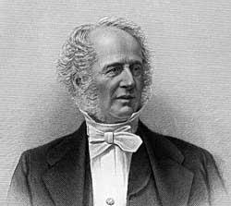  “What do I care about law? Ain't I got the power”? | - Made his prices very low which made other companies go out of business. Once there were no other companies Vanderbilt would then raise his price.  - First bought tiny railroad lines then joined them all together to form a giant powerful company  - Was in control of all the railroad lines from New York to Chicago | - Built Vanderbilt University  - Made shipping products easier and faster  - Made other companies go out of business  - People think he gave the government money in exchange for helping his business  - Seen as cold and uncaring  - His railroads helped farmers and factory owners along with every day people  - Made travel cheaper and faster

INFO |  | METHODS | INFORMATION ABOUT CARNEGIE
- Born in Scotland and moved to the United States  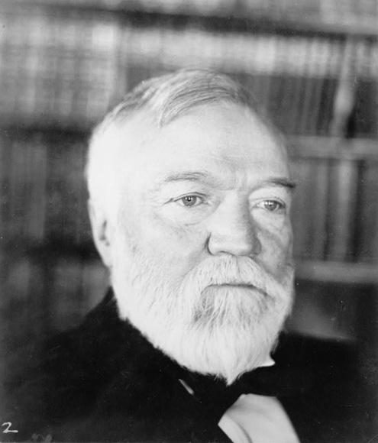  “And while the law of competition may be sometimes hard for the individual, it is best for the race, because it ensures the survival of the fittest in every department”. |  | - He created a monopoly which means he controlled all the companies that sold steel and could charge as much as he wanted  - Built the largest and most modern steel mill in the world | - When his company produced steel it allowed other countries to open  - Paid workers low wages  - His steel was used to create important railroads  - Created company towns where many of his workers lived – towns were not safe a had lots of pollution  - Gave money to create thousands of public libraries and Carnegie Mellon University  - Provided jobs  - Gave away 90% of his money  - when workers went on strike, refusing to work until they made more money, he ordered his manager to have security guards shoot the strikers  - Says he made the best and cheapest product
INFO | METHODS |  |  | INFORMATION ABOUT ROCKEFELLAR
- Started first company before he was 20 years old  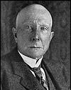  ”I believe that the power to make money is a gift from God”. | - Made his prices very low which made other companies go out of business. Once there were no other companies Vanderbilt would then raise his price.  - Made secret deals with the railroads to get cheaper shipping prices |  |  | - His business sold oiler for a lower price  - Paid workers low wages  - Made oil available to more people  - Sometimes he lied to get what he wanted  - When some miners complained he closed mines and let workers starve  - Provided jobs  - Created the University of Chicago  - Other workers on strike were shot at and killed  - Gave away half of his money to help others

PAT DOCUMENT ORGANIZER: The Rise of Big Business and Government’s Expanding Role in the Economy
Evidence Chart | Task Skill:  What industry was each man in charge of?  (Use initials given to indicate specific captain) | Task Skill:  What were some positive impacts of each man?  (Use initials given to indicate specific captain) | Task Skill:  What were some negative impacts of each man?  (Use initials given to indicate specific captain)
Document A  Captains of Industry Notes | JR CV
KEY: AC= Andrew Carnegie JR= John Rockefeller CV= Cornelius Vanderbil

Helpful Economic Vocabulary to use
Profit | Monopoly | Production | Consumption | Unemployment/Employment
Scarcity | Households | Businesses | Poor working conditions | Resources
Income | Steel Industry | Railroads | Oil Industry | Labor Unions

PAT SENTENCE STARTERS
UNIT VI: THE RISE OF BIG BUSINESS AND GOVERNMENT’S EXPANDING ROLE IN THE ECONOMY

Directions: use these sentence starts to construct your profile on Carnegie, Rockefeller and Vanderbilt.

- Use the following phrases to introduce each man.
Andrew Carnegie …
John Rockefeller …
Cornelius Vanderbilt…
…best know for … | …commonly given credit for … | …started the… | …created the …

- Once you have introduce each man explain how they came to power
… Carnegie …
… Rockefeller …
... Vanderbilt…
…grew his business by… | In order to succeed he … | …was known to … | …commonly would…
…created his business by… | …started by…

- Use the following sentence starters to give examples of both positive and negative impacts each man had on America
For Example, … | …as can be seen in … | …supports…
…as demonstrated by … | An illustration of… | An example …
Specifically, … | …is shown… | Such as…

PAT Writing Template
Complete for each of the men. Use the sentence starters to help you create your product.
Name of Leader:

Introduction:

Positive Trait | Negative Trait

Name of Leader:

Introduction:

Positive Trait | Negative Trait

Name of Leader:

Introduction:

Positive Trait | Negative Trait

PAT Score Form

Teacher: Unit #: Date: ____________

Student Name | Content |  |  |  | Basics |  |  |  | Analysis |  |  |  | Application |  |  |  | Communication |  |  |  | Total
 | 4 | 3 | 2 | 1 | 4 | 3 | 2 | 1 | 4 | 3 | 2 | 1 | 4 | 3 | 2 | 1 | 4 | 3 | 2 | 1

