MINI-PERFORMANCE ASSESSMENT TASK
Grade 7

UNIT VI: The Rise of Big Business and Government’s Expanding Role in the Economy

STANDARD: CE.12a; USII.4d,e

ENDURING UNDERSTANDING: Economics can transform a nation.

CONCEPTUAL UNIT QUESTION: How did economics influence the growth of industry and big business? How do all of the parts of the economy work together?

SCENARIO: You are on the City Council of a city that recently completed construction on a new library. The suggested name is the “Captains of Industry Library”, named after Vanderbilt, Rockefeller and Carnegie. However, not all city residents are happy about the name; many citizens believe these three men were Robber Barons not Captains of Industry. As a member of the local legislative branch you have decided to host a debate about whether these men are Captains of Industry or Robber Barons. Before the debate you will need to research these three men and develop your own opinion as to whether they are Captains of Industry of Robber Barons.

TASK: You will collect information from the documents provided to
- identify and describe the work done by each of these men,
- analyze the positive and negative aspects of their actions,
- construct and present an argument to support whether these men are Robber Barons or Captains of Industry and if the library should be named after them.

DOCUMENTS: Use each of the documents provided to research information on your task. Use the DOCUMENTS GRAPHIC ORGANIZER to organize your information. Include and cite evidence from at least 2 of the documents in your product.
Document A: Rockefeller, Vanderbilt and Carnegie notes
Document B: Graphs and illustrations from Teacher’s Curriculum Institute,
Rise of Industrial America
Document C: Circular Flow diagram

PRODUCT: You will create a written explanation that justifies your selection of the title of Robber Baron or Captain of Industry.
- accurately describe the actions of Carnegie, Rockefeller and Vanderbilt
- clearly state your position on whether they are Robber Barons or Captains of Industry
- construct a persuasive argument for or against the name of the library
- use content-related vocabulary
- specifically incorporate evidence from at least 2 documents included in the task

PAT RUBRIC: The Rise of Big Business and Government’s Expanding Role in the Economy
Category | 4 Exceeds Expectations | 3 Meets Expectations | 2 Approaching Expectations | 1 Below Expectations | Score
Content | Demonstrates thorough and accurate understanding of the business practices and careers of the captains of industry and the positive and negative effects of their actions. | Demonstrates a complete and accurate understanding of the business practices and careers of the captains of industry and the positive and negative effects of their actions. | Demonstrates an incomplete understanding of the business practices and careers of the captains of industry and the positive and negative effects of their actions. | Demonstrates inaccuracies and misconceptions about the business practices and careers of the captains of industry and the positive and negative effects of their actions.
Basic Skills | Demonstrates mastery of identifying who the captains of industry were, the specific industries they worked in, and specific business practices of each. | Demonstrates identification of who the captains of industry were, the specific industries they worked in, and specific business practices of each without significant error. | Demonstrates a number of errors or omissions when identifying who the captains of industry were, the specific industries they worked in, and specific business practices of each. | Demonstrates many critical errors when identifying who the captains of industry were, the specific industries they worked in, and specific business practices of each.
Analysis/Interpretation  Skills | Examines thoroughly all of the given documents.  Analyzes and evaluates information from the documents to make meaningful conclusions about the positive and negative effects of actions of the captains of industry. | Examines several of the given documents.  Makes a credible effort to analyze and evaluate information from some of the documents to make conclusions about the positive and negative effects of the actions of the captains of industry. | Examines some of the given documents.  Makes little effort to analyze and/or evaluate information.  Makes weak or irrelevant conclusions about the positive and negative effects of the actions of the captains of industry. | Gives no evidence that given documents were examined.  Fails to analyze and evaluate information to make any conclusions about the positive and negative effects of the actions of the captains of industry.
Application/  Synthesis  Skills | Cites and elaborates on evidence from at least three of the given documents to develop an in-depth position on whether the captains of industry helped or hurt the country. | Cites some evidence from 1-2 of the given documents to identify a position on whether the captains of industry helped or hurt the country. | Cites some evidence from the given documents to restate information.  Does not construct a clear position on whether the captains of industry helped or hurt the country. | Cites no evidence from the given documents.  Does not construct a position on whether the captains of industry helped or hurt the country.
Communication Skills | Product is well organized with clearly stated, complex ideas supported by citations from the documents and effectively conveys the message. | Product is somewhat organized with clearly stated basic ideas supported by citations from the documents and adequately conveys the message. | Product is poorly organized. Ideas may be unclear and/or weakly supported by the documents and poorly conveys the message. | Product is unorganized with irrelevant statements and no document citations and fails to convey the message.

Document A
Vanderbilt, Carnegie and Rockefeller Profiles

Cornelius Vanderbilt
Shipping and Railroads
INFO | METHODS | POSITIVES | NEGATIVES
- Known as the “Railroad King”  - Made his fortune in the steamship business  - Entered the railroad business at age of 69  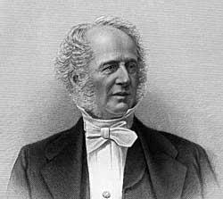  “What do I care about law? Ain't I got the power”? | - Set his prices far below those of his competitors to steal their business  - Bought out competitors  - Consolidated small railroad lines into one of the first giant corporations in the USA  - Ultimately controlled railroad lines from New York to Chicago | - Made shipping products faster and more efficient  - Railroads laid the foundation for industrialization and were key to getting factory and farm products to their markets  - Made other big businesses possible  - Made travel less expensive and faster  - Donated money to found Vanderbilt University in Nashville, TN | - Put competitors out of business  - New York Times called him a “robber baron” for putting his competition out of business whenever he could  - Accused of bribing government officials to help his business  - Seen as cold and uncaring. When asked by a newspaper reporter if the railroads shouldn’t be run for the public good (instead of profit), he replied, “Let the public be damned”

Document A cont.

Andrew Carnegie
Steel
INFO |  | METHODS | POSITIVES |  |  | NEGATIVES
- Immigrant from Scotland  - Worked his way up from having almost nothing through a variety of work experiences  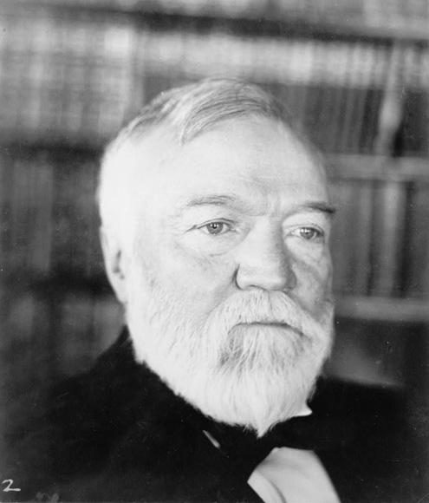  “And while the law of competition may be sometimes hard for the individual, it is best for the race, because it ensures the survival of the fittest in every department”. |  | - MONOPOLY – controlled much of the steel industry and was therefore able to set higher prices  - VERTICAL INTEGRATION – his companies controlled all the steps in the production process, allowing him to cut costs  - Built the largest and most modern steel mill in the world  - Expanded his business during periods of decline, which meant he was able to do so cheaply | - Steel allowed new industries to develop and grow, helped with the growth of cities and transportation  - Provided jobs  - Says he made the best and cheapest product  - Wrote Gospel of Wealth; he said rich ought to use their money to improve society  - Set up cultural, educational and scientific institutions  - Gave money to create thousands of public libraries, Carnegie Hall (concerts), Carnegie Mellon University  - Gave away 90% of his fortune |  |  | - Paid workers low wages  - Created company towns where many of his workers lived – towns were not well-maintained, lots of pollution  - Homestead Strike: when workers went on strike, he ordered his manager to have security guards shoot the strikers to keep them out of the factories so replacements could work
Document A cont.

John D. Rockefeller
Standard Oil
INFO | METHODS |  |  | POSITIVES | NEGATIVES
- Graduated from high school, good in math  - Started first company before he was 20 years old  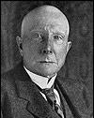  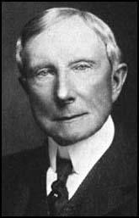  ”I believe that the power to make money is a gift from God”. | - MONOPOLY  - Lowered his prices so much that his competitors went out of business  - Bought up companies that went out of business  - Because he had a MONOPOLY, he could charge high prices and because there was no competition  - Also used idea of VERTICAL INTEGRATION, in which he bought all the steps in the production process. Ex: owned the company that made the wooden barrels for the oil  - Made secret deals with the railroads to get cheaper shipping prices |  |  | - Greater efficiency and secret deals led to LOWER PRICES for oil  - Increased output of oil  - Provided jobs  - Founded University of Chicago  - Started the Rockefeller Foundation to give away money for purposes like improving teaching and medical research  - Helped fund high schools in the South and helped rid the South of hookworm  - Gave away half of his money | - Used dishonest methods to become successful, like creating a monopoly so he could control prices, and making secret deals  - Paid workers low wages.  - When some miners tried to form unions, he closed mines and let workers starve  - Other workers on strike were shot at and killed

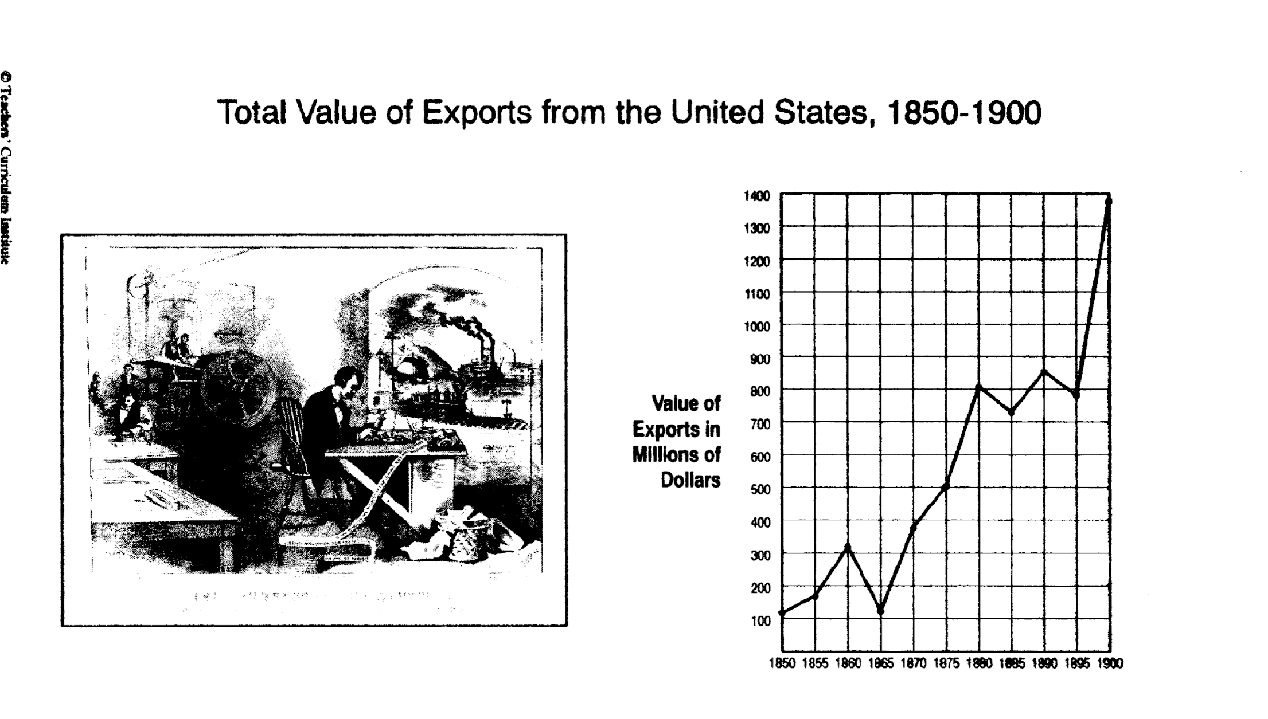
Document B

THINK ABOUT: How did the work of the captains of industry connect to the information in this graph?

Document B cont.
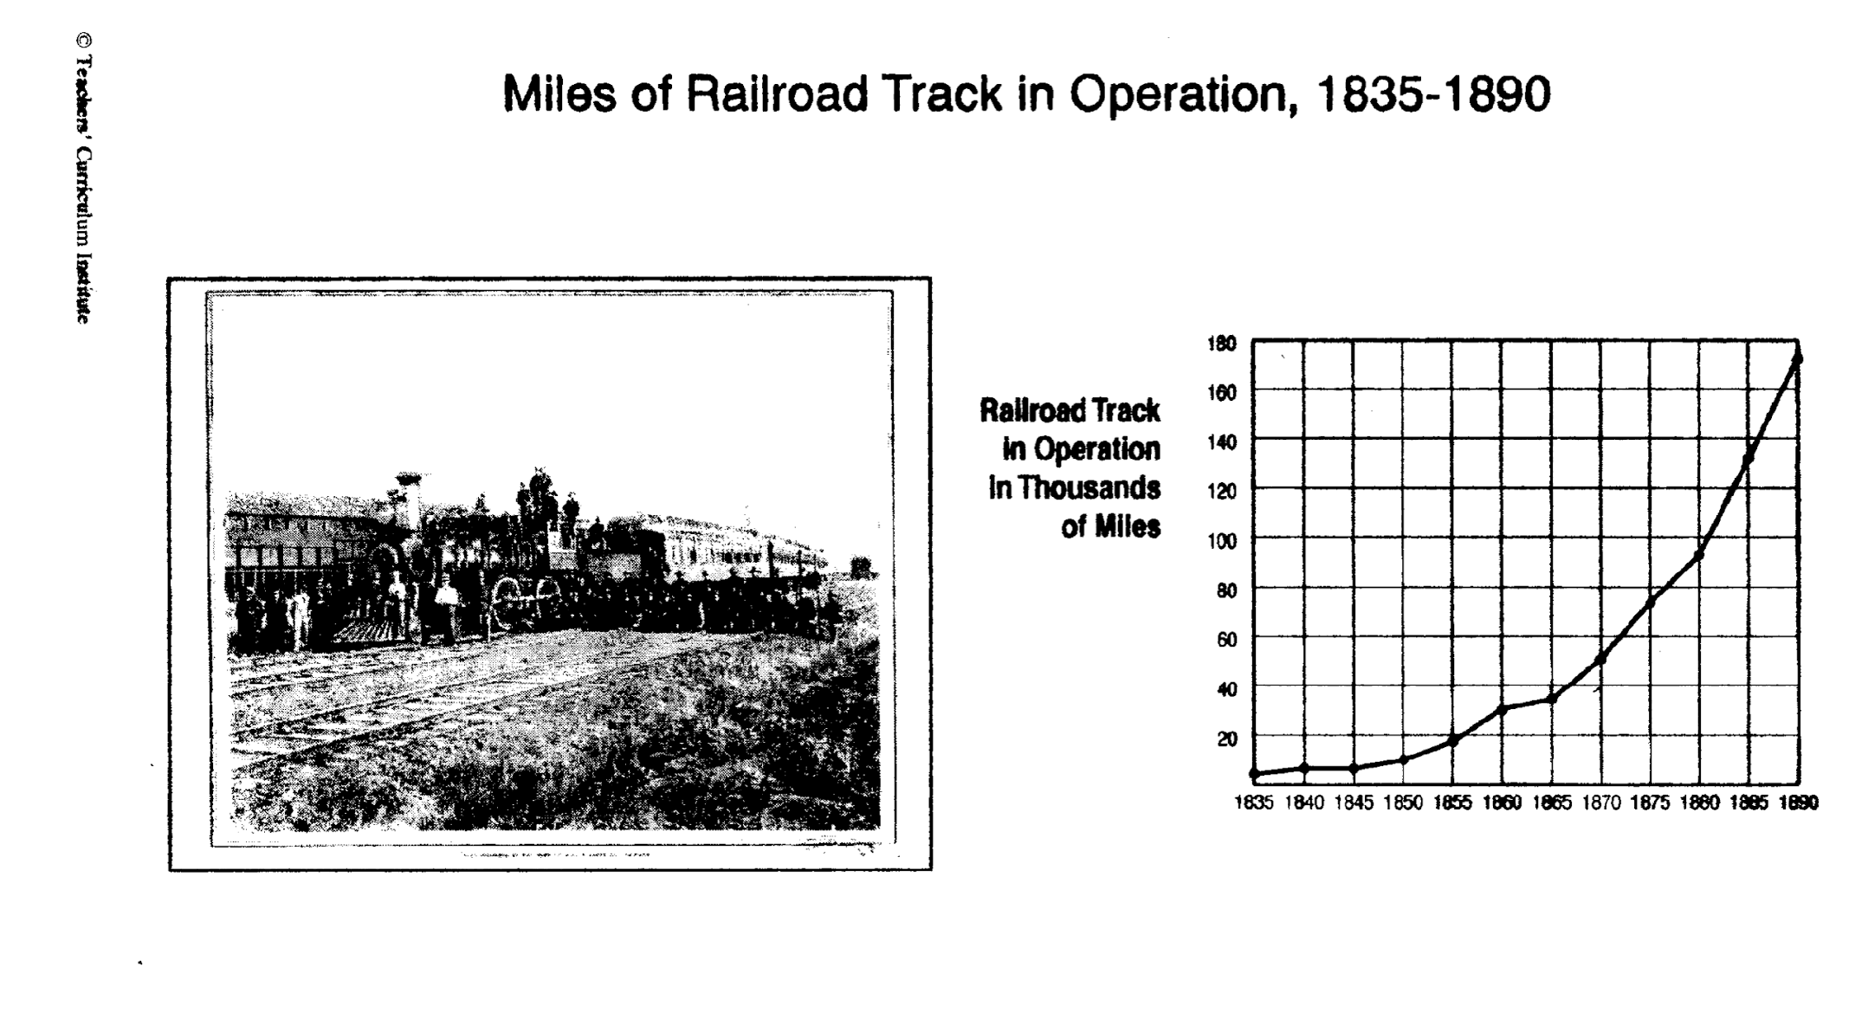
THINK ABOUT: Which captain of industry worked to expand this specific industry?

Document B cont.
THINK ABOUT: Which captain of industry worked to expand this specific industry?
Document B cont.
THINK ABOUT: How did the captains of industry affect the number of nonagricultural workers during the years shown in this graph?

Document C: Circular Flow Diagram
Workers would sell their labor to Carnegie, Vanderbilt and Rockefeller

Households Business

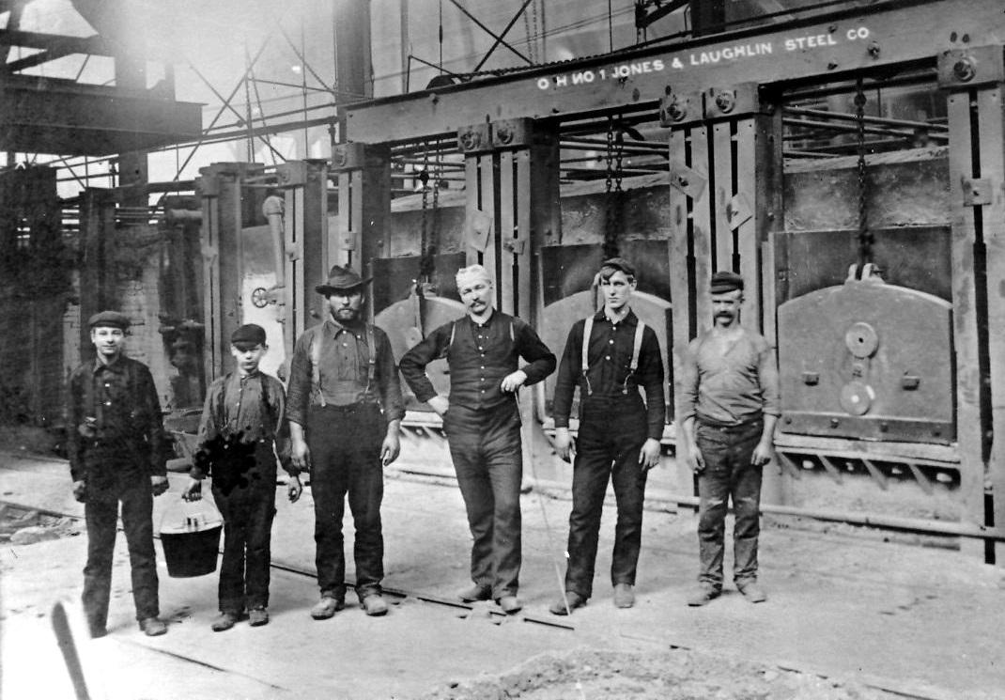

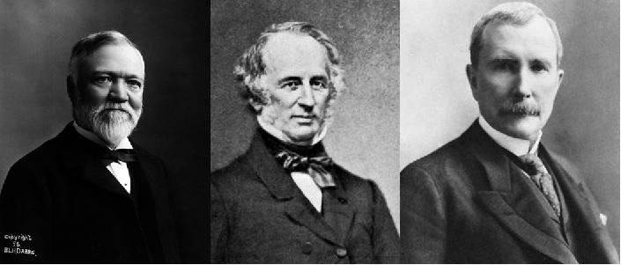
Carnegie, Vanderbilt and Rockefeller pay their workers an income

Households then use the money from their incomes to buy goods and service

Carnegie, Vanderbilt and Rockefeller would use labor to produce goods and services which they would sell to households, including their workers.

THINK ABOUT: How do Carnegie, Rockefeller and Vanderbilt contribute to and fit into the Circular Flow?

PAT DOCUMENT ORGANIZER: The Rise of Big Business and Government’s Expanding Role in the Economy
Robber Baron: a ruthlessly powerful U.S. capitalist or industrialist of the late 19th century considered to have become wealthy by exploiting natural resources, corrupting legislators, or other unethical means. | Captain of Industry:  a business leader whose means of amassing a personal fortune contributes positively to the country in some way.
Evidence Chart | Task Skill:  Identify and describe the work done by Carnegie, Rockefeller and Vanderbilt.  (Use initials given to indicate specific captain) | Task Skill:  Analyze the positive effects of the work done by Carnegie, Rockefeller and Vanderbilt.  (Use initials given to indicate specific captain) | Task Skill:  Analyze the negative effects of the work done by Carnegie, Rockefeller and Vanderbilt.  (Use initials given to indicate specific captain)
Document A  Captains of Industry Notes | AC JR CV | AC JR CV | AC JR CV
Document B  Industrialization Graphs | AC JR CV | AC JR CV | AC JR CV
Document C  Circular Flow Chart | AC JR CV | AC JR CV | AC JR CV

Helpful Economic Vocabulary to use
Profit | Monopoly | Production | Consumption | Unemployment/Employment
Scarcity | Households | Businesses | Poor working conditions | Resources
Income | Steel Industry | Railroads | Oil Industry | Labor Unions
PAT Score Form

Teacher: Unit #: Date: _________

Student Name | Content |  |  |  | Basics |  |  |  | Analysis |  |  |  | Application |  |  |  | Communication |  |  |  | Total
 | 4 | 3 | 2 | 1 | 4 | 3 | 2 | 1 | 4 | 3 | 2 | 1 | 4 | 3 | 2 | 1 | 4 | 3 | 2 | 1

