MINI-PERFORMANCE ASSESSMENT TASK
Grade 7: Audio Tour of the Franklin Delano Roosevelt Memorial

UNIT VIII: Boom to Bust: The Role of Government Expands

STANDARD: CE.13b.c.e.f; USII.6d

ENDURING UNDERSTANDING: Government intervention may be necessary in times of crisis to meet the changing needs of society.

CONCEPTUAL UNIT QUESTION: What role should the government play in the daily lives of its citizens?

SCENARIO: You are a National Parks Service ranger at the Franklin Delano Memorial in Washington D.C. You are giving a tour of the Memorial.. You are standing in front of the breadline portion of the monument tour and one of the visitors asks you the following question: How did President Roosevelt change the role of government in people’s daily lives during the Depression? Your task will be to respond to the visitor’s question with a short speech.

TASK: You will collect information from the documents to
- identify and describe the purpose of specific New Deal programs
- identify and analyze Roosevelt’s point of view in regard to the federal government’s intervention during the great depression.
- create a short speech that explains your answer to the question posed by the visitor.

DOCUMENT: Use each of the attached documents provided to research information on your task.
Document A: Table of New Deal Programs
Document B: Excerpts from President Franklin Roosevelt’s speeches on
government intervention

PRODUCT: You will produce a short speech (2-3 paragraphs) that
- accurately explains how the role of government changed during FDR’s administration
- provides examples of how the government supported people during the great depression
- uses content related vocabulary including specific New Deal programs
- provides a clear, organized speech, specifically incorporates evidence from the two documents included in the task

ADDITIONAL RESOURCES:
- Picture of FDR memorial monument
- PAT Graphic Organizer for taking notes
- Rubric
Category | 4 Exceeds Expectations | 3 Meets Expectations | 2 Approaching Expectations | 1Below Expectations | Score
Content | Demonstrates thorough and accurate understanding of the federal government’s response to the Great Depression. | Demonstrates a complete and accurate understanding of the federal government’s response to the Great Depression. | Demonstrates an incomplete understanding of the federal government’s response to the Great Depression. | Demonstrates inaccuracies and misconceptions about the federal government’s response to the Great Depression.
Basic Skills | Identifies and thoroughly describes specific New Deal programs without error. | Identifies and describes specific New Deal programs, without significant error. | Demonstrates a number of errors when describing specific New Deal programs but can complete a basic identification of them. | Demonstrates many critical errors when identifying and describing specific New Deal programs.
Analysis/Interpretation  Skills | Examines thoroughly all of the given documents.  Analyzes and evaluates information to identify different points of view on the federal government’s response to the Great Depression. | Examines several of the given documents.  Makes a credible effort to analyze and evaluate information from some of the documents to identify different points of view on the federal government’s response to the Great Depression. | Examines some of the given documents.  Makes little effort to analyze and/or evaluate information to identify different points of view on government’s response to the Great Depression. | Gives no evidence that given documents were examined.  Fails to analyze and evaluate information different views on the federal government’s response to the Great Depression.
Application/Synthesis  Skills | Cites and elaborates on evidence from at least three of the given documents to develop an in-depth position on what role the federal government should play in solving economic problems. | Cites some evidence from 1-2 of the given documents to identify a position on what role the federal government should play in solving economic problems. | Cites some evidence from the given documents to restate information.  Does not construct a position on what role the federal government should play in solving economic problems. | Cites no evidence from the given documents.  Does not construct a position on what role the federal government should play in solving economic problems.
Communication Skills | Product is well organized with clearly stated, complex ideas supported by citations from the documents and effectively conveys the message. | Product is somewhat organized with clearly stated basic ideas supported by citations from the documents, and adequately conveys the message. | Product is poorly organized. Ideas are unclear, weakly supported by the documents and poorly conveys the message. | Product is unorganized with irrelevant statements and no document citations and fails to convey the message.
PAT RUBIC: Boom to Bust: The Role of Government Expands

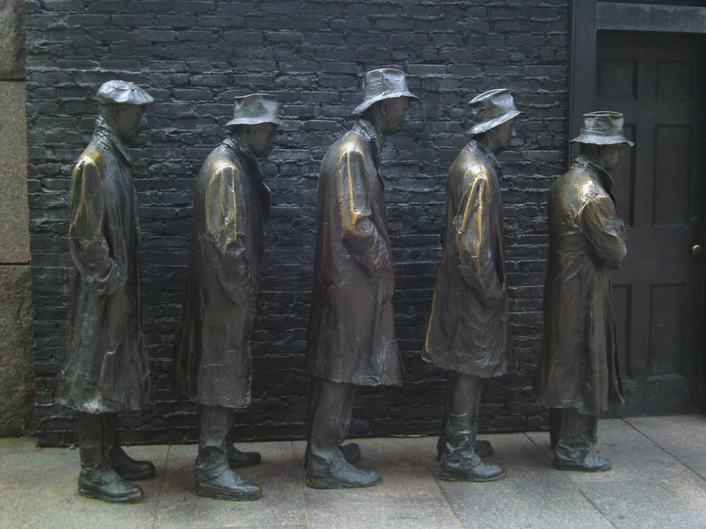
ROOSEVELT MEMORIAL

Document A
Table of New Deal Programs
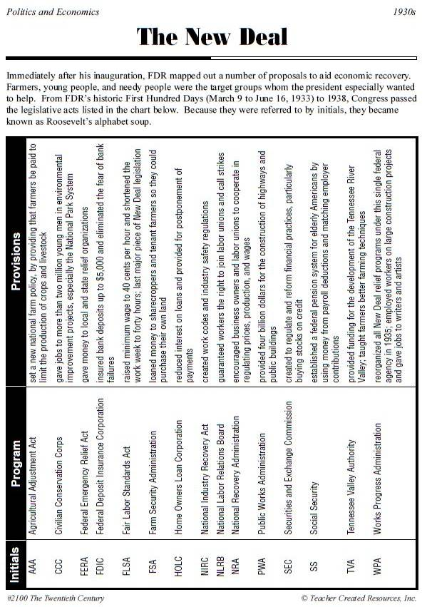

Document B
Excerpts from President Roosevelt’s speeches on government intervention

Excerpt 1
GLOSSARY
relief –getting money from the government because they are poor or unemployed
not local but national –means that the problem was a nation-wide problem
sufficient—enough
credit – money that can be borrowed
assumed—taken-on; take responsibility for
shrink from it—quit doing it
pending –waiting on
Absorption – To be taken in
Tide – Large and increasing quantity or volume
There [are] three and one half million employable people who are on relief; with them the problem is different and the responsibility is different. This group was the victim of a nation - wide depression caused by conditions which were not local but national. The Federal Government is the only governmental agency with sufficient power and credit to meet this situation. We have assumed this task and we shall not shrink from it in the future. It is [clearly important for the government] to ask you to make it possible for the United States to give employment to all of these three and one half million employable people now on relief, pending their absorption in a rising tide of private employment.

Adapted text from speech given by President Franklin Delano Roosevelt,
January 4, 1935
Reprinted in The Public Papers and Addresses of
Franklin D. Roosevelt, Vol. 4, 1935,
(New York City: Random House, 1938)

-----------------------------------------------------------------------------------------
Excerpt 2
GLOSSARY

withdraw from giving –stop giving
perhaps –maybe
local—meaning, something that the city (not national) government needs to fix
Grudging – Unwilling, reluctant
starvation wages –earning so little money at a job that you are still starving
lies not within the province –is not the responsibility
relief –getting money from the government because they are poor or unemployed
Squalor – Filthiness, neglect
Reduction –decrease
Advance—continue to do what is already being done
Mandate—the job of speaking for, and helping the people who voted for a leader
Shall we say to the several millions of unemployed citizens who face [starvation], "We will withdraw from giving you work. We will turn you back to the charity of your communities and those men of selfish power who tell you that perhaps they will employ you if the Government leaves them strictly alone?"
Shall we say to the needy unemployed, "Your problem is a local one [and all the Federal government will do to help] is pay to your city or to your county a few grudging dollars to help maintain your soup kitchens?"
Shall we say to the children who have worked all day in the factories, "Child labor is a local issue and so are your starvation wages; something [the separate] forty-eight States [have to fix]?"

Document B cont.

lies not within the province –is not the responsibility
relief –getting money from the government because they are poor or unemployed
Squalor – Filthiness, neglect
Reduction –decrease
Advance—continue to do what is already being done
Mandate—the job of speaking for, and helping the people who voted for a leader

Shall we say to the unemployed and the aged, "Social security lies not within the province of the Federal Government; you must seek relief elsewhere?"
Shall we say to the men and women who live in conditions of squalor in country and in city, "The health and the happiness of you and your children are no concern of ours?" […]
I am confident that the Congress of the United States well understands the facts and is ready to wage unceasing warfare against those who [say we should abandon the programs of the New Deal]. […]
National income increases; employment increases. Therefore, we can look forward to a reduction in the number of those citizens who are in need. […]
In the light of our [great] progress, [I] recommend to the Congress that we advance; that we do not retreat. I have confidence that you will not fail the people of the Nation whose mandate you have already so faithfully fulfilled. […]

Adapted text from speech given by President Franklin Delano Roosevelt
January 3, 1936
Reprinted in The Public Papers and Addresses
of Franklin D. Roosevelt, Vol. 5, 1936
(New York City: Random House, 1938)

Document Analysis Chart
Mini PAT The Boom to Bust Period

Document | What quotes and/or actions help us understand FDR’s views of government intervention?  (Record what you find below) | How did FDR change the role of government in people’s lives?  (Record evidence and predictions below)
Document A
Table of New Deal Programs

Document B
Excerpt from FDR’s speech on government intervention

PAT Score Form

Teacher: Unit #: Date: ___________

Student Name | Content |  |  |  | Basics |  |  |  | Analysis |  |  |  | Application |  |  |  | Communication |  |  |  | Total
Student Name | 4 | 3 | 2 | 1 | 4 | 3 | 2 | 1 | 4 | 3 | 2 | 1 | 4 | 3 | 2 | 1 | 4 | 3 | 2 | 1 | Total

