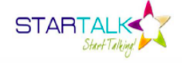

Save the Date!
July 9 – 27, 2018
Kenmore Middle School
8:20 am – 12:50 pm

For more information, contact:
APS World Languages Office
Elisabeth Harrington, Supervisor elisabeth.harrington@apsva.us
703-228-6097

For the 12th year, APS will offer a FREE 3-week immersion program for rising 6th - 8th grade students interested in Arabic and Chinese. STARTALK is a federally funded program established by the National Security Initiative
“to expand foreign language education in under-taught critical languages.”

