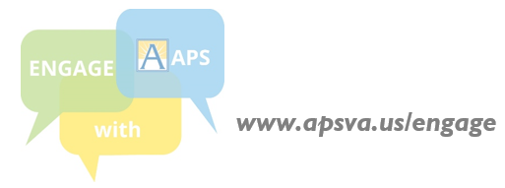



## **ENGAGE WITH APS: The 2018-24 Strategic Plan**

## **What is the 2018-2024 Strategic Plan?**

## Every six years, APS works with community members to develop a plan that charts a course for students, staff, and the school division overall, and ensures our schools can create new opportunities and meet the evolving needs of students. This new plan will be adopted by the School Board in June 2018.

## **Who is involved in developing this plan?**

## All community members can contribute thoughts and ideas via in-person meetings and online questionnaires. This process is being led by a steering committee with 24 members who represent diverse parent, staff, student, and community perspectives and interests, and have worked on this since Fall 2017.

## **What is the status of this plan?**

The Steering Committee has presented draft sections for community review and input during the process:

* **APS Mission and Vision Statements:** Reflects our community’s expectations, hopes and aspirations for APS
* **Core Values:** Serves as the foundation for an inclusive and effective direction for student success
* **Goals and Strategies:** Articulates the aims of our school division and our approach to achieve these
* **DRAFT PLAN:** Stakeholders are currently able to review the draft plan in its entirety and provide input

## **What does this draft plan contain?**

Please review the draft plan, April 2-19, at [**www.apsva.us/engage/strategic-plan/**](http://www.apsva.us/engage/strategic-plan/)**.**  ***It is essential to get community input to finalize and present the School Board with an updated 2018-24 draft Strategic Plan.***

The content is still in draft form and undergoing changes, but some examples of what it addresses include:

* Preparing students for college, careers and life
* Providing an academically challenging education that also supports students’ social/emotional needs
* Partnering with staff, students, families, and our community to support the success of our students
* Investing in our workforce to ensure APS is a place in which talented individuals choose to work
* Planning for the careful and strategic use of resources to meet our community's needs now and in the future

|  |
| --- |
| **Please Participate: Share Your Views and Contribute to the 2018-24 Strategic Plan!**   * **Review the draft 2018-24 Strategic Plan:** [www.apsva.us/engage/strategic-plan/](http://www.apsva.us/engage/strategic-plan/) * **Share your input on the draft plan by *Thursday, April 19:*** * **Complete a community questionnaire:** [www.apsva.us/engage/engage-aps-online-feedback/](http://www.apsva.us/engage/engage-aps-online-feedback/) * **Write to** [engage@apsva.us](mailto:engage@apsva.us) |