Recommended Reading
The following books are suggested reading and have been jointly recommended by Arlington Public Schools and the Arlington Gender Identity Alliance. We are pleased to provide these books in our counseling offices and libraries for use by students and staff.

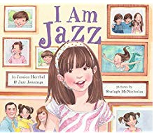
Elementary to Middle School
Red
Annie’s Plaid Shirt
I am Jazz
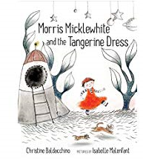
My Princess Boy
Introducing Teddy
Be Who You Are
And Tango Makes Three
Morris Mickelwhite and the Tangerine Dress
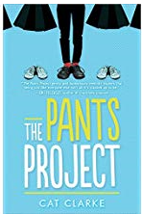
One
Amazing Grace
The Pants Project
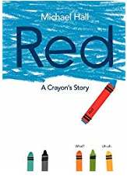
George

Middle to High School
Freakboy
And She Was
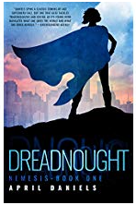
Star-Crossed
The Nemesis series (Dreadnought and Sovereign)
Beautiful Music for Ugly Children
I am J

