

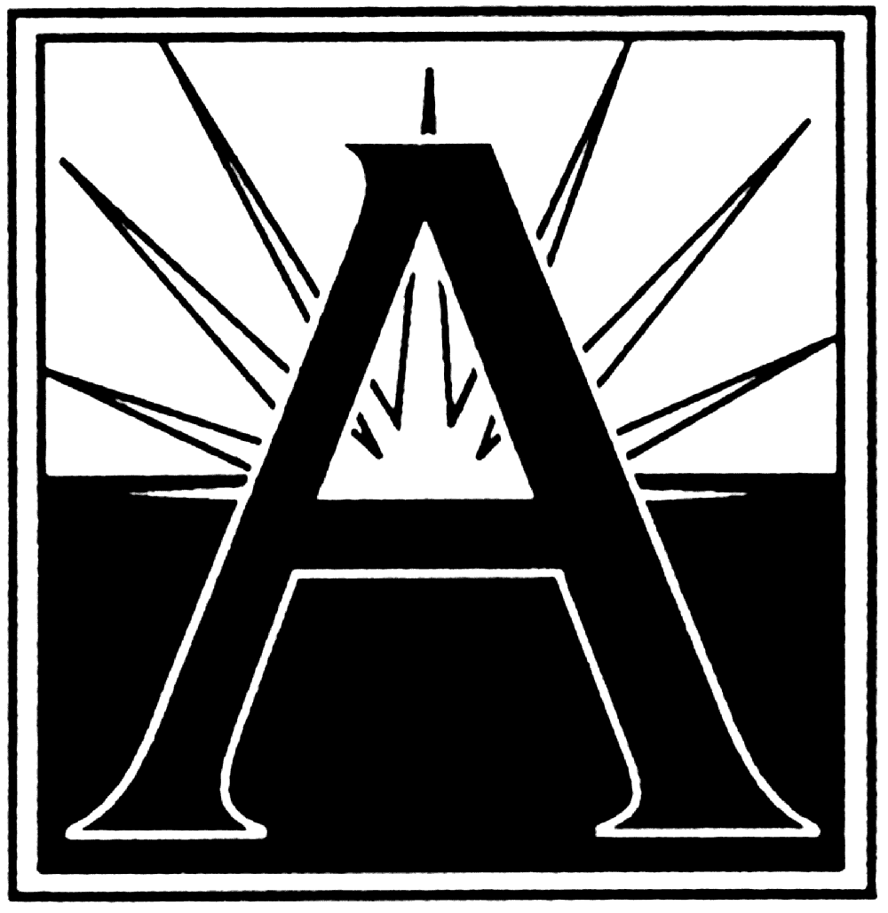

early childhood



early childhood



**ARLINGTON WEEK OF THE YOUNG CHILD**

Celebrating the potential of

Arlington’s youngest learners!

April 8 – 12, 2019

**What is the Week of the Young Child or WOYC?**

The Week of the Young Child is an annual celebration hosted by The National Association for the Education of Young Children (**NAEYC**) celebrating; early learning, young children, their teachers, and families.

The purpose of the **WOYC** is to focus public attention on the needs of the young children and their families and to recognize the early childhood programs and services that meet those needs.

**NAEYC** first established the **WOYC** in 1971, recognizing that the early childhood years (birth through age eight) lay the foundation for children’s success in school and later life.

***Join the conversation on social media about the WOYC and share your photos by using***

***#ArlWOYC***

**Sponsored By:**

Arlington Public Schools

Office of Elementary and Early Childhood Education

2110 Washington Blvd.

Arlington, VA 22204

703-228-8632

**www. apsva.us**

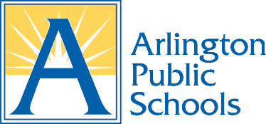

**ARLINGTON WEEK OF THE YOUNG CHILD**

Celebrating the potential of Arlington’s Youngest Learners!

April 8 – 12, 2019

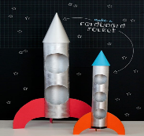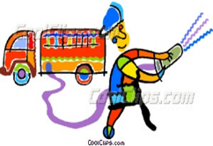

**Where In The World? Visit to the David M. Brown Planetarium**

The Planetarium will host a special show for young learners, featuring BIG BIRD from Sesame Street! This program was designed especially for young learners.

“Big Bird” will take you through the universe and through the solar system and back! This event is open to all ages and children with accompanying adult.

**\*Maximum seating capacity for the show is 55\***

**DATE**: **Tuesday, April 9, 2019**

**TIME:** **1:30 p.m.  
LOCATION: David M. Brown Planetarium, 1426 N Quincy Street, Arlington, VA 22207**

**Wild, Wacky, Wonderful Willy WOO WOO Magic Show!**

It’s the wild and wacky word of “Willy Woo Woo” and his fantastical magic show! Willy has been entertaining children at private events and large events throughout the DC Metropolitan Area for many years. He will bring his fantastic magic to the Children’s School for a “magical” performance!

**Date**: **Wednesday, April 10, 2019**

**Time: 10:00 – 11:30 a.m.**

**Location: The Children’s School**

4420 Fairfax Drive #202 Arlington, VA 22203



**FIRE Safety and Fire Engine Presentation!**

Firefighters are very important community helpers. At this event, one of our very own APS VPI Teachers, Jake Ramsay, will join the Arlington County Fire Department to demonstrate fire safety practices, and show you a real fire engine! Mr. Ramsay is also a Volunteer fireman! Special thanks to the ACFD and Jake Ramsey for organizing this event.

**Date:** **Wednesday, April 10, 2019**

**Time: 3:15- 3:45 p.m.**

**Location: Barrett Elementary School: 4401 N Henderson Rd. Arlington, VA 22203 (*Open to children ages 0 -7 with an adult*)**

**THE BIG YELLOW BUS!**

Why wait until Kindergarten to explore a real APS school bus? You don’t! At this event, children ages 0-5 with an accompanying adult will have the opportunity to explore an APS school bus. Children will learn about how the bus operates and how to be safe on a school bus. This event will take place rain or shine, and is open to the public.

**Date**: **Thursday, April 11, 2019**

**Time: 11:30 – 12:30 a.m.**

**Location: The Marshall Building parking lot. 2847 Wilson Blvd. Arlington, VA 22201**

**MEET “SNICKERS” and FRIENDS!**

Did you know that APS is home to a ***very special*** miniature horse, named “Snickers”? The Animal Science Program at the APS Career Center, is home to a variety of animals. Participants will have an opportunity to learn all about “Snickers” and her animal friends and meet the students who care for the animals. All children must be accompanied by an adult, and each session is limited to 20 participants per session. There will be 2 sessions scheduled.

**Date:** **Thursday, April 11, 2019**

**Time: 2:00 and 4:00 PM (session 2 if enough participants)**

**Location: APS Career Technical School: 816 S Walter Reed Drive Arlington, VA 22204**

**ENCORE Theater Presentation!**

Encore Stage and Studio Productions will present their latest show: ***“Rocket Woman***”

Students and children will meet one imaginary friend, cardboard boxes and a brave Rocket Woman! Together they make a journey that is out of this world!

Encore recommends this production for children ages 1 and up! This production is open to the students in the Pre-K classes at Carlin Springs Elementary and their families!

**Date: Friday, April 12, 2019**

**Time: 1:30 -2:30 p.m.**

**Location: Carlin Springs Elementary School: 5995 5th Rd S Arlington, VA 22204 **

**ARLINGTON WEEK OF THE YOUNG CHILD** **EVENTS**



**Officer Shawn with his Police Cruiser!**

Have you ever wanted to meet a police officer? Officer Shawn from the Arlington County Police Department, School Resource Officer Unit, will talk to children about the role of a police officers in our community and how to stay safe. Participants will have a chance to see the inside of a police cruiser! All ages are welcome with an accompanying adult. The event will take place come “rain or shine!”

**DATE**: **Tuesday, April 9, 2019**

**TIME**: **9:30-10:30 a.m.**

**LOCATION:** **Drew Model School 3500 S 24th Street, Arlington VA 22206**

*\*\*Special thanks to ACPD for supporting this event\*\**