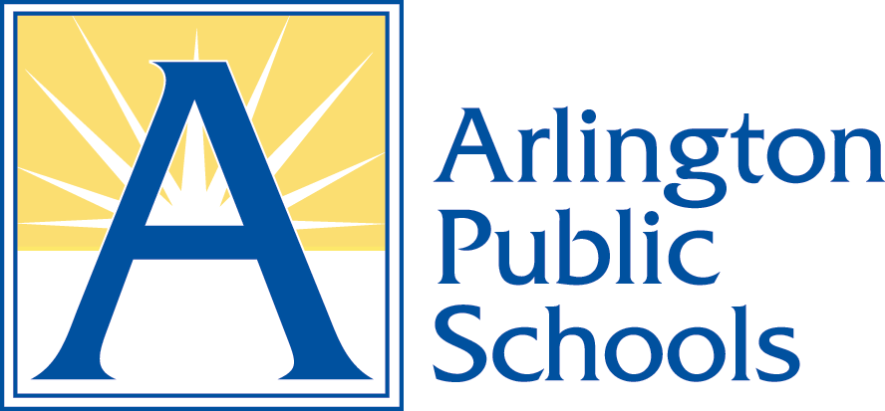

June 2020

Dear Parent/Guardian:

This spring, your child took an English language proficiency test called, Assessing Comprehension and Communication in English State-to-State for English Language Learners (ACCESS for ELLs). This test is required by the Every Student Succeeds Act (ESSA). It measures the English language proficiency of students in grades K-12. This includes students whose parents/guardians have opted them out of services.

Your child took tests in four areas: listening, speaking, reading, and writing. The results are enclosed. The report shows the English language proficiency level your child attained in each area, as well as an overall English language proficiency level. Please see the attached document, “Parent/Guardian Guide to the Individual Student Report, Grades Kindergarten-12”.

The results of the test will be used as a measure of English language proficiency for students in Arlington and Virginia. Students cannot fail the ACCESS for ELLs test.

If you would like further information about your child’s performance on this test, please contact the school.

Sincerely,

Office of English Learners

Enclosure

ACCESS for ELLs Results Letter, 2020, English

