Attachment A – Discussion Guide and Input Form for Arlington Career Center Project Meeting #1

Provide input on Arlington Career Center: Siting and Transportation

Send completed forms to engage@apsva.us by Feb. 2, 2022
View recordings of the Jan. 19 BLPC/PFRC meeting at www.apsva.us/engage/arlington-career-center-project/

Background on Siting
- Review the preliminary site plan diagram
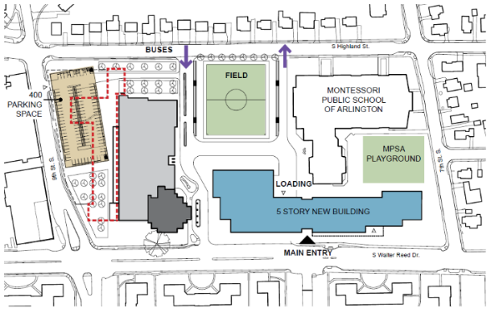
    - Highlights of preliminary site plan
      - New ACC building (blue tone) constructed fronting Walter Reed Dr.
      - Columbia Pike Branch Library (dark grey tone) remains in current location
      - Majority of existing ACC building (light grey tone) remains for a future use TBD
      - Portion of existing ACC building (red dashed line) demolished to accommodate parking structure
      - New above ground parking structure (tan tone) constructed at S. Highland St. and 9th St. S.
      - MSPA building remains in current location and MSPA playground relocated to existing ball field area
      - New field created in approximate location of existing surface parking lot
    - Preliminary site plan builds from prior work
      - Career Center Working Group provided guidance on massing and density of building on site
      - The prior BLPC/PFRC process – did not define project requirements that are built into this work
        - ACC is an option school, specifications similar to H-B Woodlawn, with a Career & Technical Education focus
        - Builds a new facility rather than building additions to existing facility which impacted school operations, added complexity, time and increased project costs

- Review PFRC Principles of Civic Design for Siting and Orientation
    - Orient the primary building entrance to the appropriate adjacent street or public space so movement and entrance to buildings are natural and intuitive.
    - Emphasize pedestrians, bicycles, and mass transit over automobiles in building placement, entry, and architecture.
    - Ensure building and site are functionally and spatially coherent, facilitating the flow of people to, from, and within the site.
    - Create “positive” outdoor spaces with a pedestrian emphasis.

- Preview topics for input
    - Height of new ACC facility
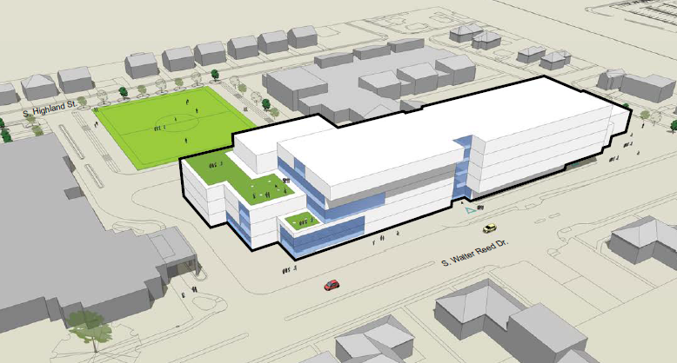 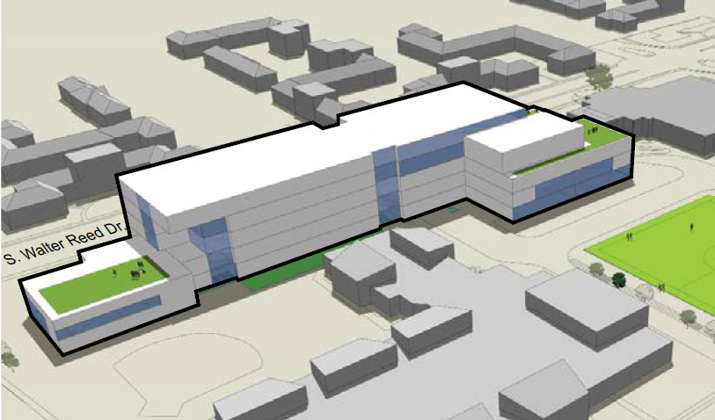
Massing View from Walter Reed Dr Massing View from MPSA
      - The preliminary site plan proposed a 5-story building along S Walter Reed Dr. that stepped down to 2-story portion adjacent to 7th St S.
      - Each story would be approximately 15 feet in building height, translating to 75 feet for a 5-story building and 90 feet for a 6-story building.
      - The Career Center Working Group reached consensus on supporting a building height of 3-4 stories along S. Walter Reed Drive, transitioning to 6-7 stories along the southern end of said street closest to 9th St S.
      - The project is located within an S-3A zoning district and the County Board, at the time of approving a Use Permit, can modify building setback and height provided certain conditions are satisfied.
    - Placement of Parking Structure
      - The preliminary site plan proposed a 4-story above ground parking structure at the corner of S. Highland and 9th St. S. to meet the project’s anticipated parking demand.
      - The location of the parking structure will remain at the locations show and will be refined based on feedback received as the design progresses.
    - Strengths and Concerns with Preliminary Site Plan
      - The design team will develop the site plan and building massing based on a variety of inputs, including stakeholder feedback.

Background on Transportation
- Review the transportation highlights from the preliminary site plan diagram
    - Main entry for new ACC building shown on Walter Reed Dr.
    - Campus bus operations to occur on a private drive on-site
    - Parent pick-up/drop-off (PUDO) not specifically identified
    - Service access to the new ACC building to occur via a private drive on-site
    - On-site parking accommodated within an above ground parking structure at the S. Highland and 9th St. S

- Review selective PFRC Principles of Civic Design related to the breakout discussion
    - Respect neighborhood context… (Civic Values)
    - Optimize open space for public relaxation and recreation, and minimize building footprint and areas used for parking, on-site roads, and service drives. (Civic Values)
    - Emphasize pedestrians, bicycles, and mass transit over automobiles and building placement, entry, and architecture.​ (Siting and Orientation)

- Preview topics for input
    - Transportation Goals
      - Goal #1: Safety of Students
        - Review walking routes to/from CC building
        - Reduce conflicts of different school transportation needs (e.g., keep passenger cars away from the school buses)
        - Careful design between County needs and school needs (e.g., make sure plans work with Walter Reed plans)
      - Goal #2: Right-sizing Career Center transportation infrastructure
        - Help determine the correct amount of space dedicated to transportation on site to accommodate needs without overbuilding, allowing for more room for buildings and green space
        - Determine which demands can be reasonably accommodated off-site
      - Goal #3: Minimizing Impacts
        - Develop strategies to reduce people driving to/from the Career Center
        - Spread out transportation demands – in time and location – to reduce overall impact
        - Determine any changes to existing and proposed transportation infrastructure (e.g., do we need to upgrade an intersection to a traffic signal?)
    - Transportation Concerns and Issues
      - Consultants collected transportation data in 2019 and fall 2021
        - In 2021 traffic volumes are lower on Walter Reed, but higher on 7th/9th/Highland and data shows larger impact of arrival/dismissal compared to 2019
        - In 2021 parking shows higher residential parking demand during day and data shows less demand on streets adjacent to Career Center mid-day
      - Consultants performed field observations in fall 2021, summarized below
        - Access control and bus conflicts
          - Controlling vehicle access and vehicle-bus conflicts is a concern across the campus
          - Plenty of space for Career Center buses but vehicles routinely ignore signs and enter bus-only areas
          - MPSA may need additional bus queuing space in the afternoons
        - Walter Reed Pick-up/Drop-off (PUDO)
          - Significant ad-hoc PUDO on Walter Reed in front of ACHS and the library
          - Did not appear to have negative impact on Walter Reed, but this activity may not be compatible with future County plans for Walter Reed
        - MPSA PUDO
          - Pick-up/Drop-off (PUDO) for MPSA along Highland significantly impacts on-street parking and causes traffic congestion during arrival/dismissal
          - Does not match observations performed in 2019 and prior dates
        - Take-aways for Concept Design
          - Identify safe routes for walkers/cyclists, take advantage of County’s Walter Reed Drive plans
          - Develop clear and separate bus and student pick-up/drop-off locations, provide more options/space for loading/unloading if needed
          - Avoid conflicts between walkers/cyclists and student pick-up/drop-off along Walter Reed drive

Questions | Responses
Identify group submitting this information | Ex. Breakout group #, stakeholder group or individual completing this form

Siting Questions
- Height of New ACC Facility | - Are there portions of the building (in blue) that could be adjusted (i.e. built taller, etc.) in exchange for more open space on the site?
 | - Are there other suggestions staff should consider regarding height of the building?
- Placement of Parking Structure | - Looking at the parking garage placement on 9th St., what works? What are the challenges? Other concerns?
 | - Are there other suggestions staff should consider when refining the parking structure?
- Strengths and Concerns with Preliminary Site Plan | Identify additional strengths and concerns with the preliminary site plan that are not addressed in the responses to questions 2 or 3.

Transportation Questions
- Transportation Project Goals for  - Safety of Students  - Right-sizing Career Center transportation infrastructure  - Minimizing traffic impacts | Are these the right goals for multimodal transportation on the stie? If not, what should be added or adjusted?
- Input on Career Center campus transportation concerns & issues | What additional transportation issues or concerns need to be addressed? (i.e. outside points in the transportation slides 14 - 18)

Send completed forms to engage@apsva.us by Feb. 2, 2022

