Discussion Guide and Input Form for Arlington Career Center Project Meeting #5

Send completed forms to engage@apsva.us by Thursday, Aug. 11, 2022

For context, review the following July 27 resources on the www.apsva.us/engage/arlington-career-center-project-concept-design-review/#BLPCMeetings

- Posted July 22 - BLPC/PFRC advance materials
- July 27 – recorded meeting and recorded breakout group discussions at

Name of person completing this form  If you are responding on behalf of a stakeholder group, enter your name and the full name of the stakeholder group. Please only send one (1) official response from the stakeholder group. | Name: ___________________________  I am completing this form on behalf of:  ☐ Myself  ☐ Stakeholder group: ______________________________  ☐ Breakout group #: ________________________________

Questions | Responses

Site and Landscape Design
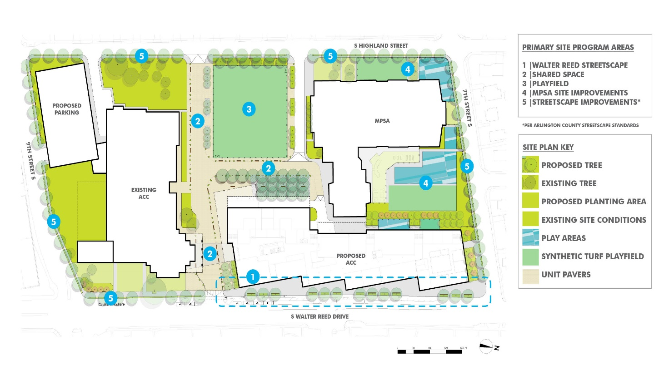

Review slides 14-29 in the Meeting #5 Advance Material.

Updates on the site and landscape design included illustration of expected improvements throughout the campus, phasing, planting strategy, and site circulation.

1a. What do you like?

1b. What do you feel requires further refinements?

Questions outside of scope

ACC Building Design

Review slides 30-46 in the Meeting #5 Advance Material.

Updates to the new ACC building design included building massing/form refinement, initial selection of exterior materials, and developing the elevations along all sides of the building.
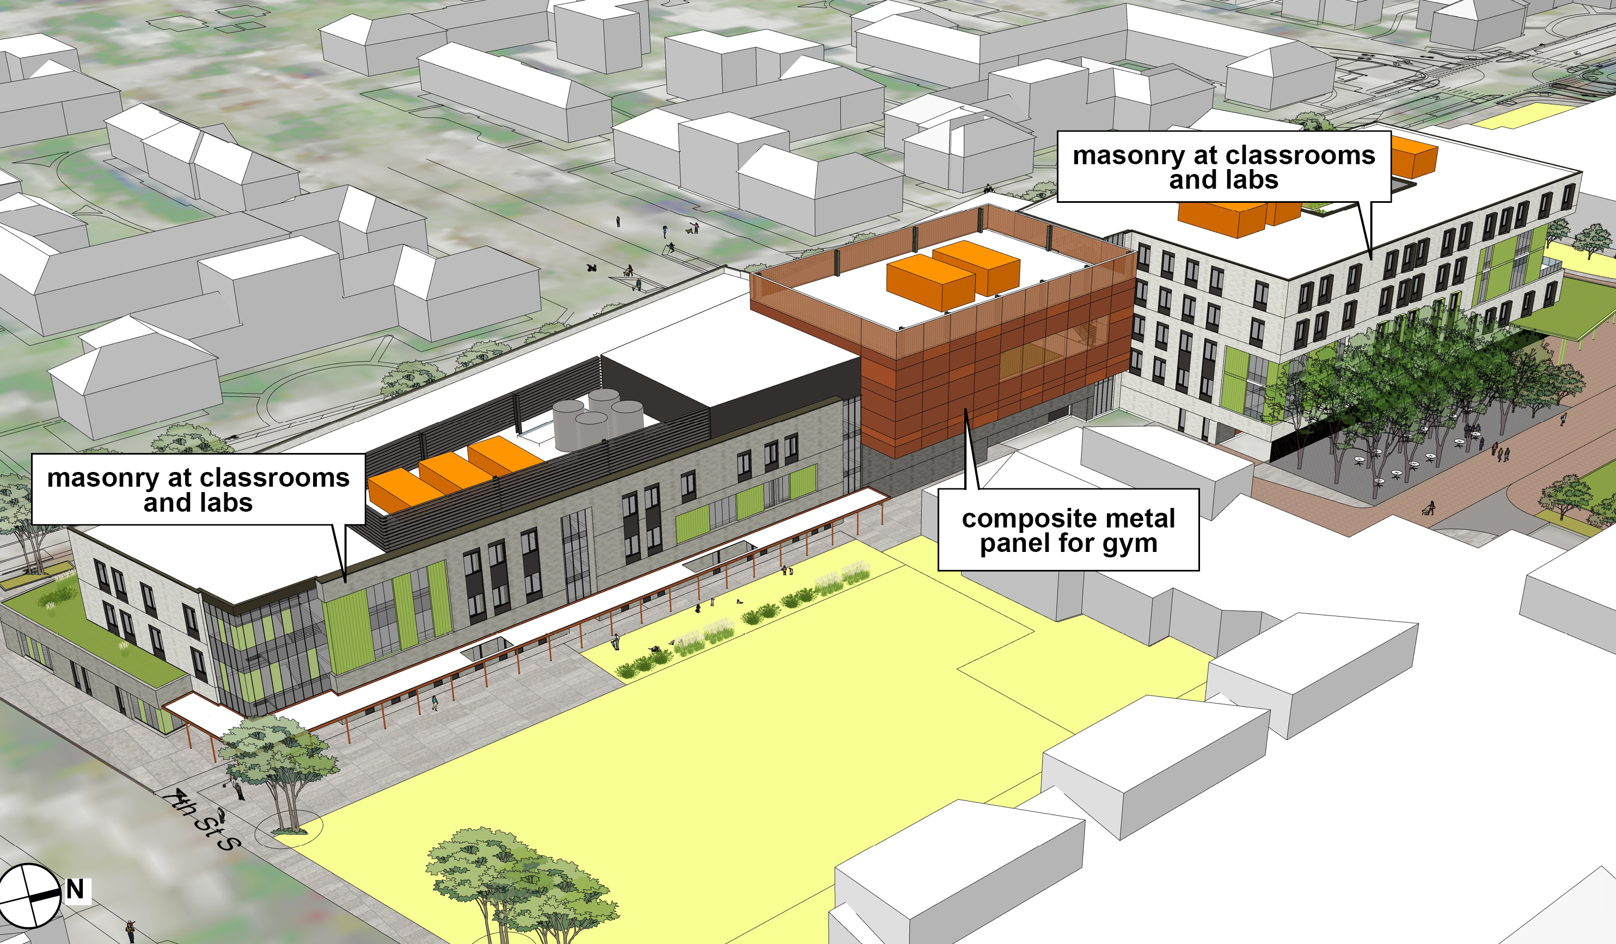
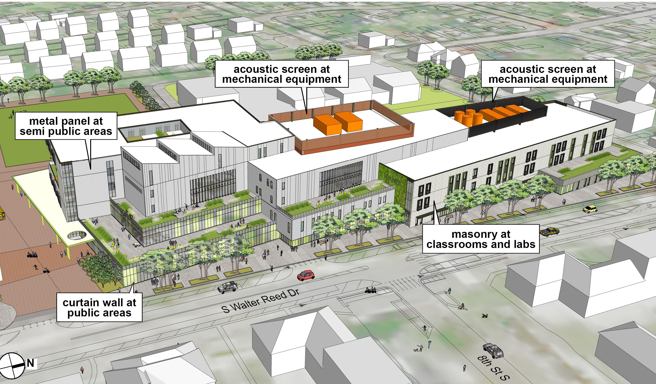

2a. What do you like?

2b. What do you feel requires further refinements?

Questions outside of scope

Parking Garage Design
- Review slides 47-53 in the Meeting #5 Advance Material.
- Updates to the parking garage design included garage massing/form refinement, initial layout and circulation, and preliminary proposal of exterior wall screening/materials.
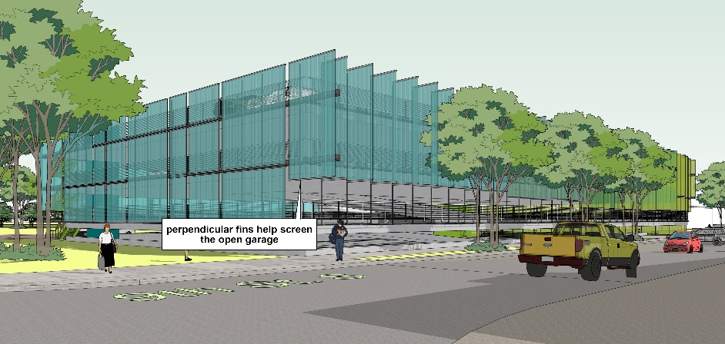
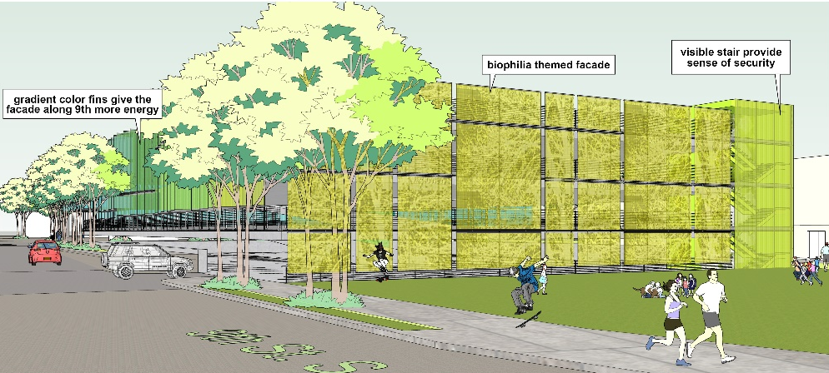

3a. What do you like?

3b. What do you feel requires further refinements?

Questions outside of scope

Additional Questions

4. Identify additional questions or concerns with the schematic design progress

5. Identify specific areas of the project that should receive further development or focus before the end of schematic design

Questions outside of scope

