2022-23 BUDGET ADVISORY COUNCIL
Wednesday, Sept. 13, 2023
Syphax Center, Room 258
7:00 PM - 9:00 PM

- Call to order 7:00
- Approval of May meeting minutes 7:05
- Public comment 7:10
- 2023-24 BAC Membership 7:15
- School Board liaison introduction and FY outlook 7:25
- School Board priorities 7:35
- APS Finance updates and announcements 7:45
- BAC proposed schedule for 2023-24 (see below) 7:55
- BAC focus & topics for the year 8:15
- Comments on policies open for comment (see below) 8:45
- Adjourn 9:00

-----------------------------------------------------------------------------------------------------------------------------------

Upcoming School Board Meetings (Board meetings are very valuable for all committee members to view; all meetings are recorded and can be watched at any time after the meeting)
- Sept 21 – 7pm
- Sept 26 – 9am-4pm (Work Session)
- Oct 12 – 7pm
- Oct 26 – 7pm

-----------------------------------------------------------------------------------------------------------------------------------
Addendum I: Proposed BAC meetings:

- October 11, 2023
- November 8, 2023
- December 13, 2023
- January 10, 2024
- February 14, 2024
- March 6, 2024
- March 13, 2024 – VIRTUAL
- March 20, 2024
- April 17, 2024 – VIRTUAL (April 10 is a holiday)
- May 8, 2024
- June 12, 2024

-----------------------------------------------------------------------------------------------------------------------------------
Addendum II: APS Policies open for comment:

K7 - Financial Management-Use of School Facilities (closes Oct 5)
Addendum III: APS School Board Work Sessions:

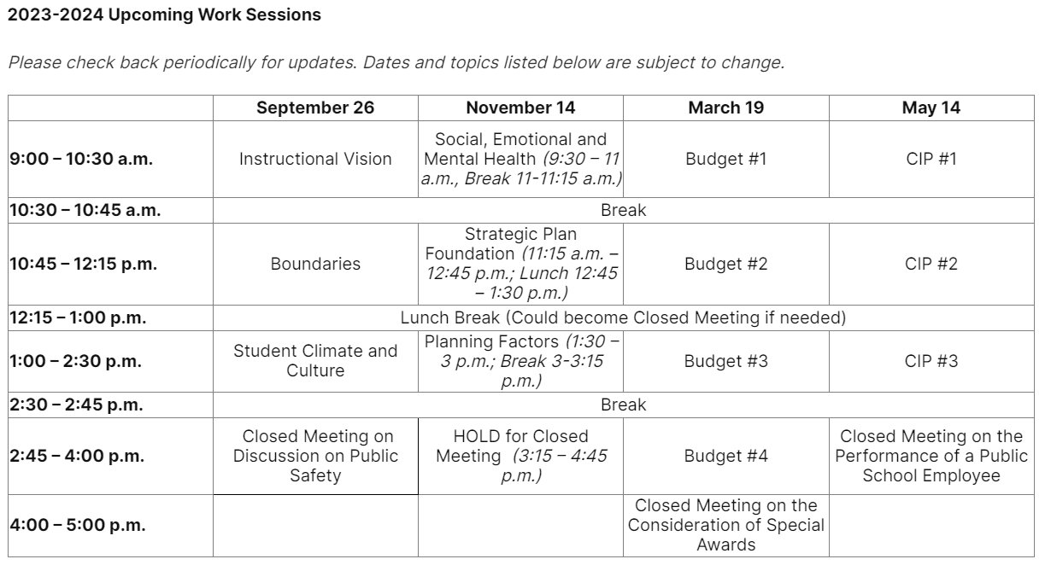

PROPOSED BAC SCHEDULE FOR 2023-24

October 11, 2023
November 8, 2023
December 13, 2023
January 10, 2024
February 14, 2024
March 6, 2024
March 13, 2024 – VIRTUAL
March 20, 2024
April 17, 2024 – VIRTUAL (April 10 is a holiday)
May 8, 2024
June 12, 2024

