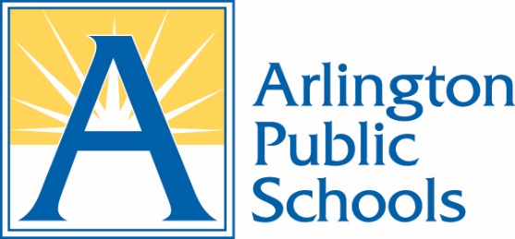

SCHOOL HEALTH ADVISORY BOARD
AGENDA
November 12, 2025
Virtual on Zoom

- Call to Order

- Adoption of Meeting Agenda

- Approval of Meeting Minutes

- Old Business and Action Items

  - Introduction of Chris Willmore
  - Staff updates

- New Business and Reports

  - Discussion of SHAB priorities
  - FLE Discussion

- Chair’s Report

- Announcements by Members

  - Device Working Group update

- Future Business

  - Next meeting date January 7 1:00-2:30 - Virtual

- Adjournment

