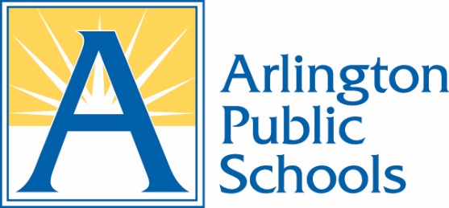

SCHOOL HEALTH ADVISORY BOARD
AGENDA
January 7, 2026
Virtual on Zoom

- Call to Order

- Adoption of Meeting Agenda

- Approval of Meeting Minutes

- Old Business and Action Items

  - Staff updates

- New Business and Reports

  - Review and vote on SHAB recommendations for ACTL consideration
  - FLE Working Group Update

- Chair’s Report

- Announcements by Members

  - Device Working Group update

- Future Business

  - Next meeting date March 18 1:00-2:30

- Adjournment

